

Statement and Confirmation of Own Work

A signed copy of this form must be submitted with every assignment.

If the statement is missing your work may not be marked.

For Level 7 assignments, please use the separate Level 7 Candidate Statement of Own Work form instead of this one.

Student Declaration

I confirm the following details:

|  |  |
| --- | --- |
| **Candidate Name:** | Zwe Khant Aung |
| **Candidate ID Number:** | P00202709 |
| **Qualification:** | Level 5 Diploma in Computing |
| **Unit:** | Artificial Intelligence |
| **Centre:** | Strategy First University |
| **Word Count:** |  |
| I have read and understood both NCC Education’s *Academic Misconduct Policy* and the *Referencing and Bibliographies* document. To the best of my knowledge my work has been accurately referenced and all sources cited correctly.  I confirm that I have not exceeded the stipulated word limit by more than 10%.  I confirm that this is my own work and that I have not colluded or plagiarised any part of it. | |
| **Candidate Signature:** | Zwe |
| **Date:** | 30.6.2024 |

Contents

Task – 1 – HTML 4

index.php (guest page/ before login) 5

Methods used in index.php 6

Output of index.php 8

b-information.php (guest page/ before login) 9

Output of b-information.php 10

b-legislation.php (guest page/ before login) 11

Output of b-legislation.php 12

login.php (guest page/ before login) 13

Methods used in login.php 13

Output of login.php 15

register.php (guest page/ before login) 17

Methods used in register.php 18

Output of register.php 20

admin-home.php (admin page) 22

Methods used in admin-home.php 23

Output of admin-home.php 26

service-setup.php (admin page) 27

Methods used in service-setup.php 28

Output of service-setup.php 31

newsletter-setup.php (admin page) 34

Methods used in newsletter-setup.php 35

Output of newsletter-setup.php 39

how-parent-help-setup.php (admin page) 43

Methods used in how-parent-help-setup.php 44

Output of how-parent-help-setup.php 47

social-media-app-setup.php (admin page) 50

Methods used in social-media-app-setup.php 51

Output of social-media-app-setup.php 54

contact-list.php (admin page) 56

Methods used in contact-list.php 57

Output of contact-list.php 58

member-list.php (admin page) 59

Methods used in member-list.php 60

Output of member-list.php 62

Task – 2 – CSS and Database 66

Task – 3 – Critical Evaluation 68

Introduction and Benefits of the Website 68

Web Development Tools for the Website 68

Usage of PHP to Design and Build the Website Database 69

How Effectively the Website Meet the Requirements 69

Task – 4 - Reflection 71

Development Tools 71

Learning From the Development of The Website 71

Discussing for A Similar Task in The Future 71

Bibliography 72

# Task – 1 – HTML

**Task - 1**

## index.php (guest page/ before login)

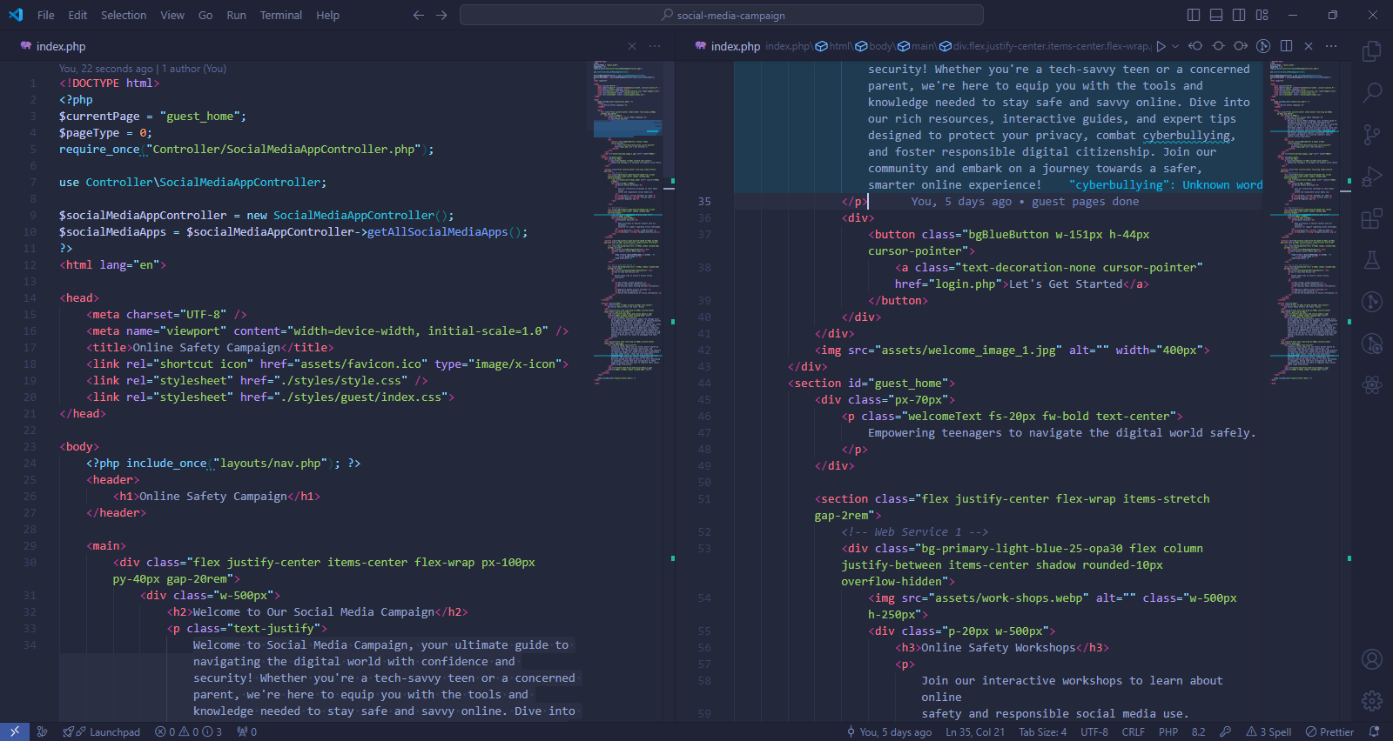

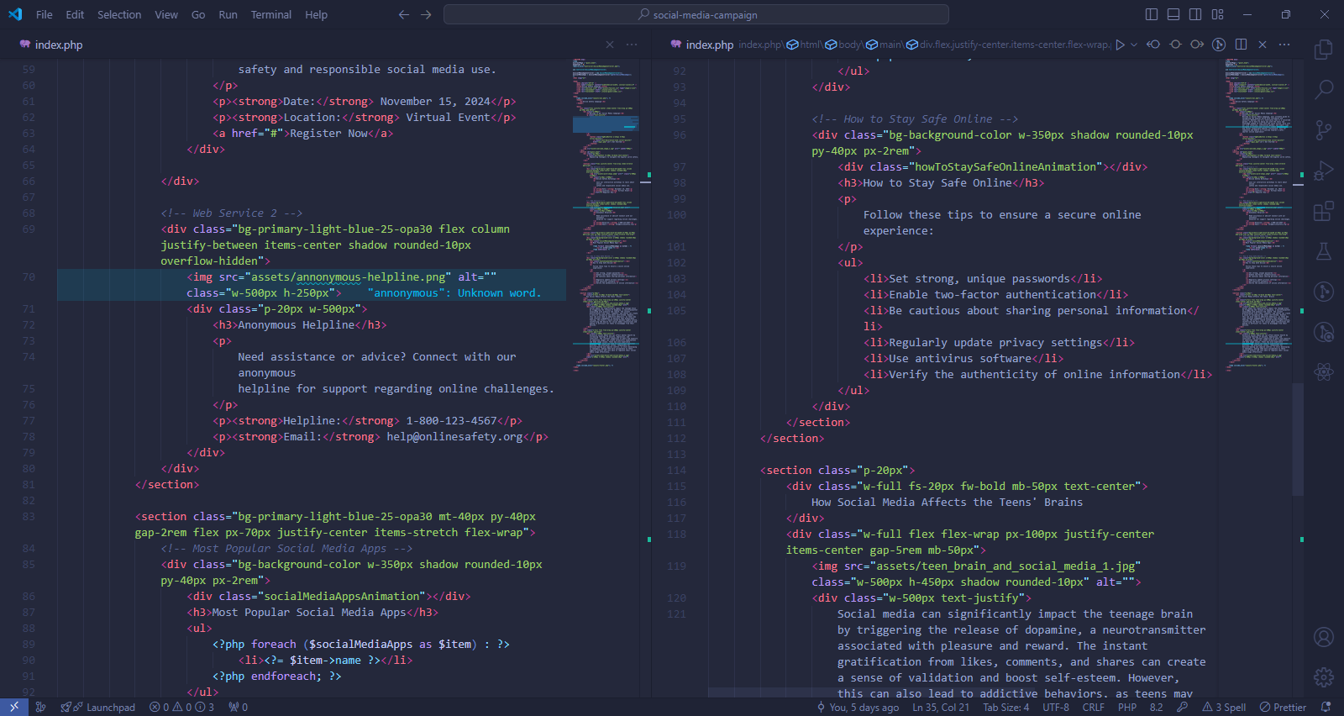

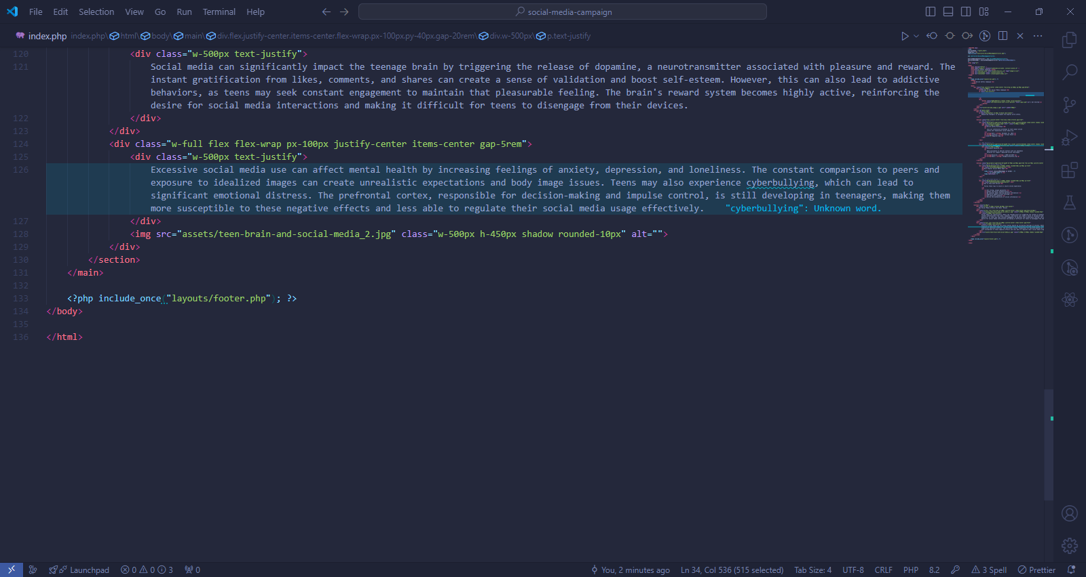

### Methods used in index.php

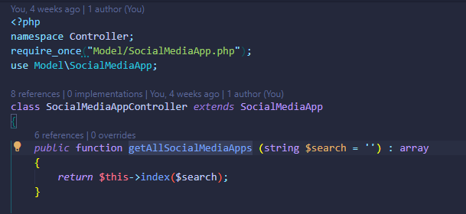

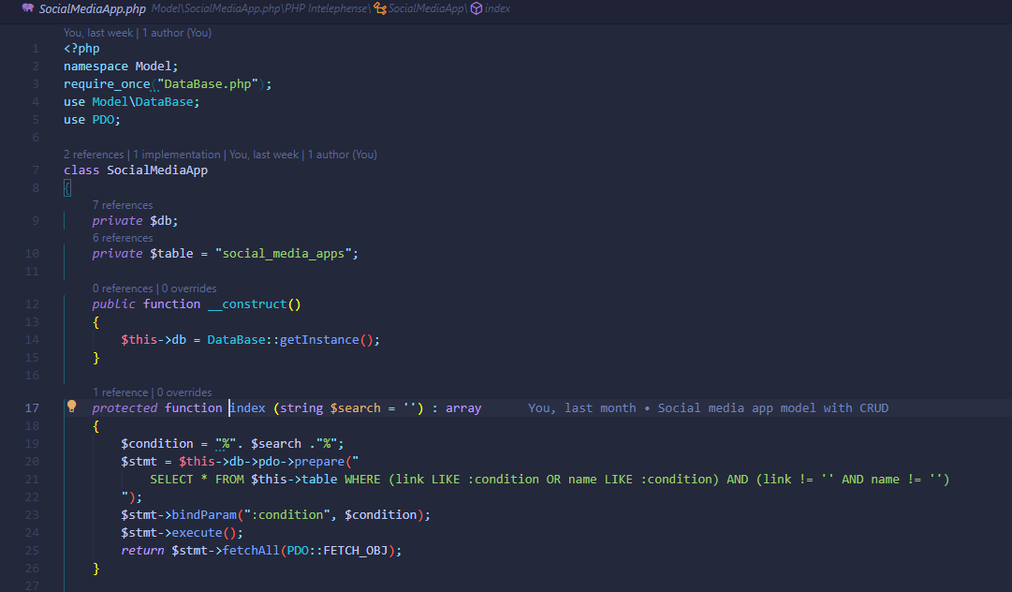

“index” method is used to search or get data from the “social_media_apps” table and that method will be is used in “getAllSocialMediaApps” method of SocialMediaAppController.

### Output of index.php

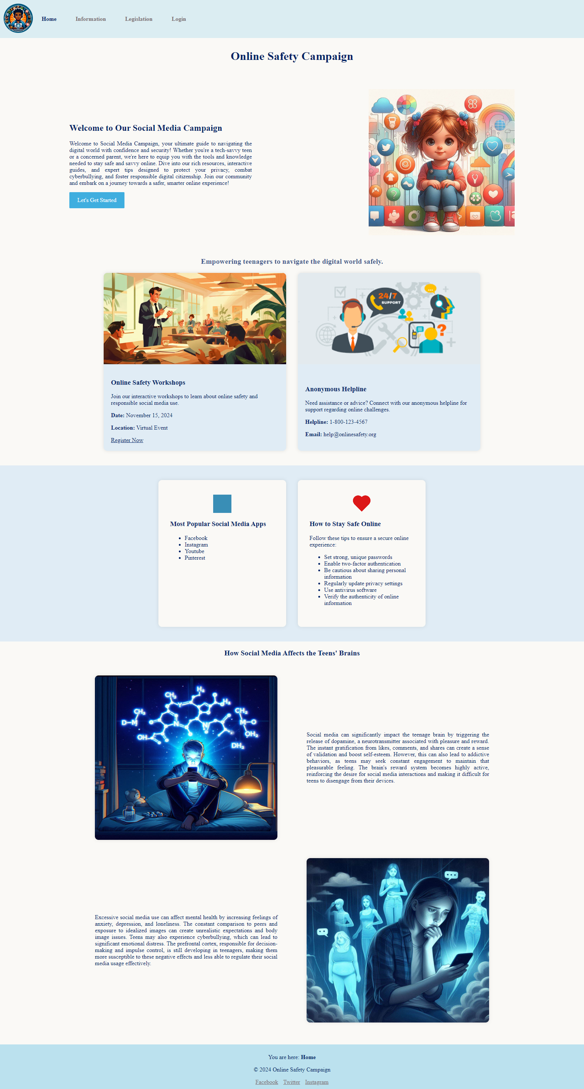

## b-information.php (guest page/ before login)

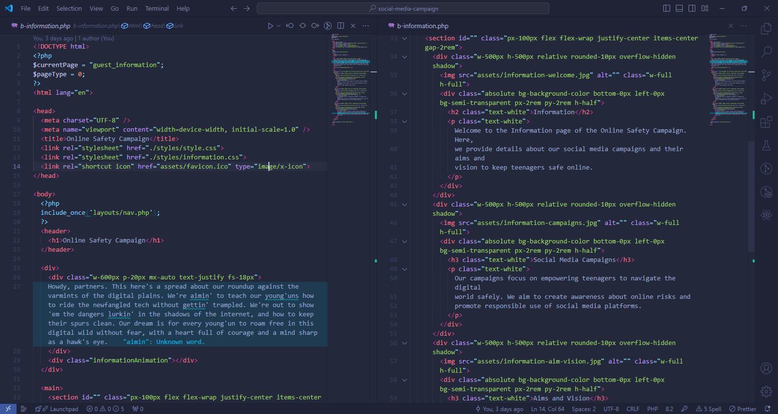

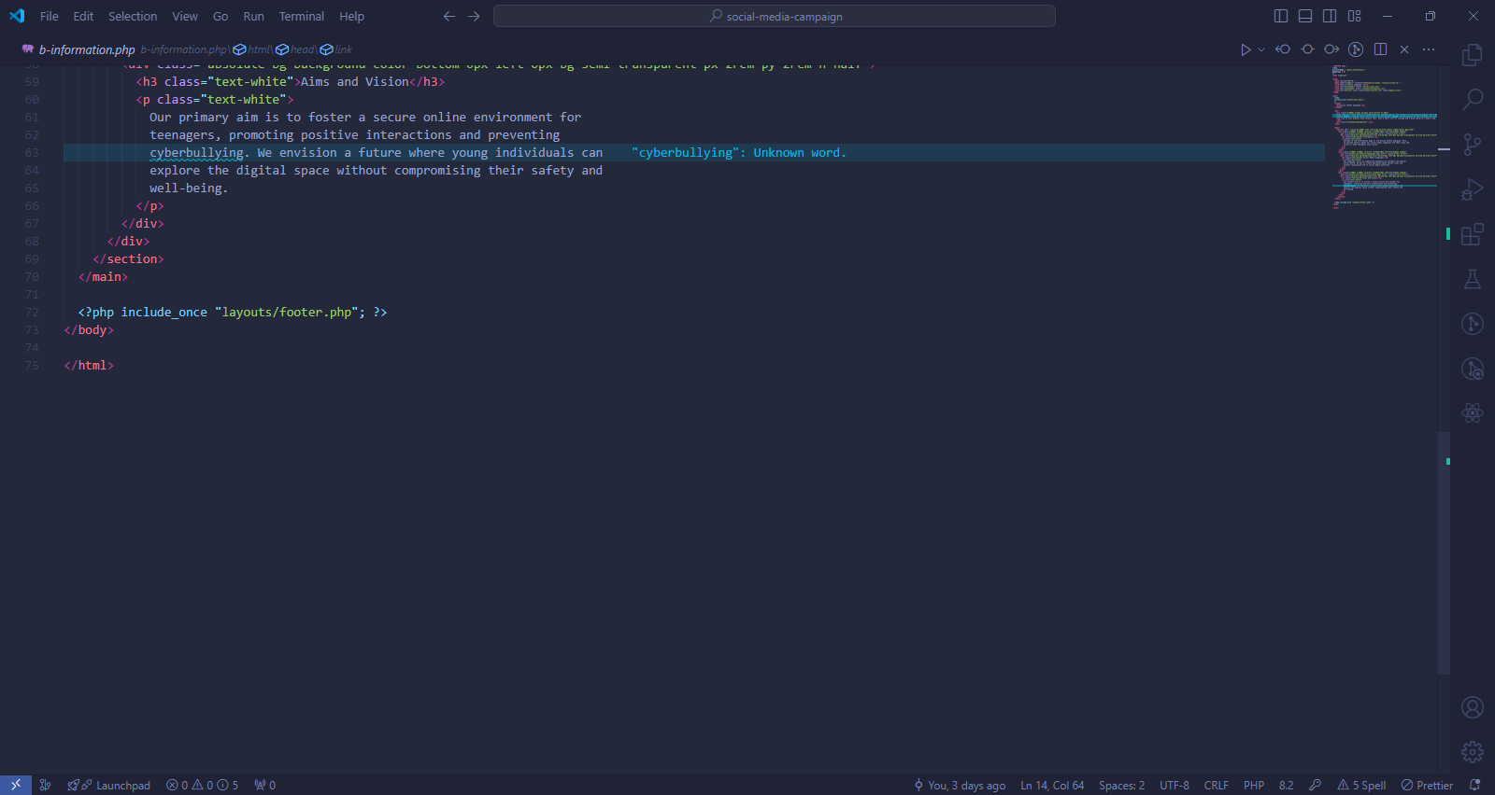

### Output of b-information.php



Black shapes under the paragraph are live animations.

## b-legislation.php (guest page/ before login)

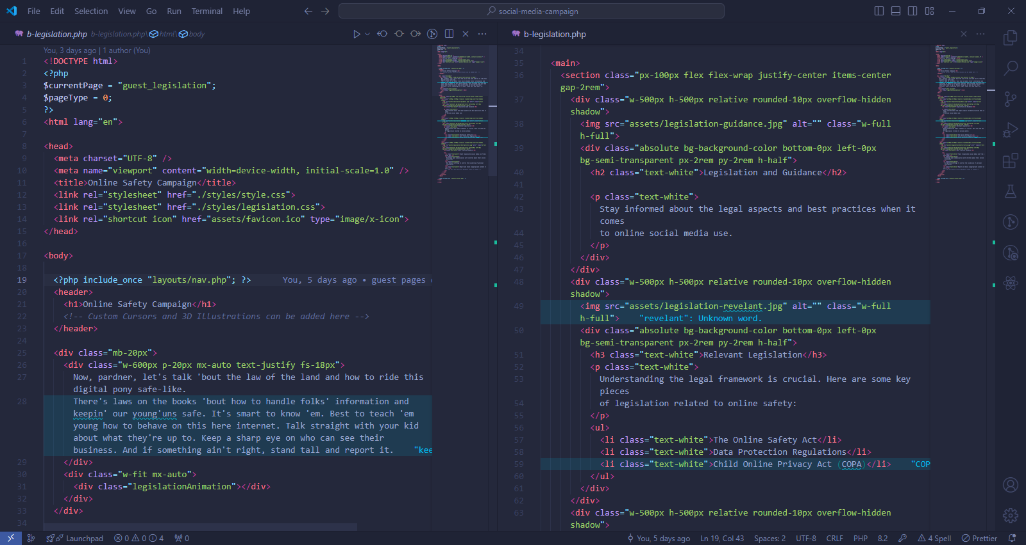

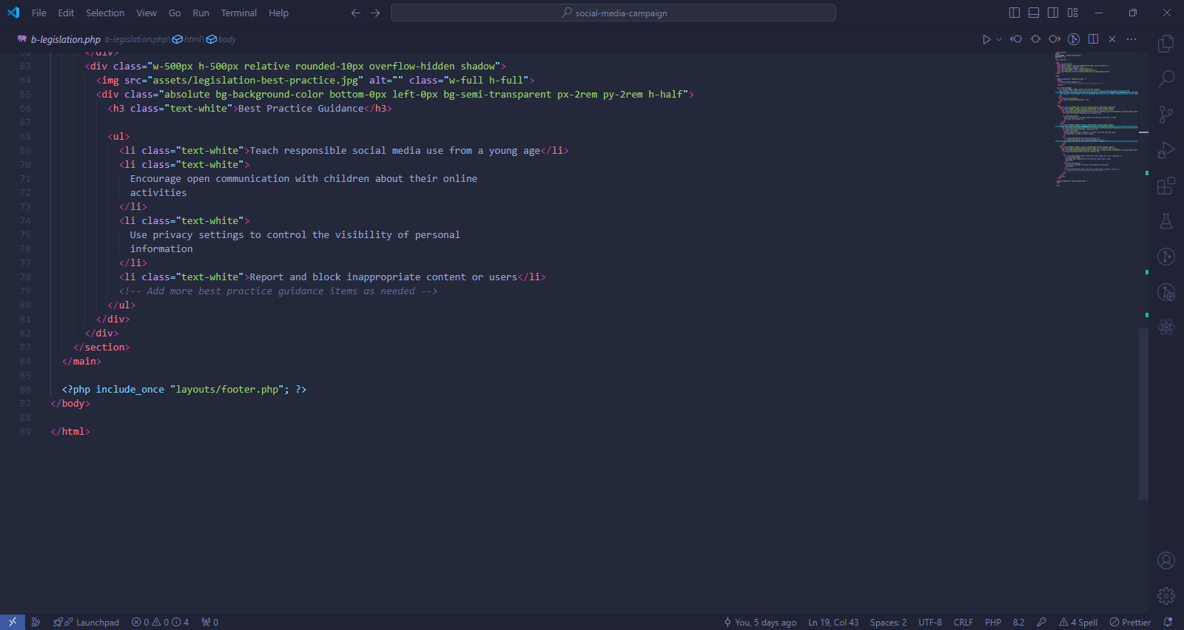

### Output of b-legislation.php

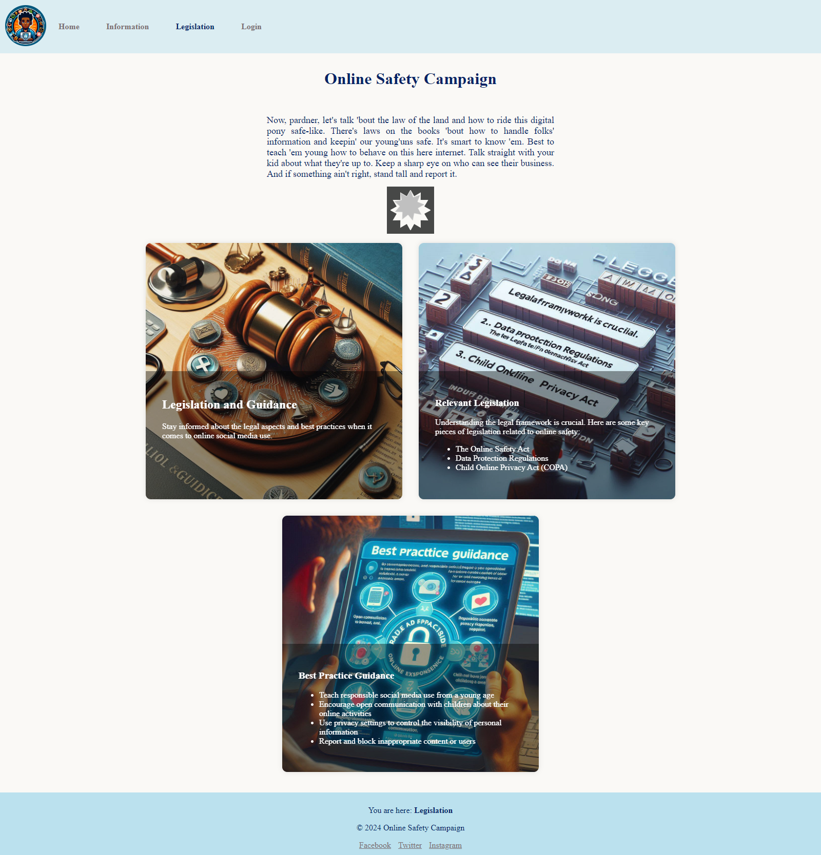

Shapes under the paragraph are live animations.

## login.php (guest page/ before login)

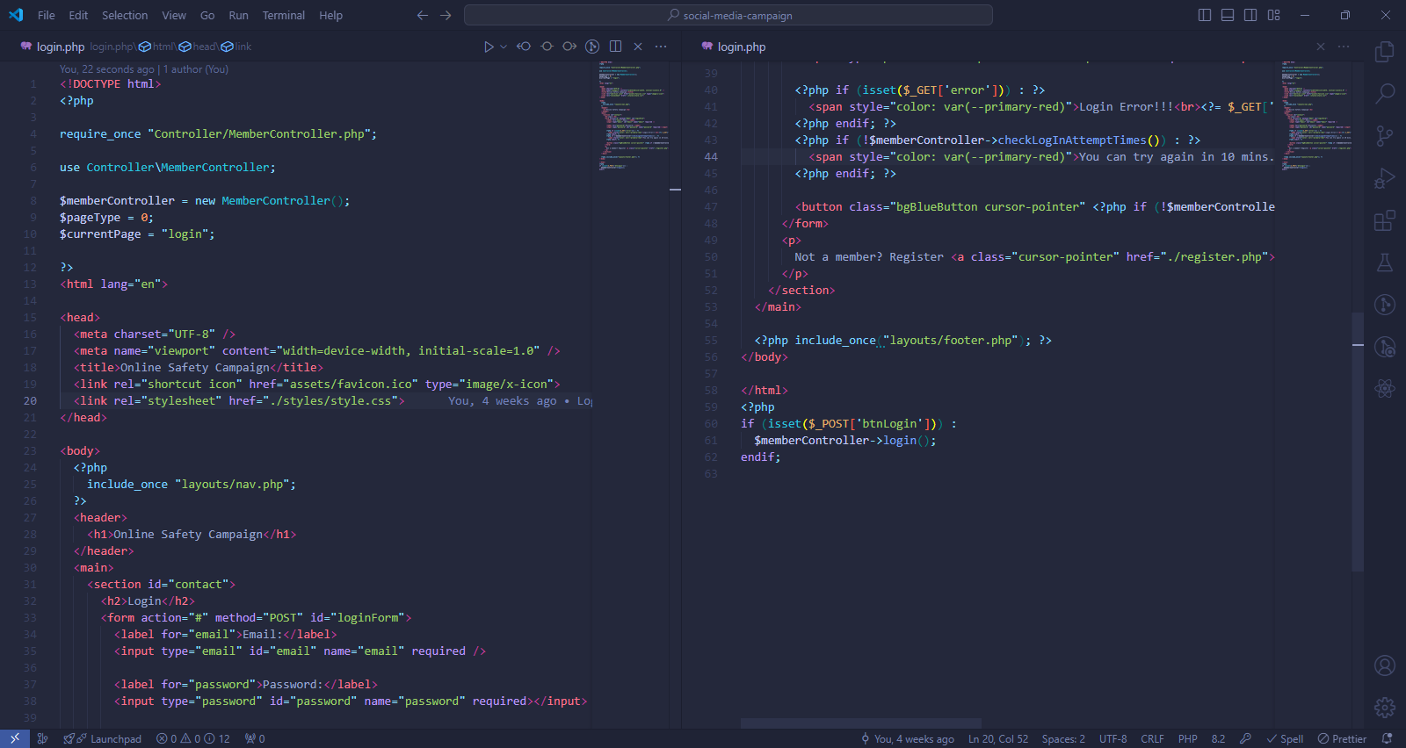

### Methods used in login.php

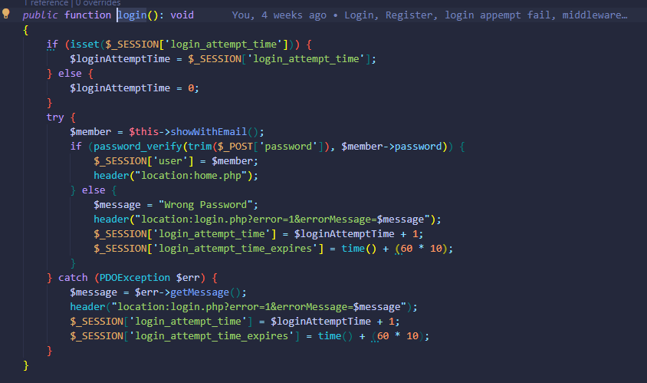

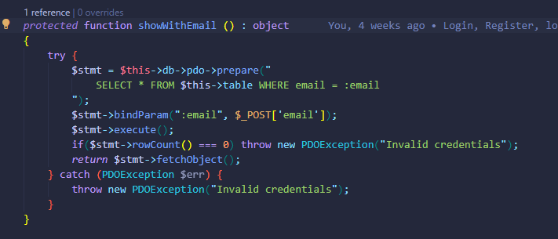

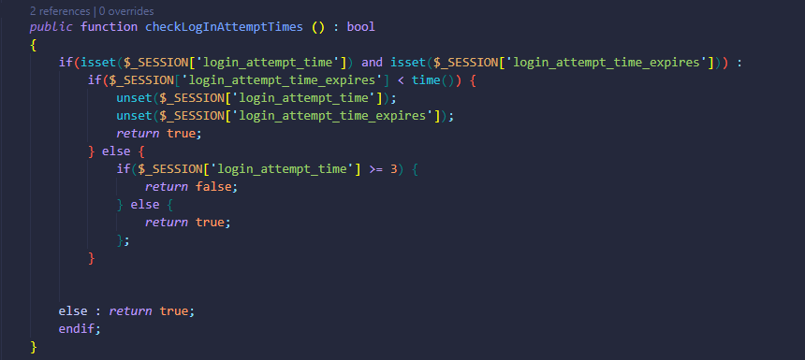

“showWithEmail” method is of “Member” Model and used for get the user information with email. “checkLogInAttemptTimes” method is of “MemberController” which extends “Member” Model will be used how many failed logins attempts the user has tried.

### Output of login.php

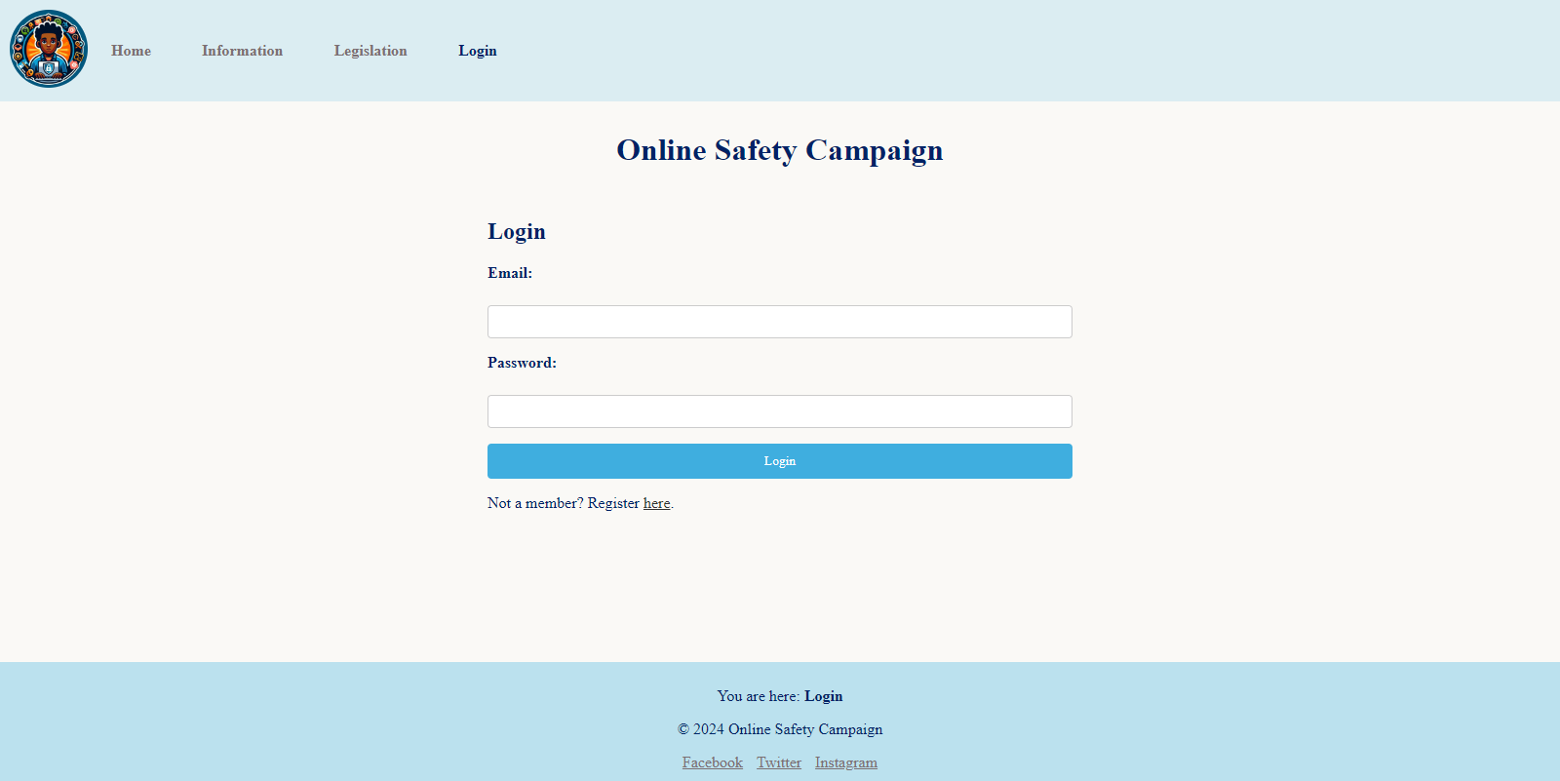

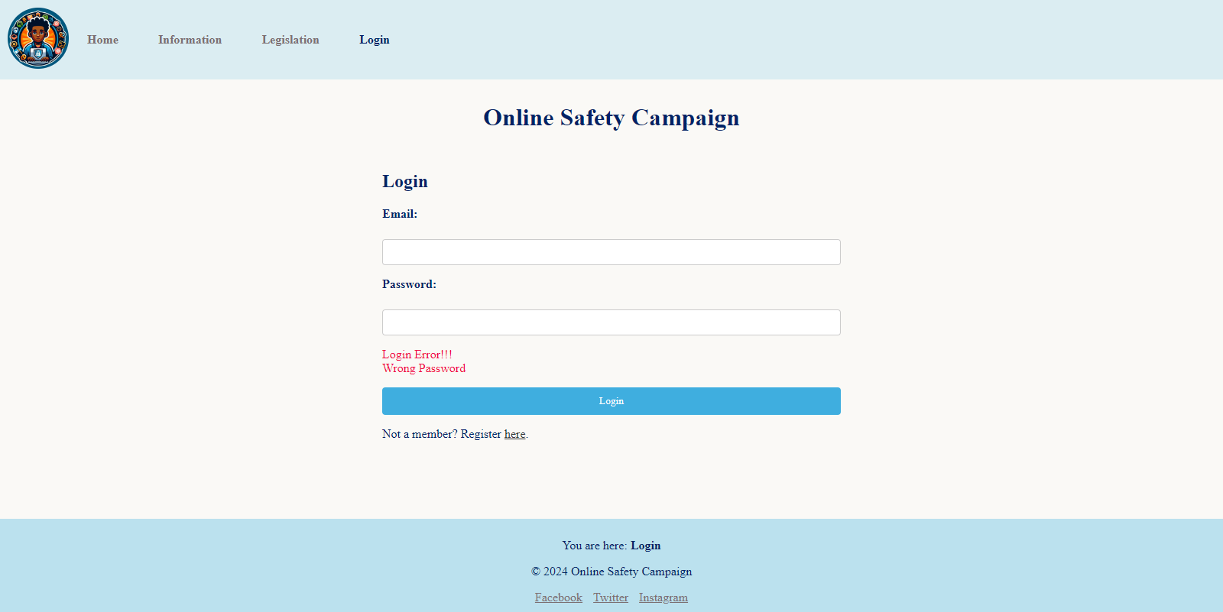

Wrong password message.

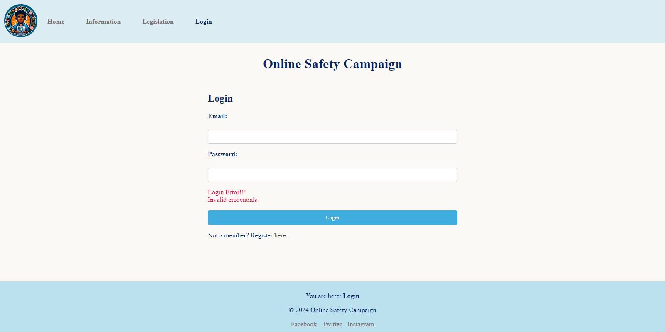

Invalid email or invalid credentials message.

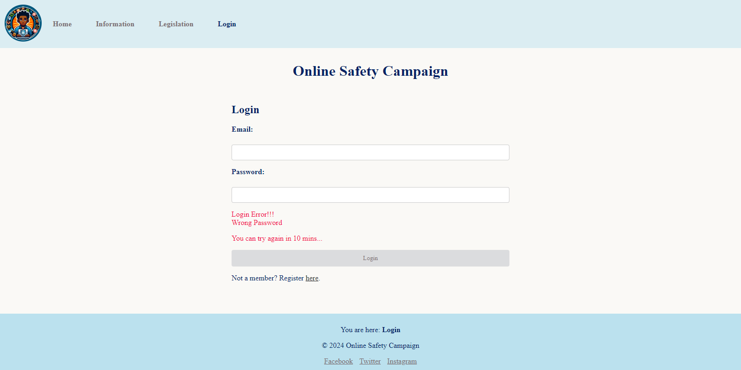

3 times log in attempt fail. The login form button will be auto disabled and will be re-enabled after 10 minutes.

## register.php (guest page/ before login)

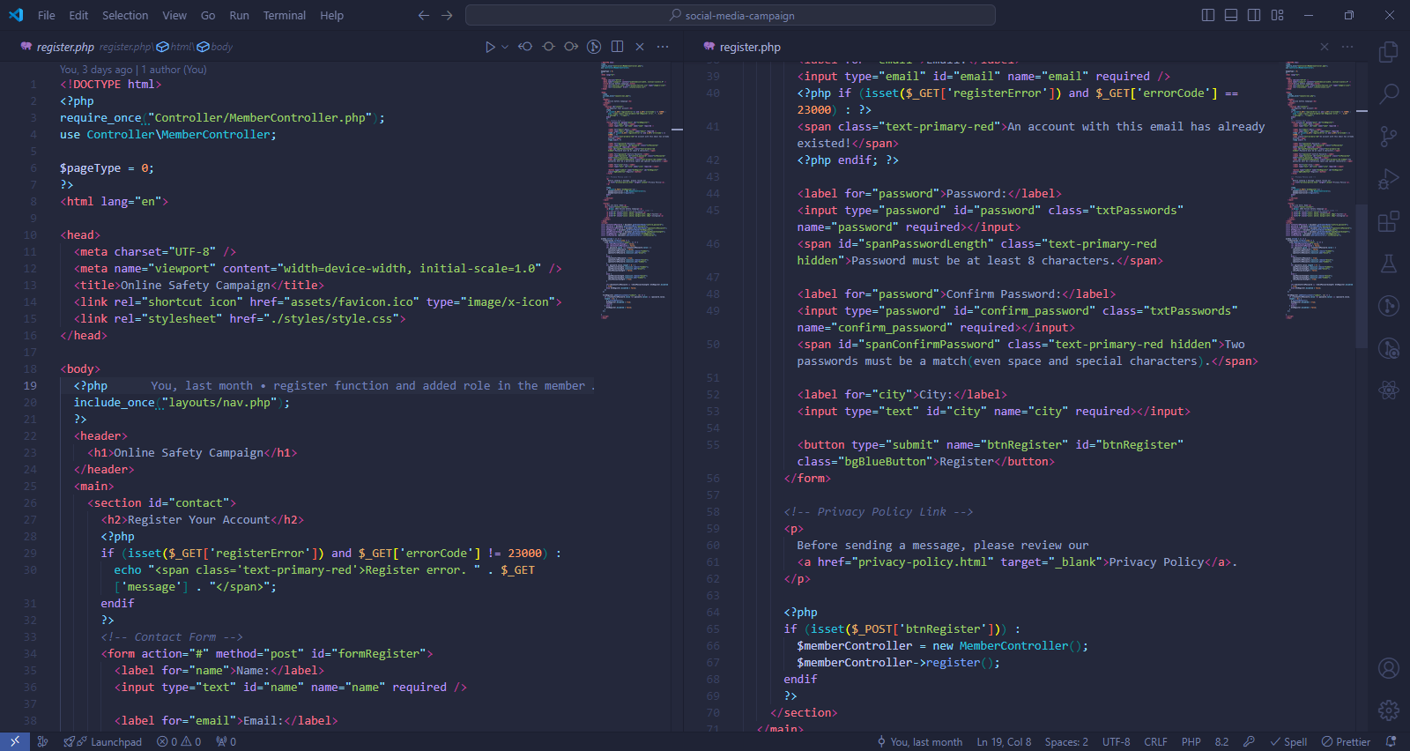

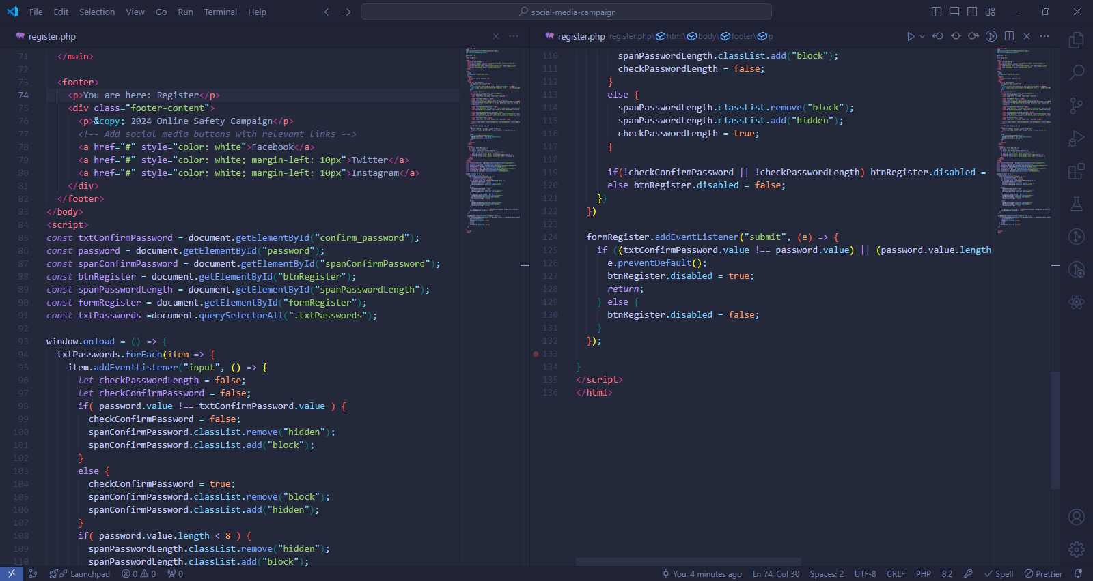

### Methods used in register.php

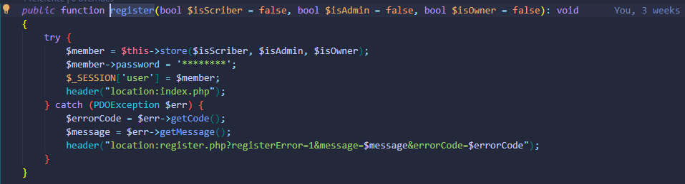

Register function of MemberController.

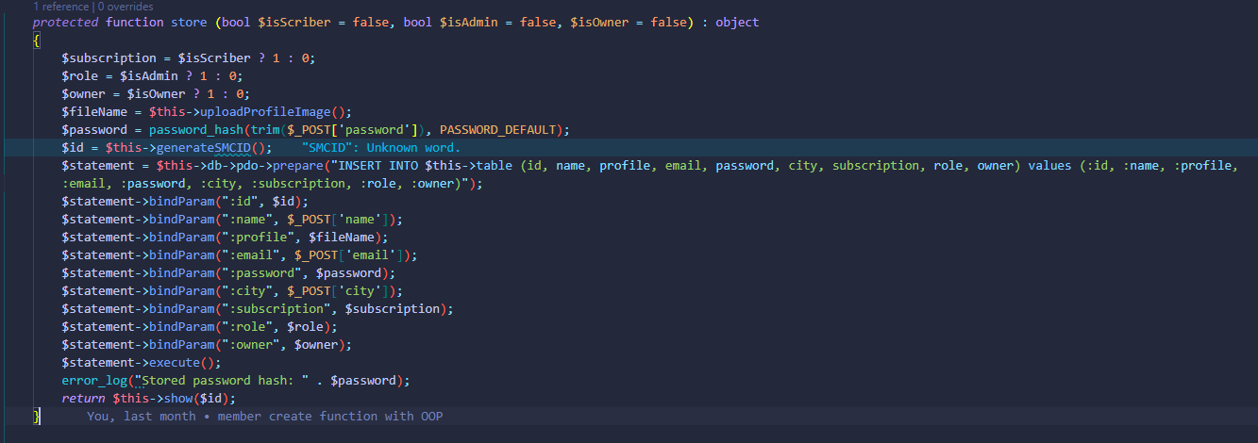

“store” function of “Member” model which will be used in register function.

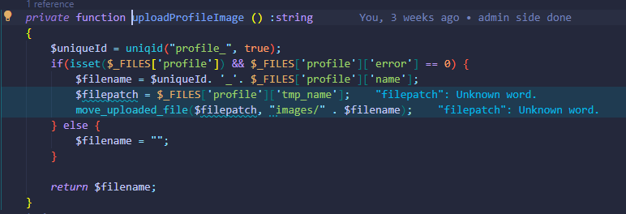

This function is used to upload profile images of members which will be used in store function.

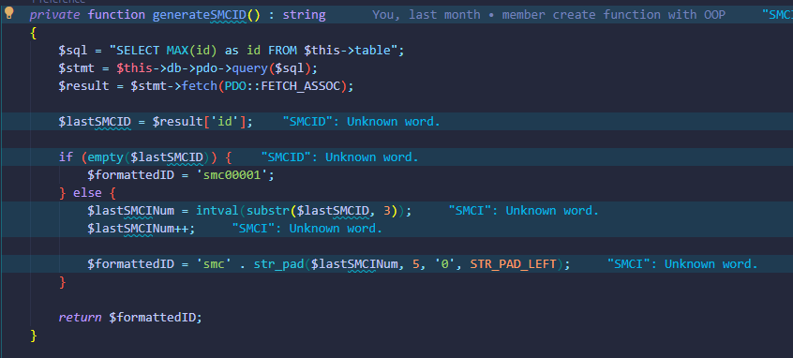

This function will be used in the store function to generate the “id” for the members.

### Output of register.php

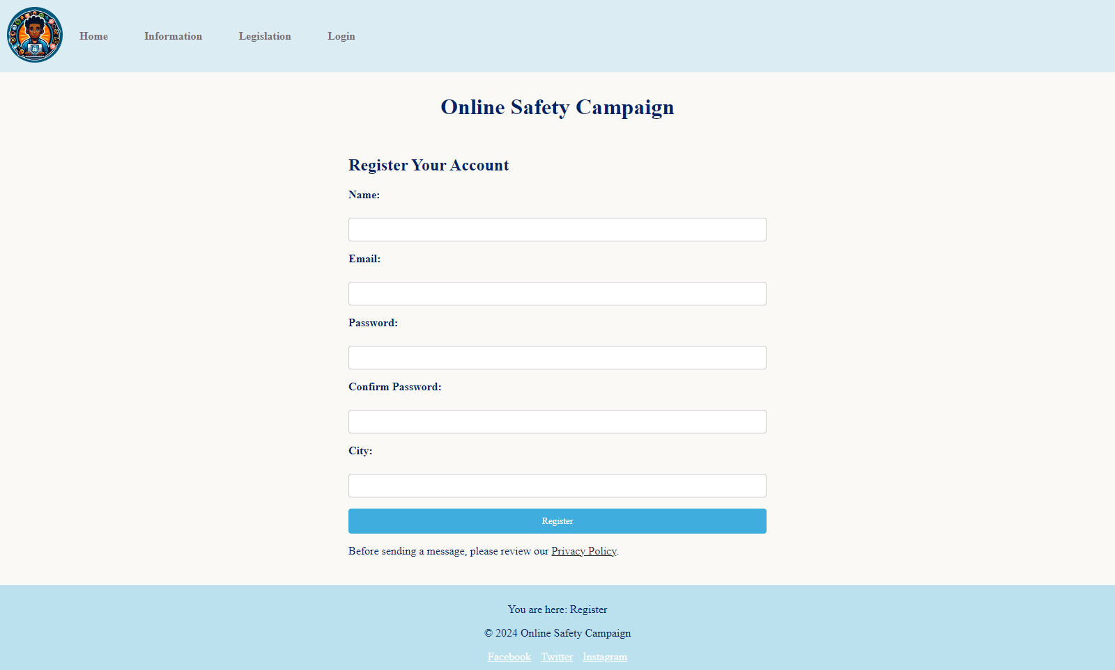

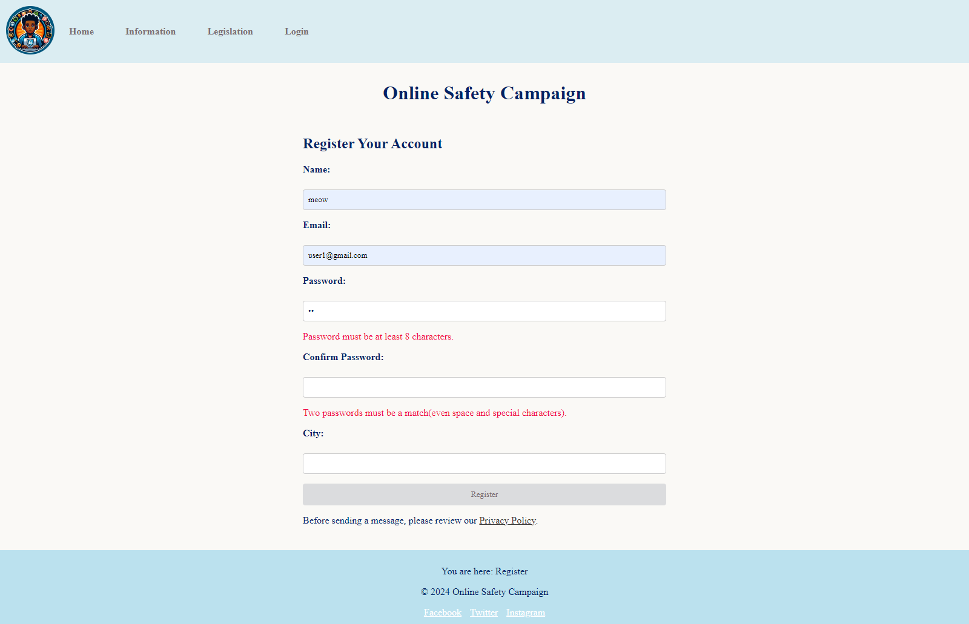

Password strength and confirm password are checked by using JavaScript.

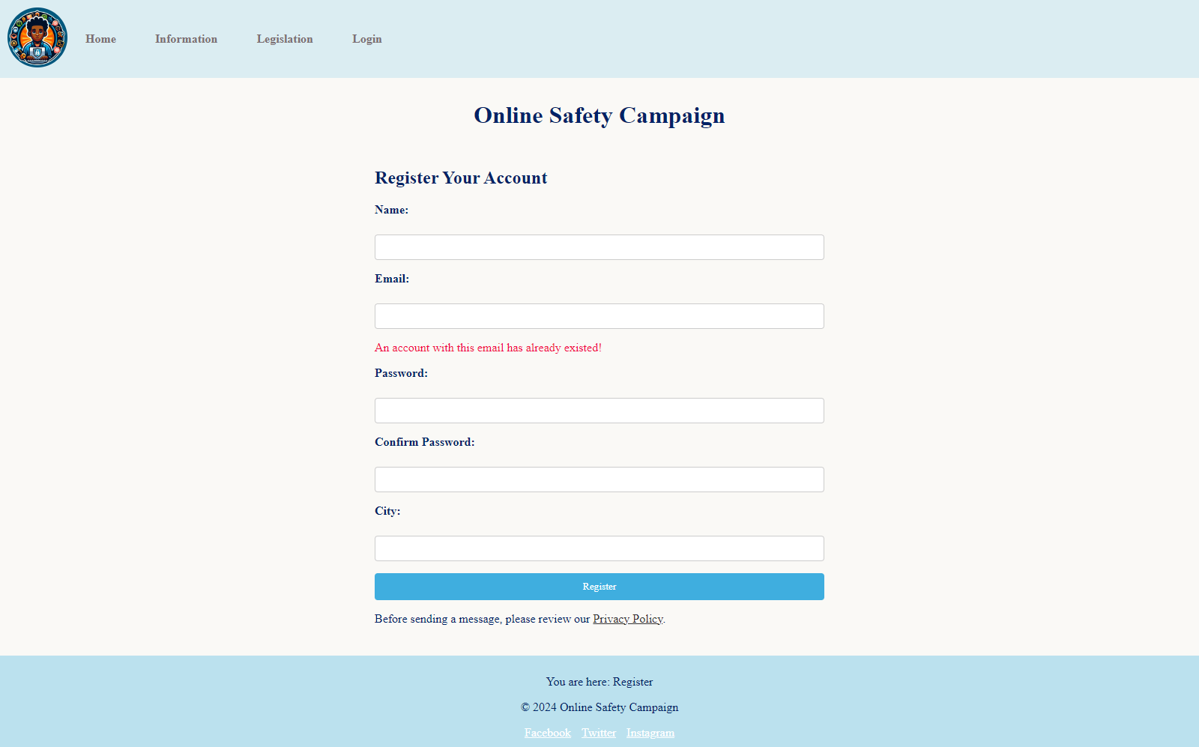

Repeating email error message. One email will be used for only one account.

## admin-home.php (admin page)

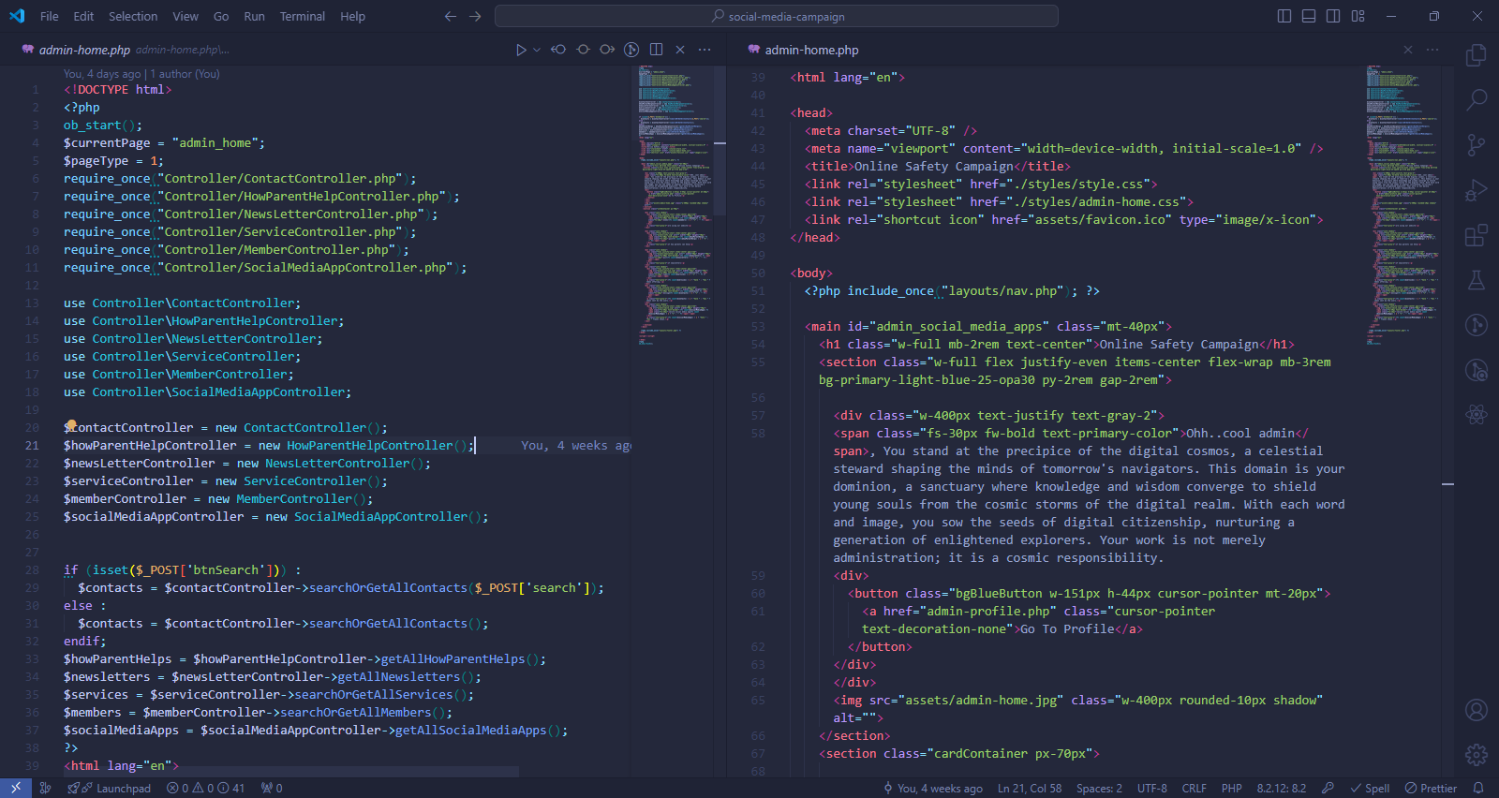

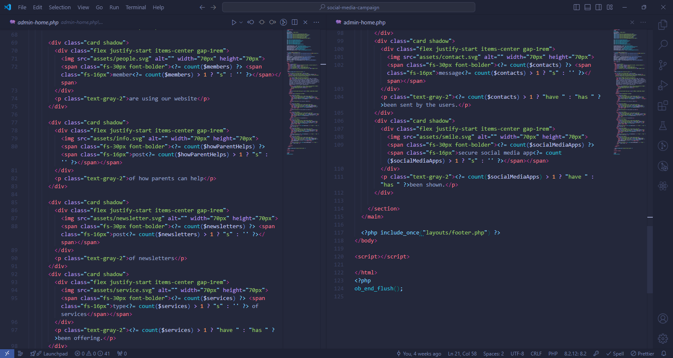

### Methods used in admin-home.php

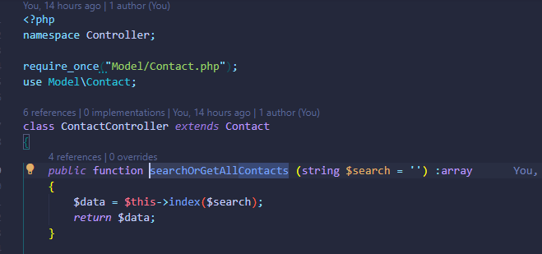

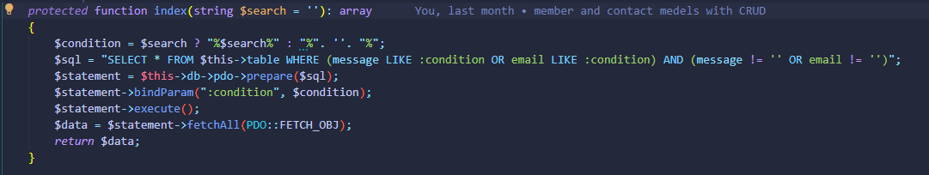

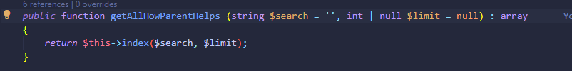

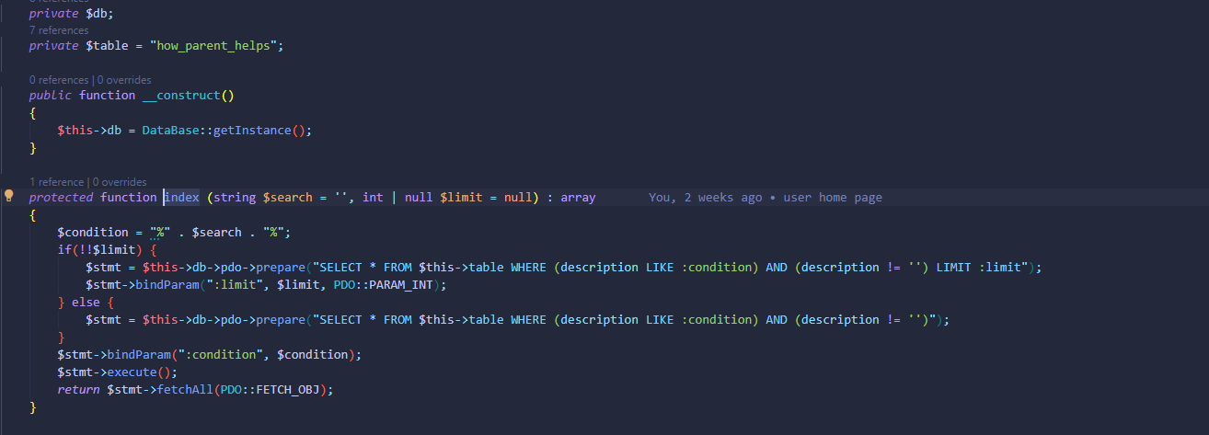

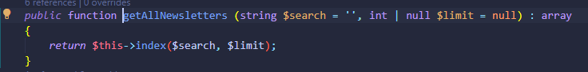

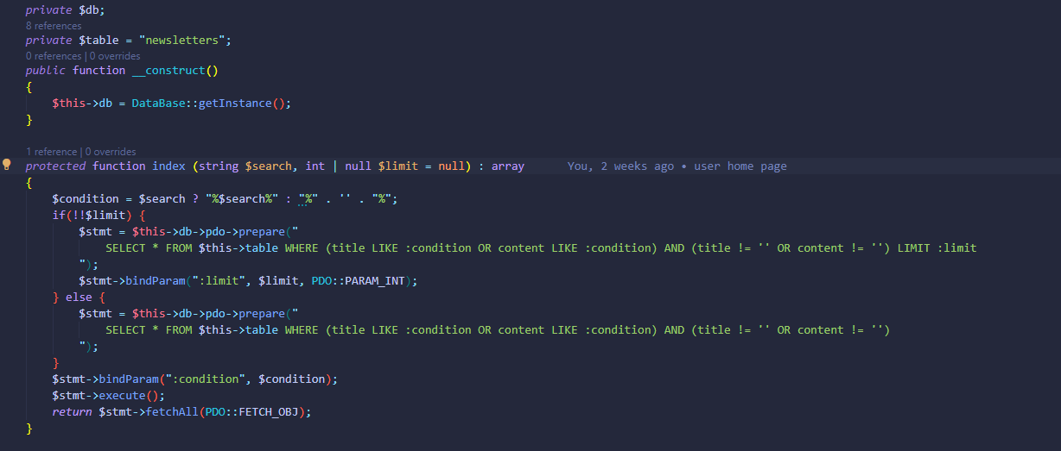

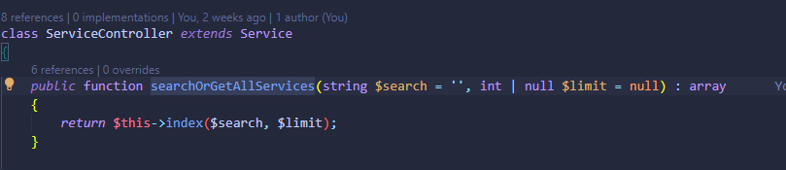

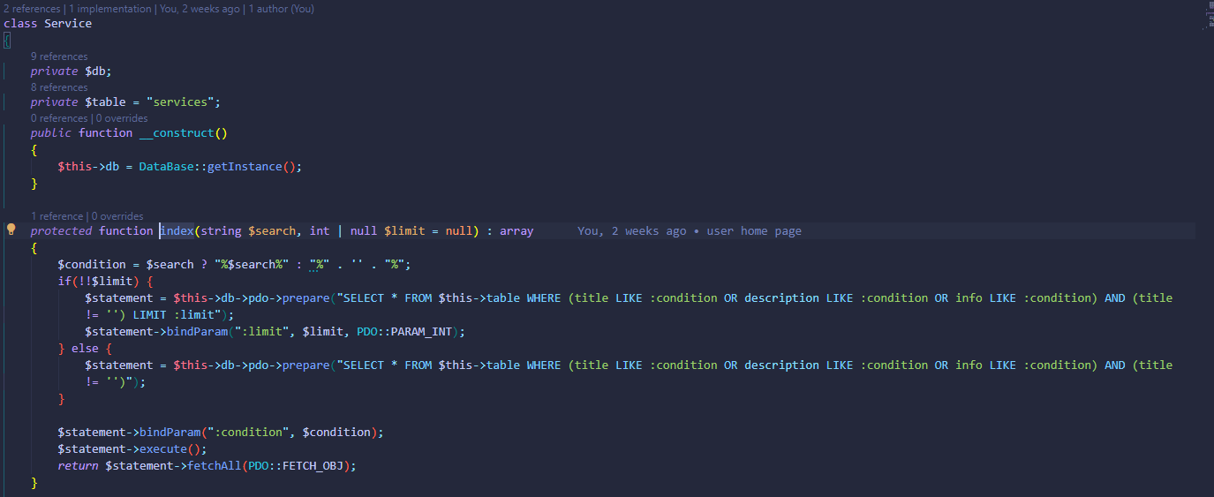

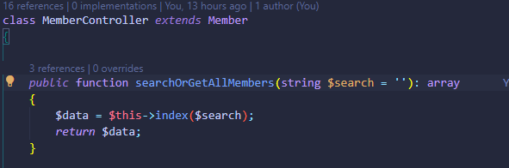

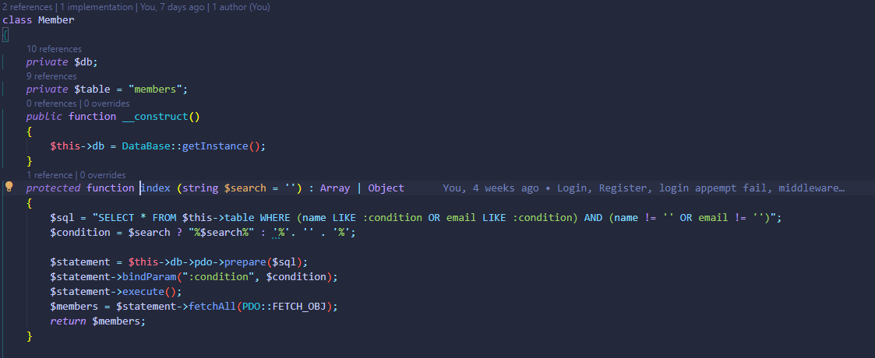

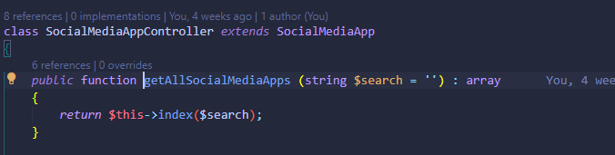

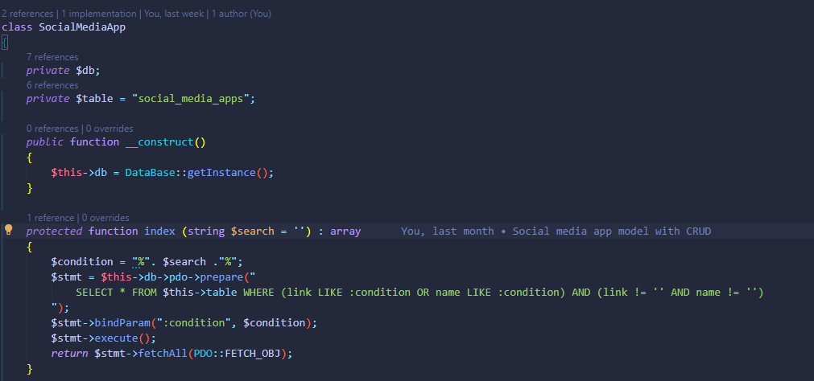

All methods directly used in “admin-home.php” are methods of corresponding controllers. Those methods use “index” methods of the Model they extend. Index methods are used to read all data or filter data with search from the corresponding database table.

### Output of admin-home.php

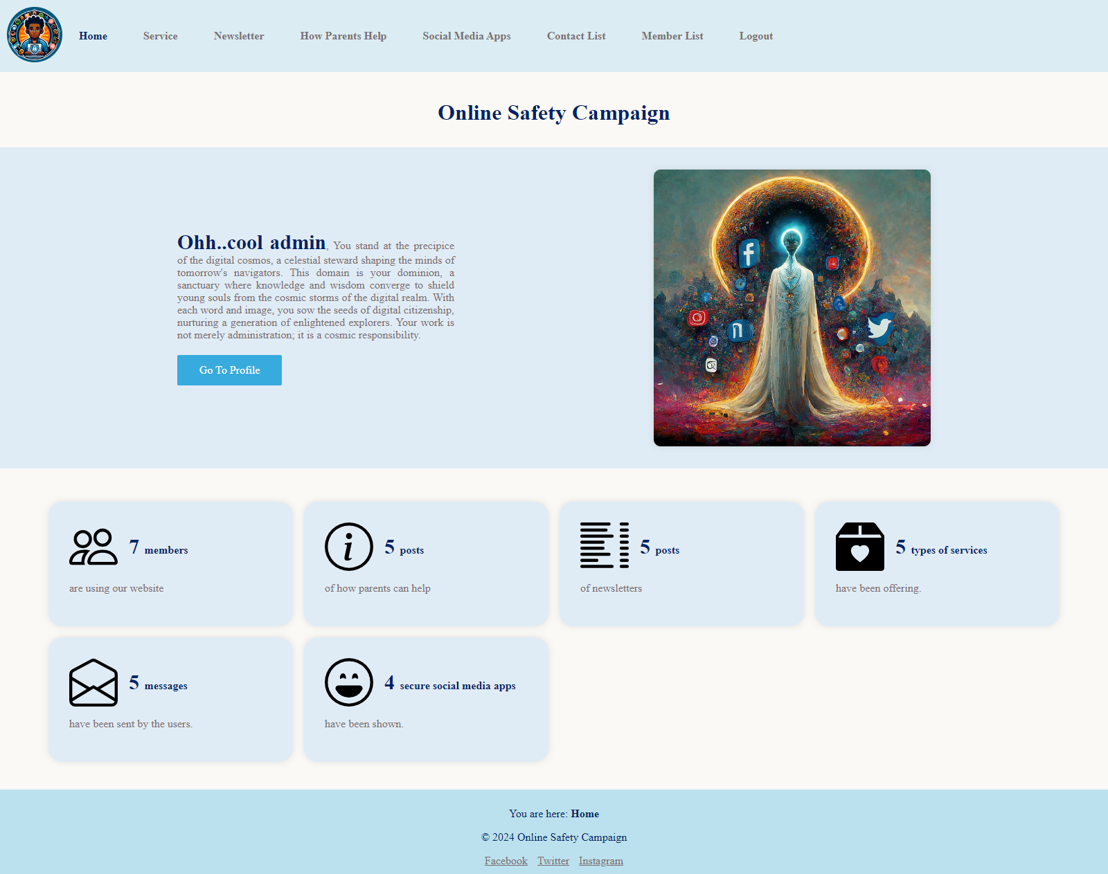

## service-setup.php (admin page)

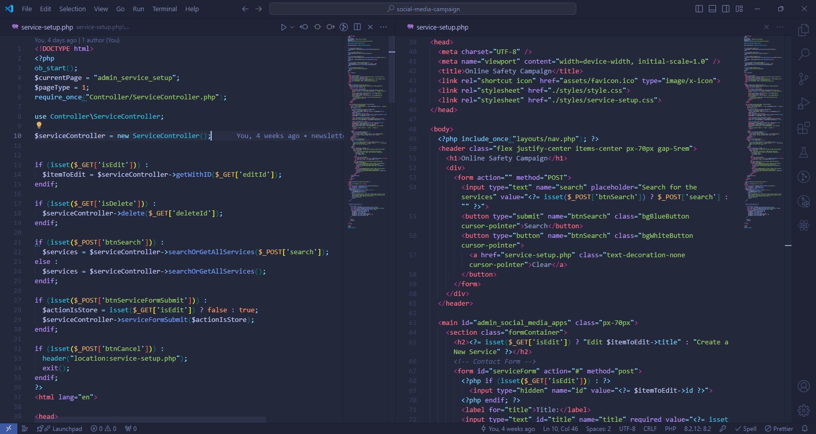

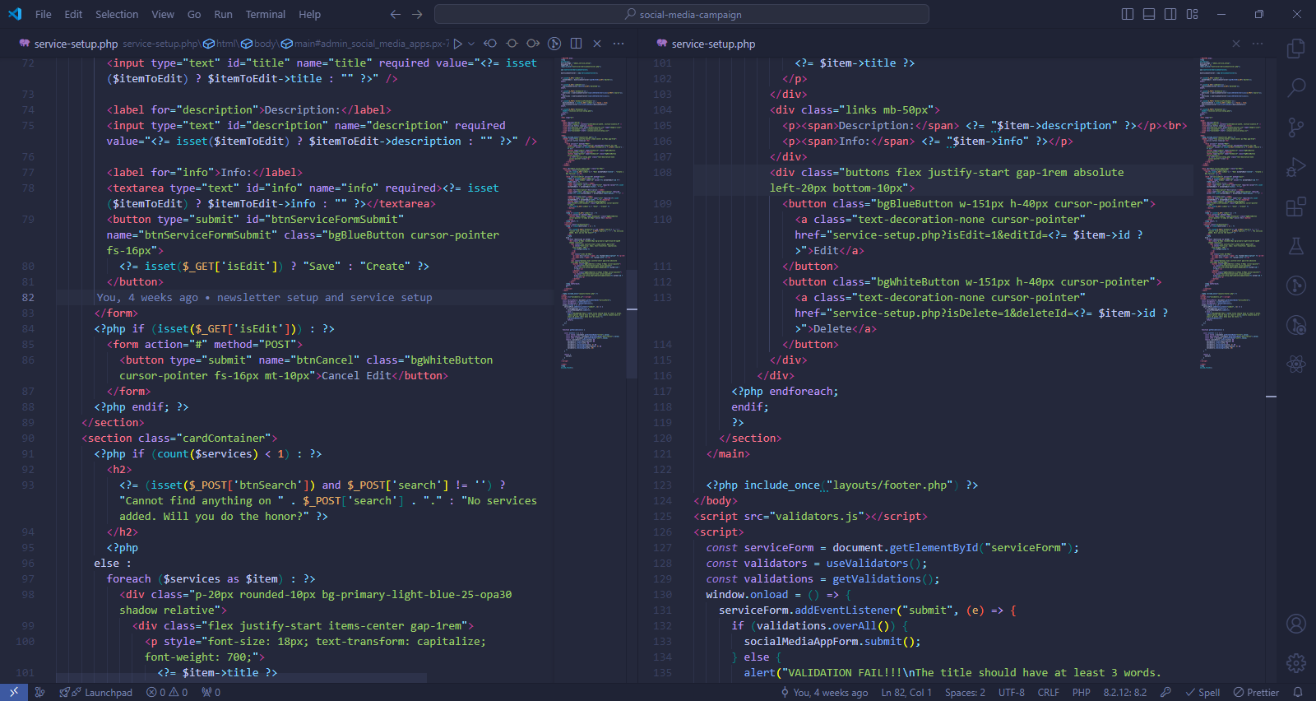

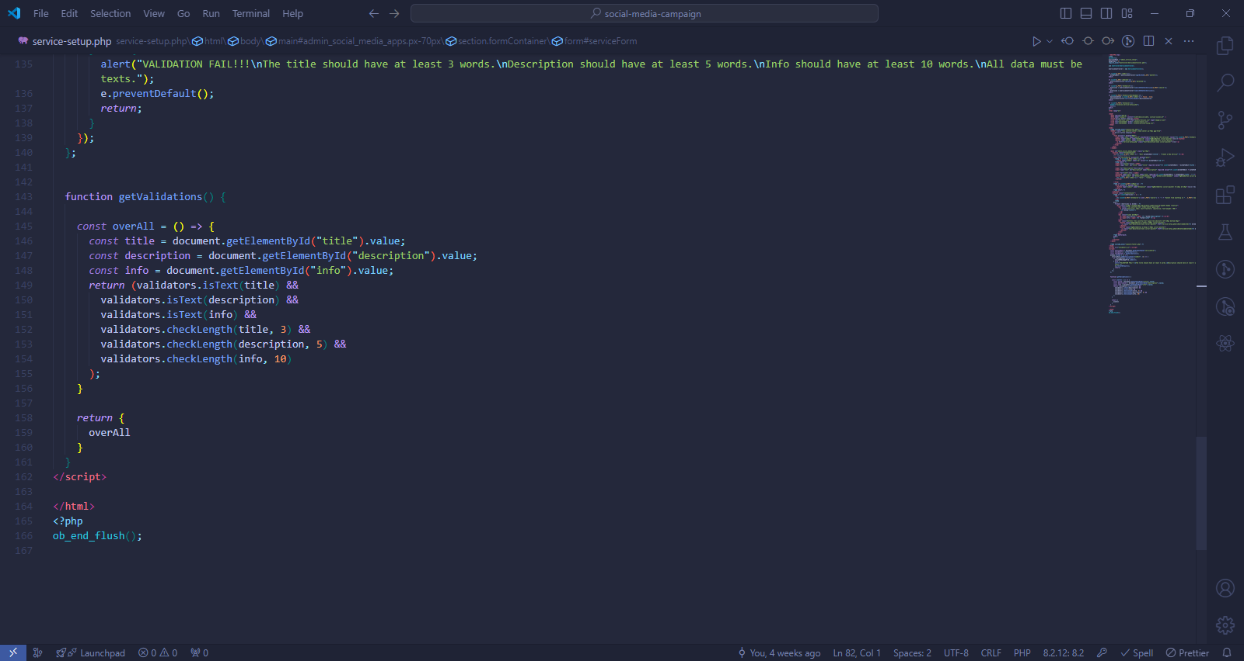

### Methods used in service-setup.php

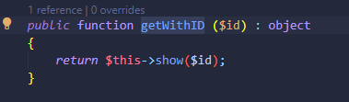

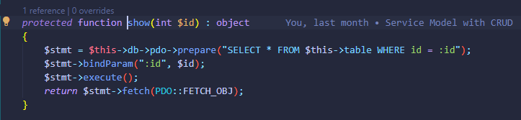

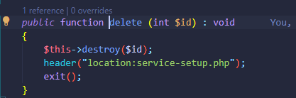

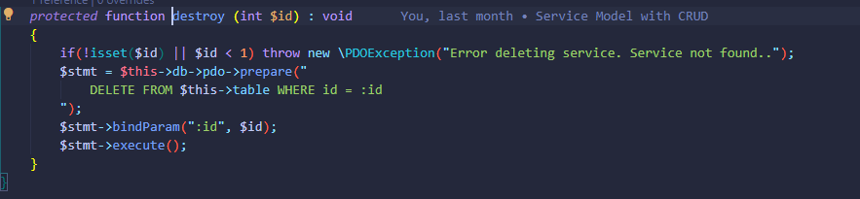

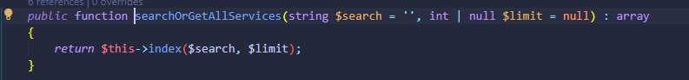

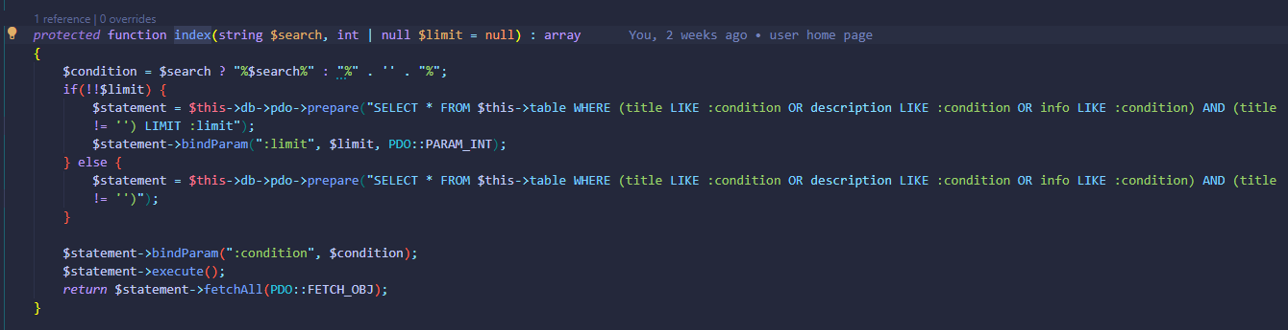

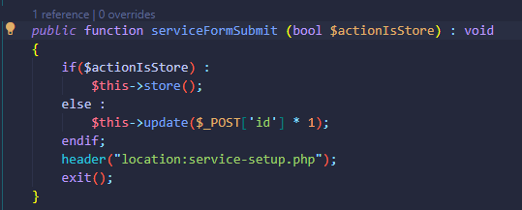

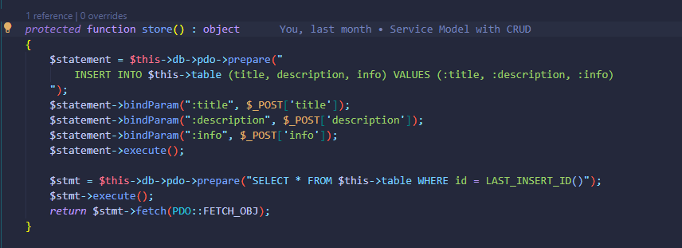

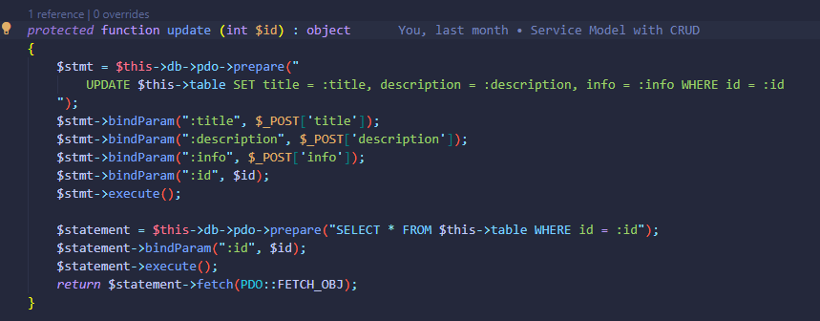

Methods directly used in the service-setup.php are from the ServiceController and it extends Service Model whose methods are used for manipulating and reading the data in the “services” table of database.

### Output of service-setup.php

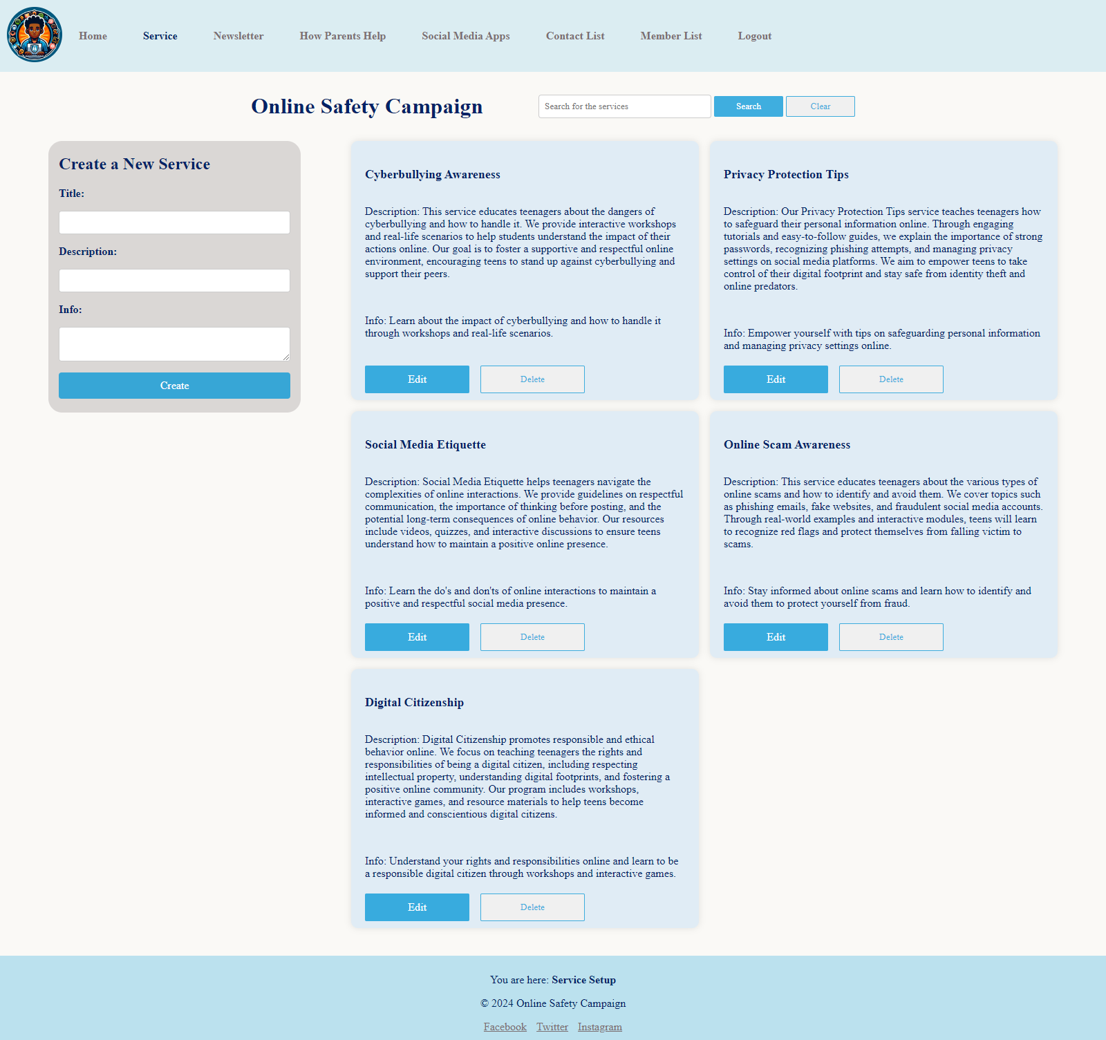

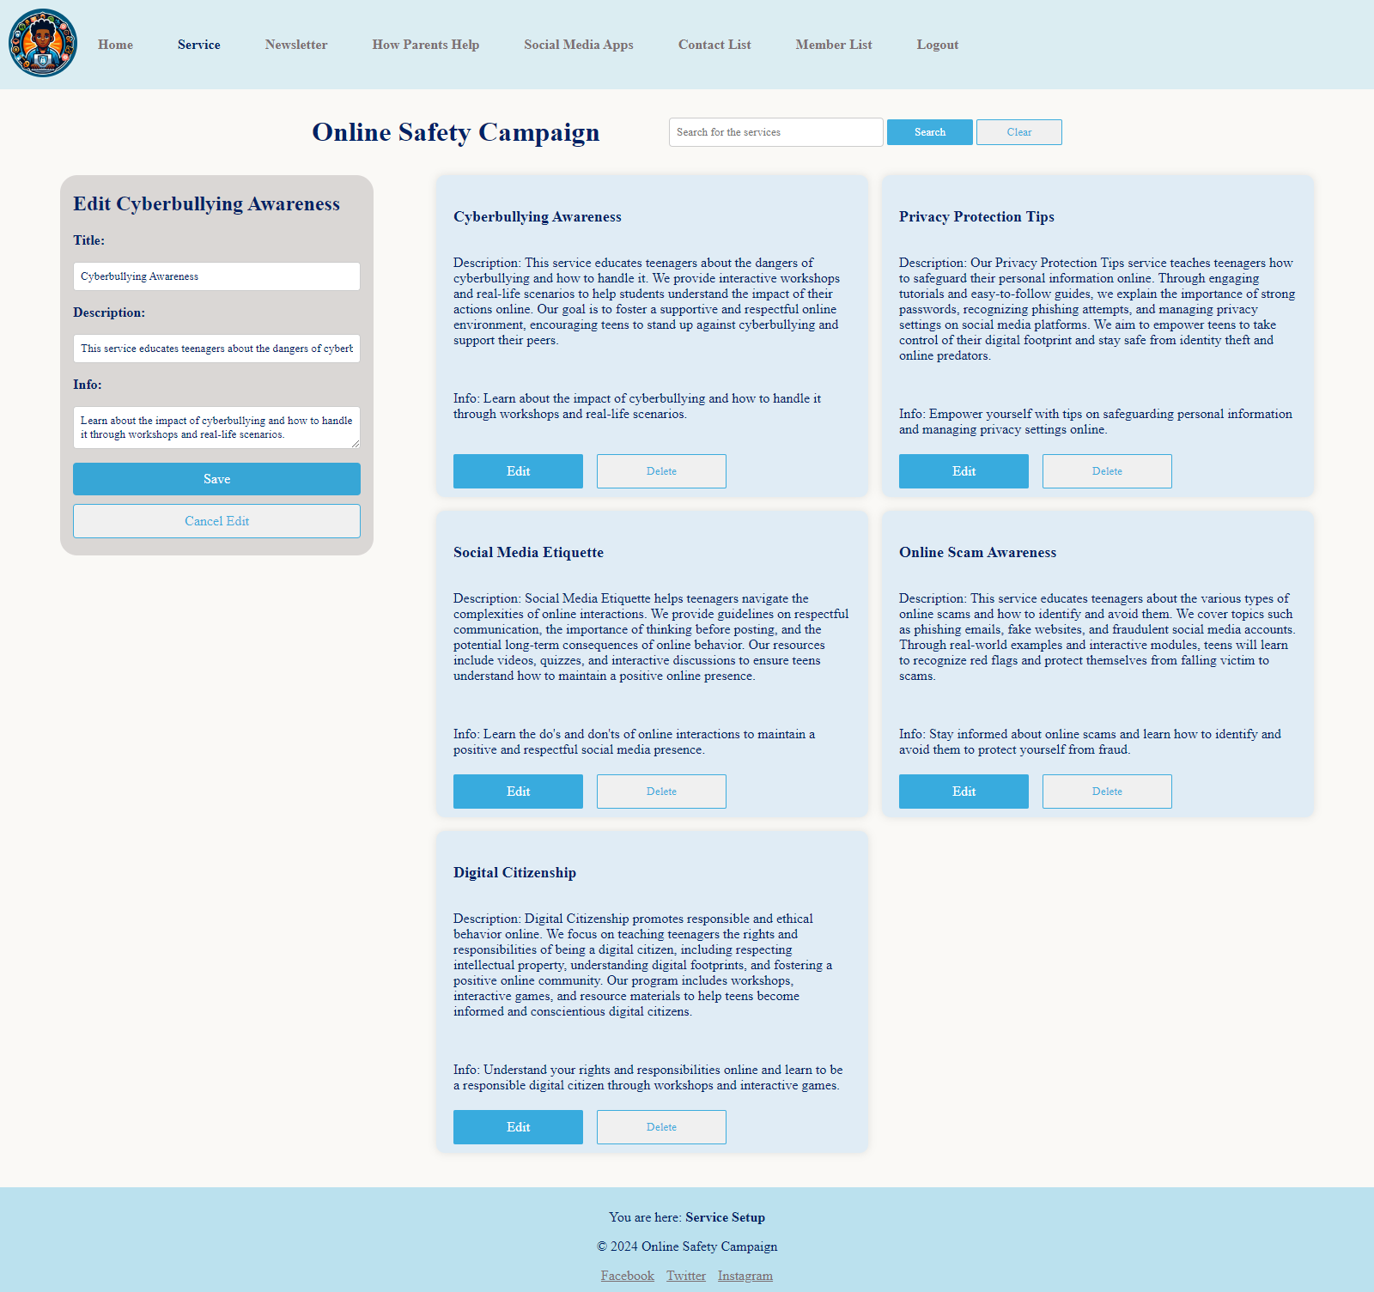

Output with edit form.

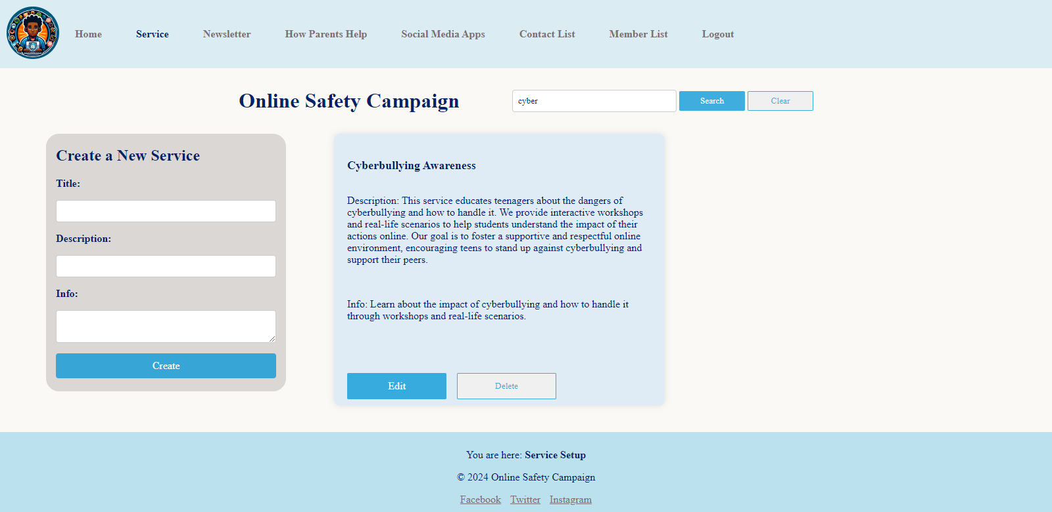

Output with search function.

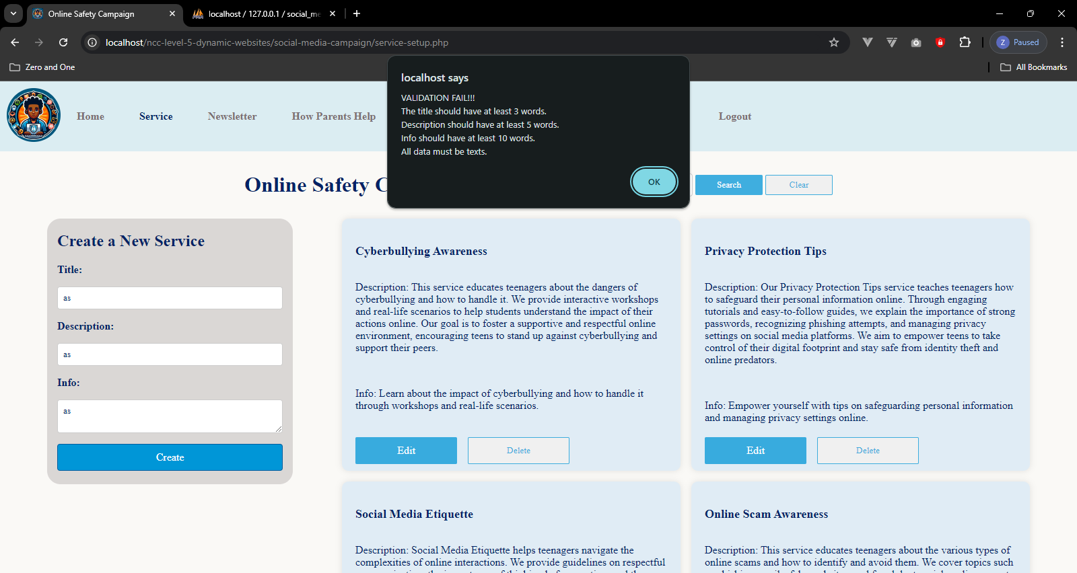

Service from data validation with JavaScript.

## newsletter-setup.php (admin page)

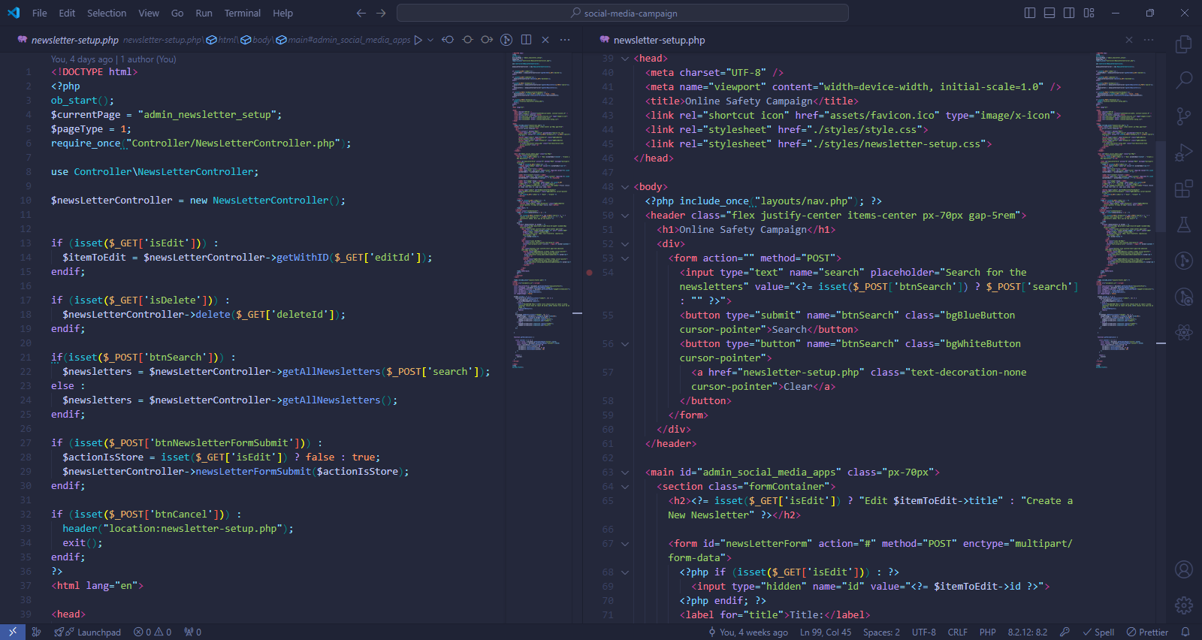

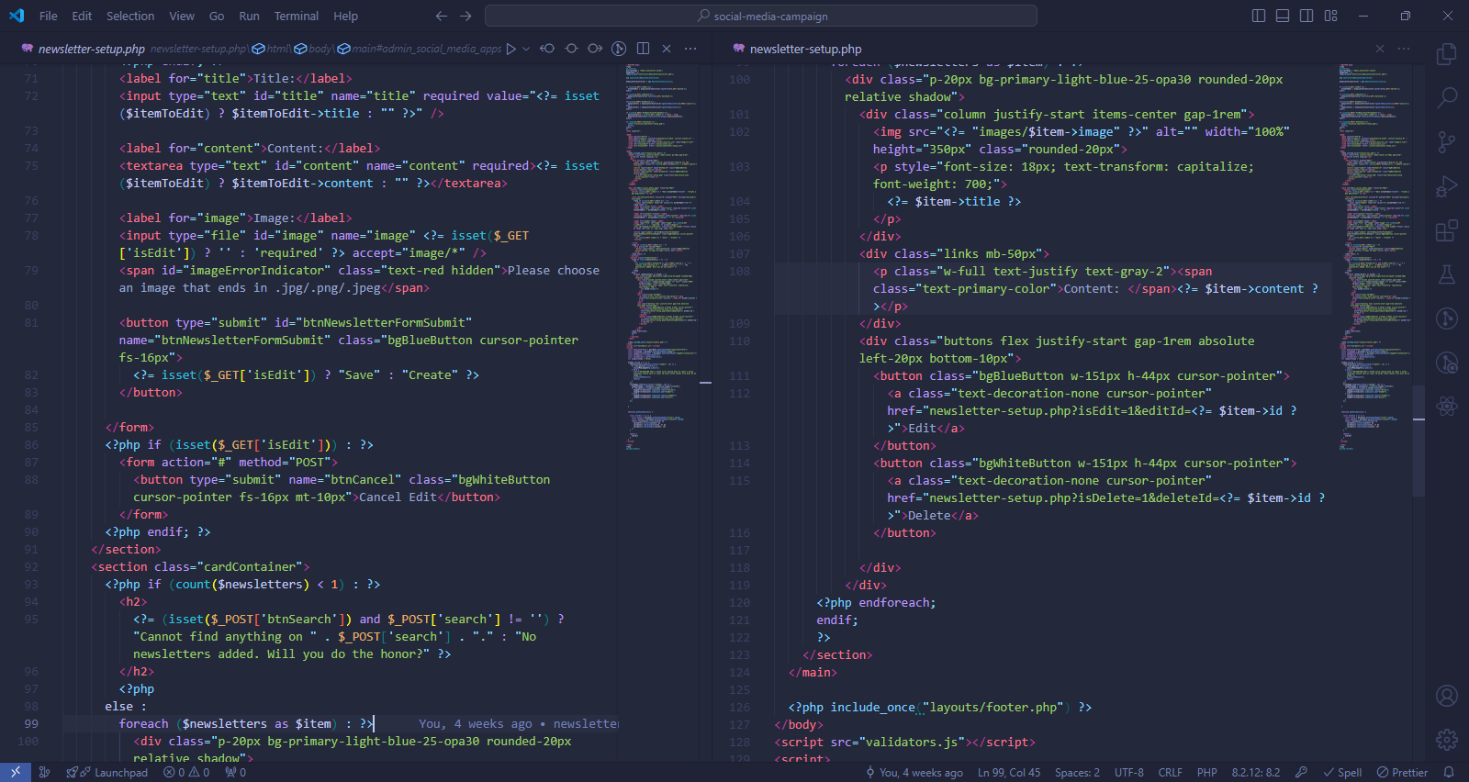

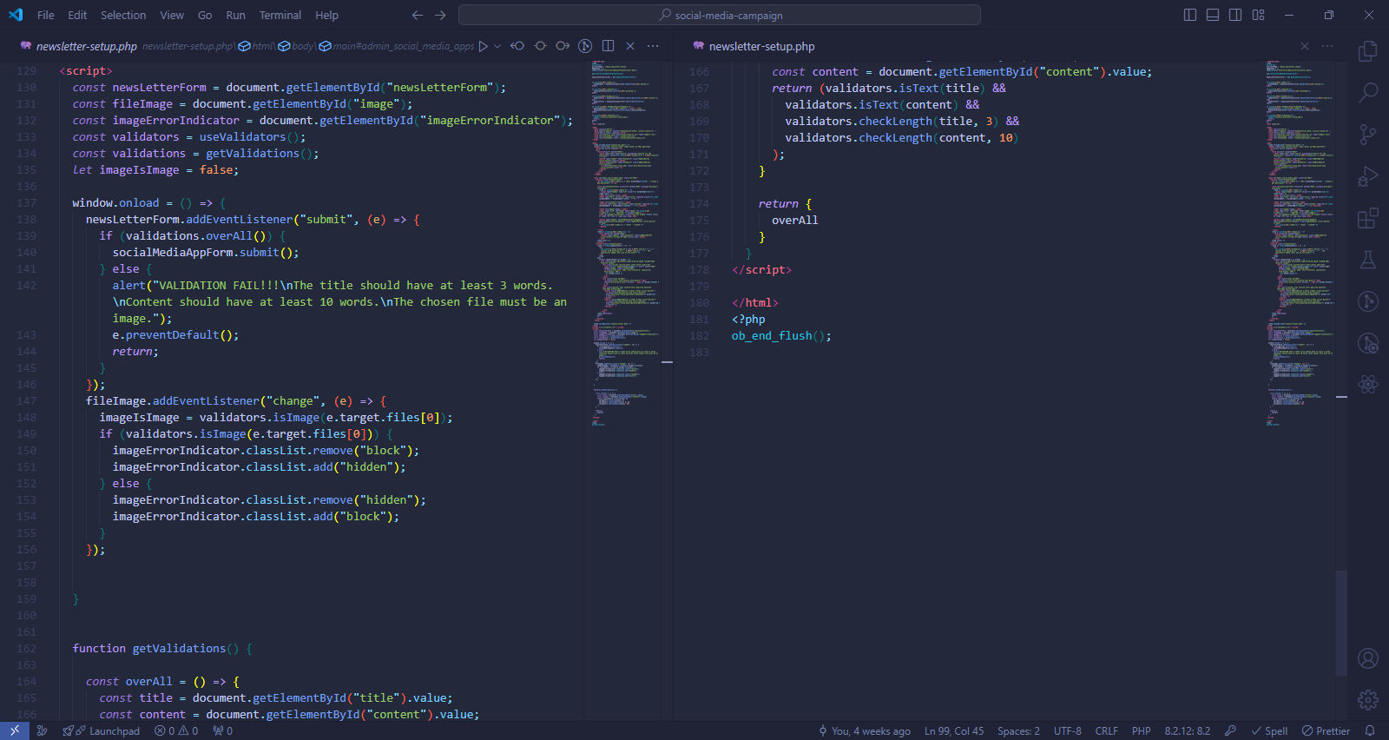

### Methods used in newsletter-setup.php

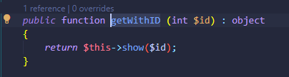

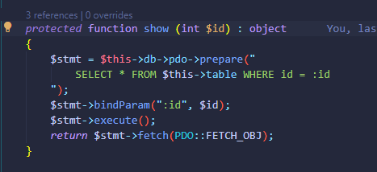

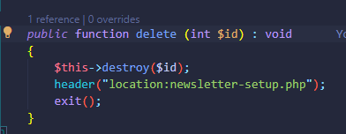

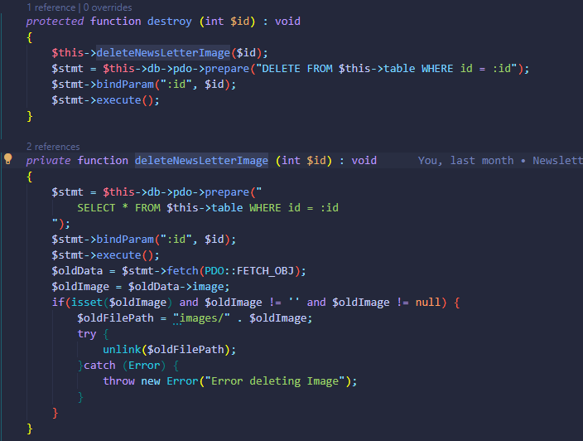

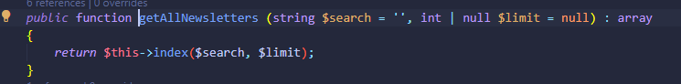

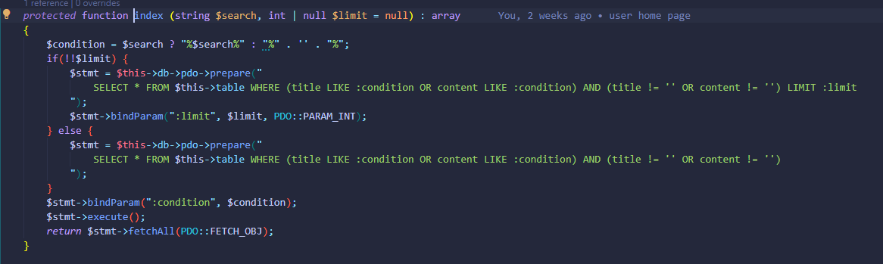

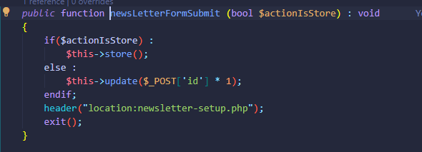

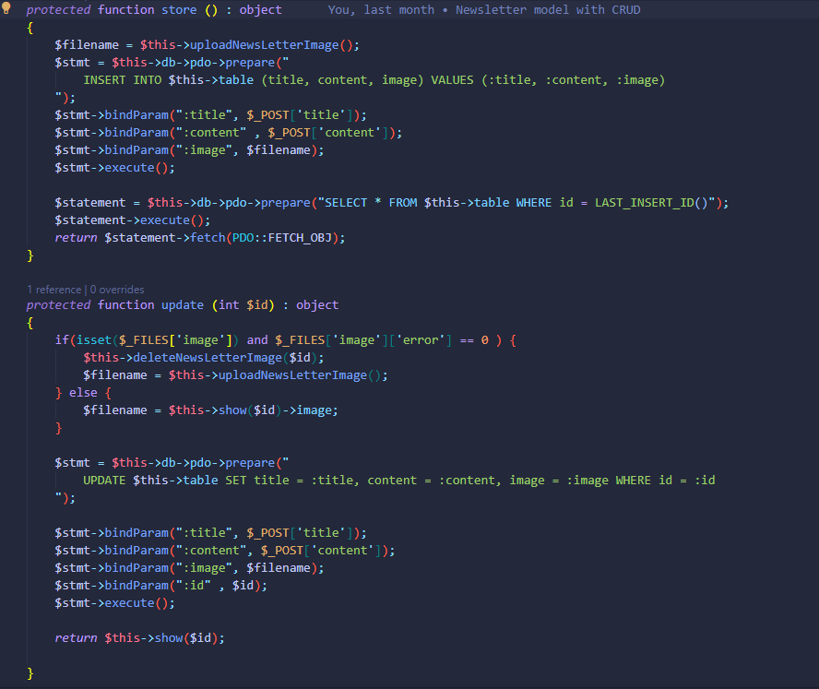

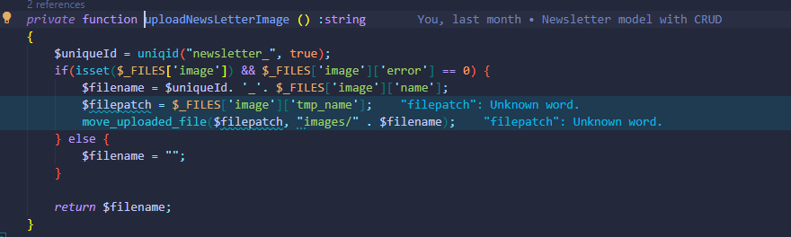

All methods directly used in newsletter-setup.php are methods of NewsLetterController which extends the Newsletter Model whose functions are responsible for reading and manipulating data of the table “newsletters”.

### Output of newsletter-setup.php

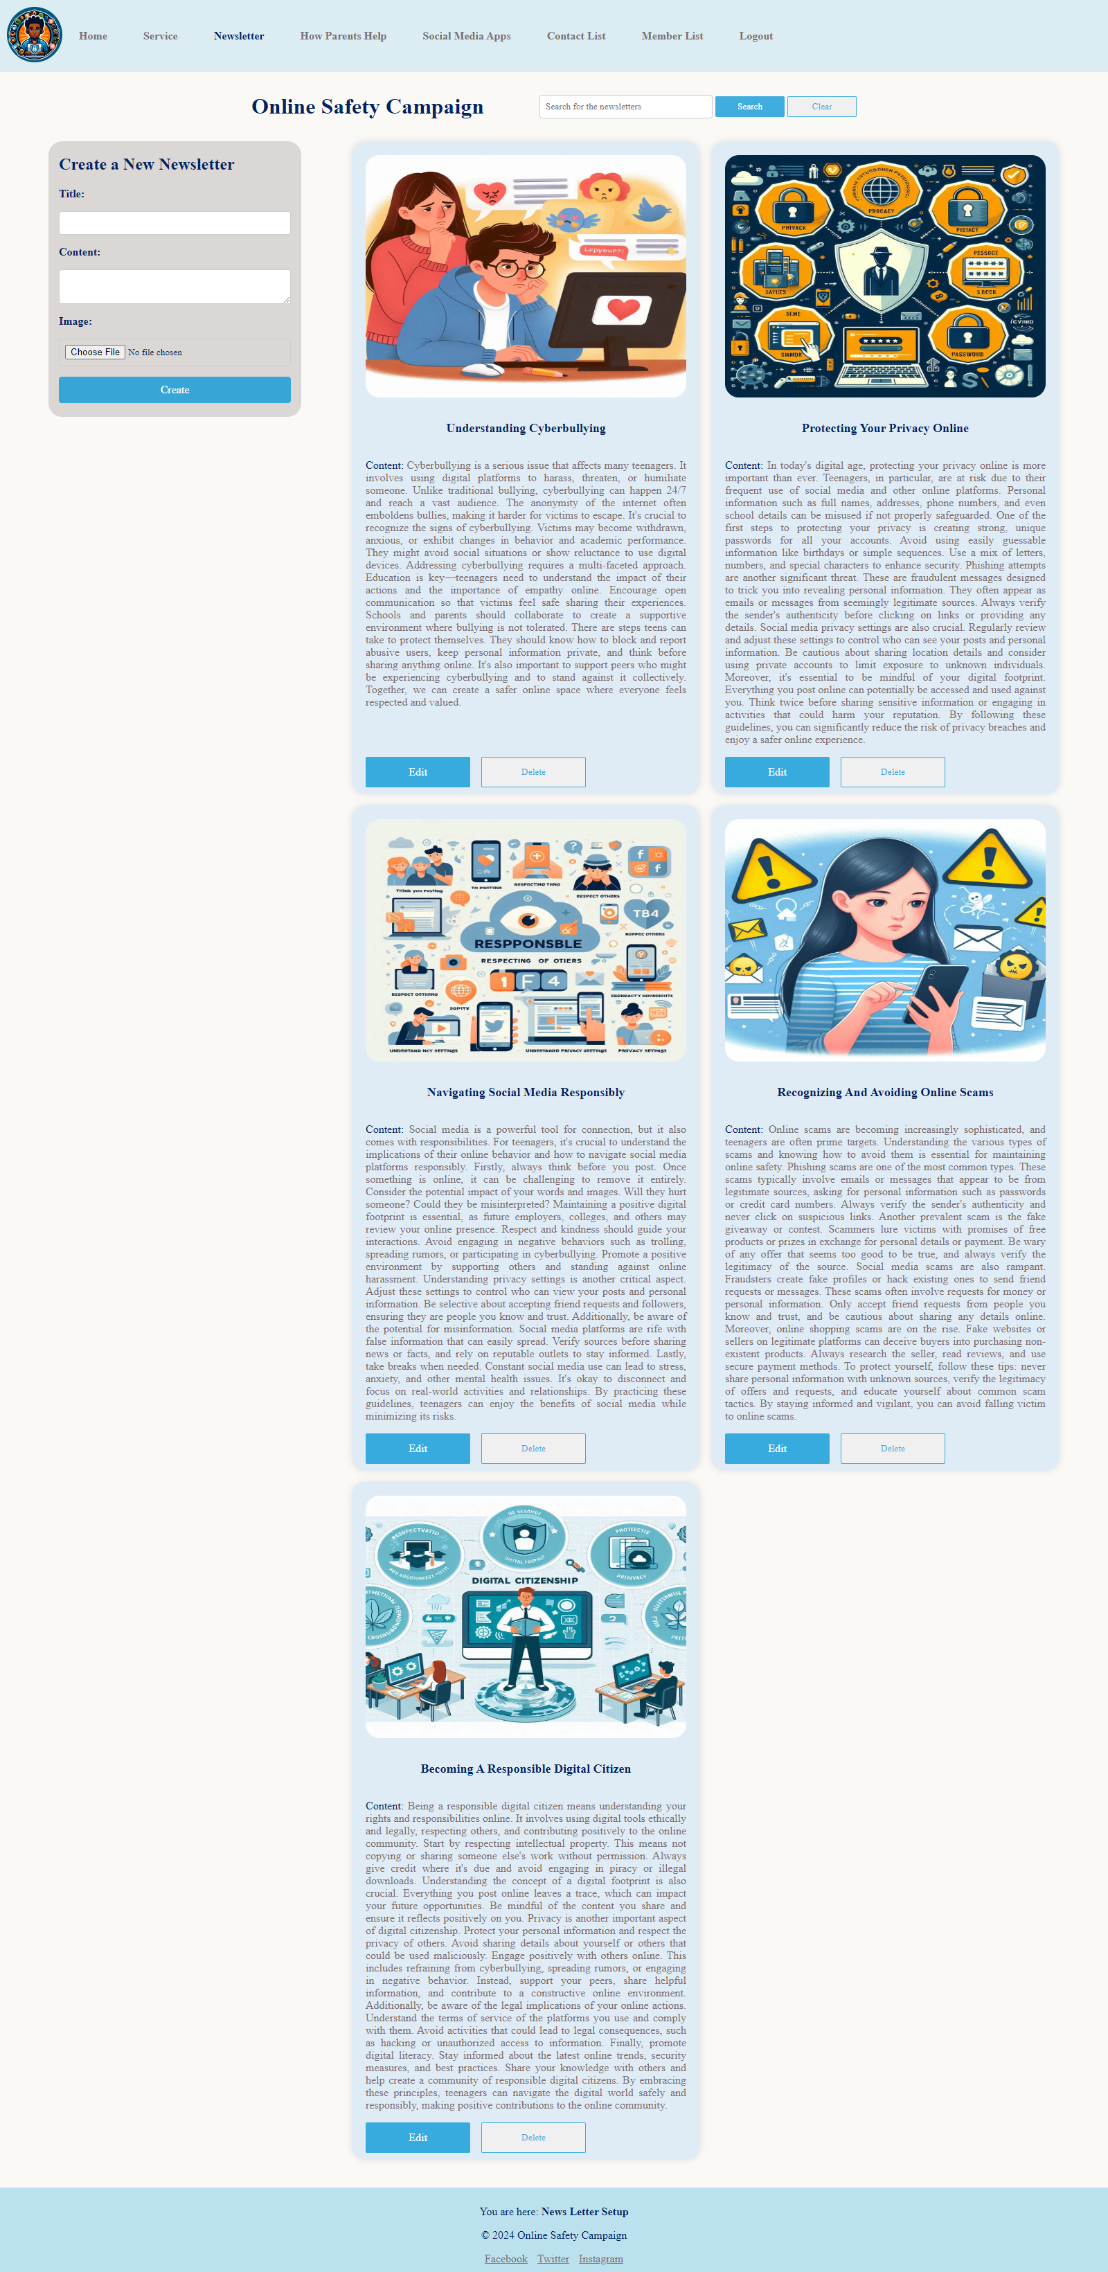



Output with edit form

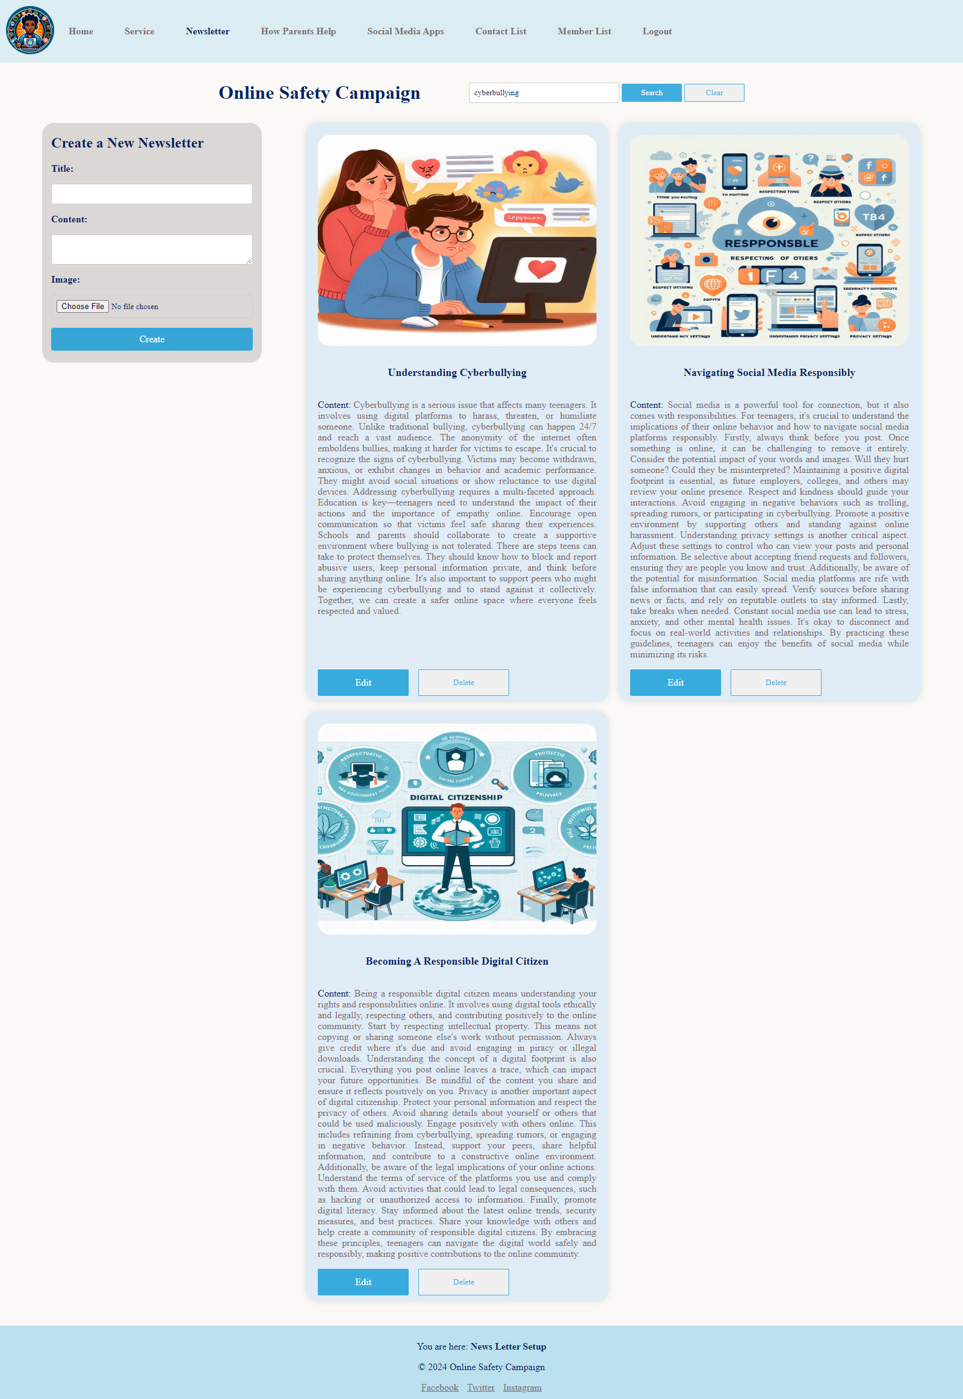

Output with search.

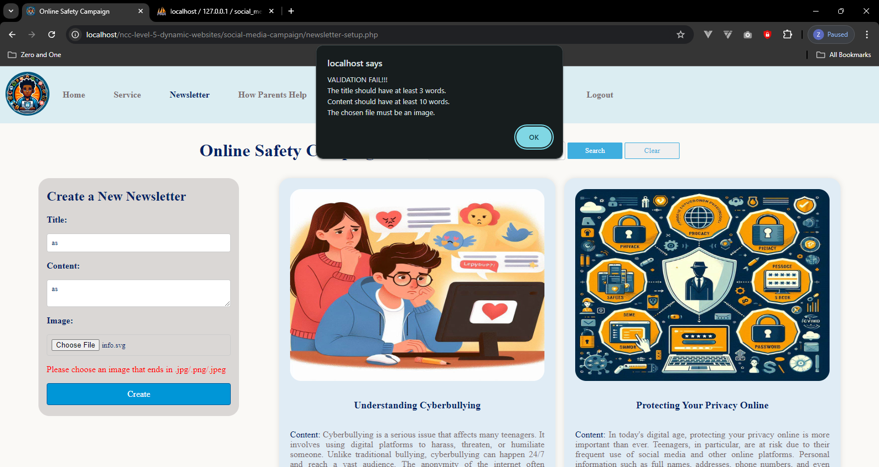

Newsletter form validation with JavaScript

## how-parent-help-setup.php (admin page)

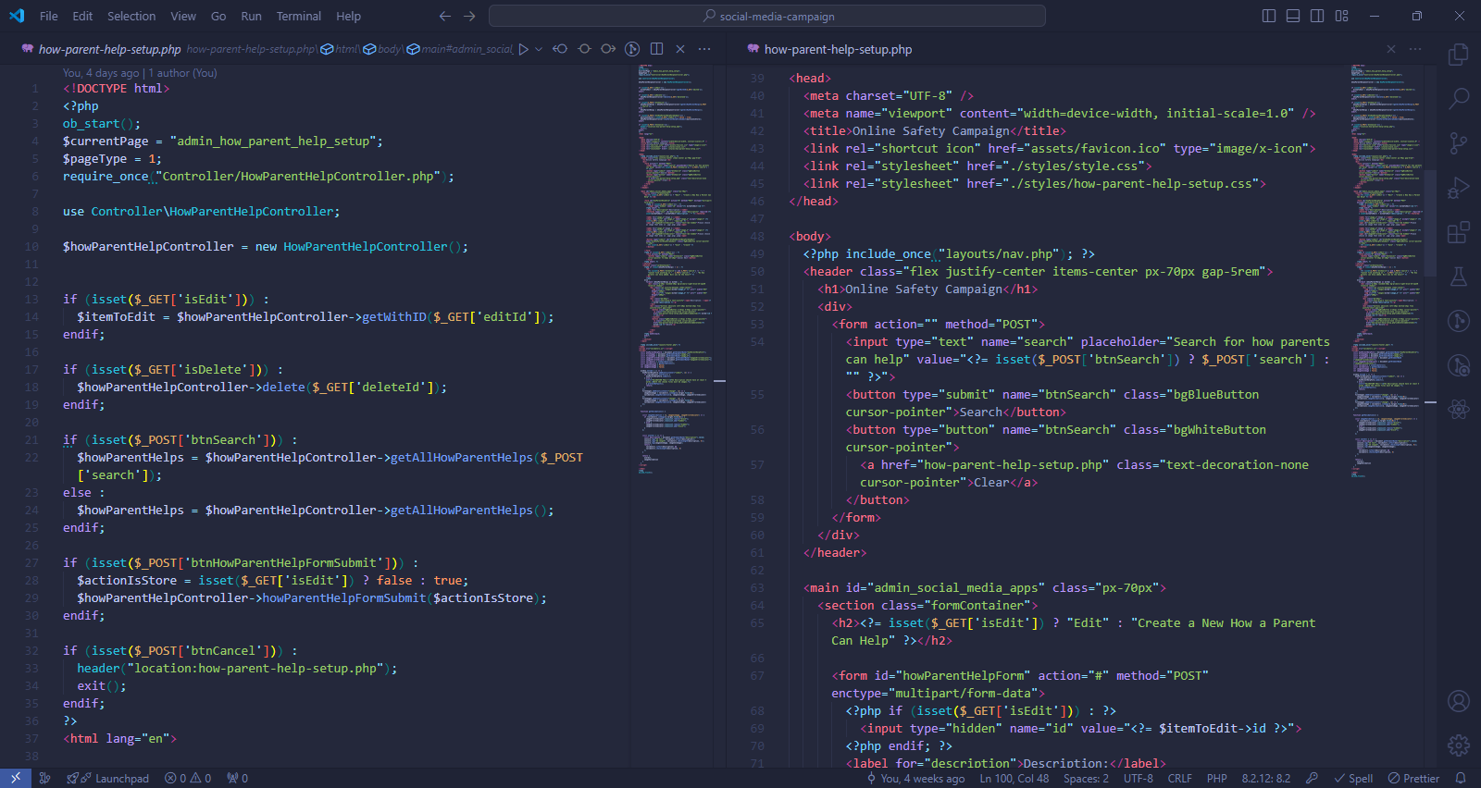

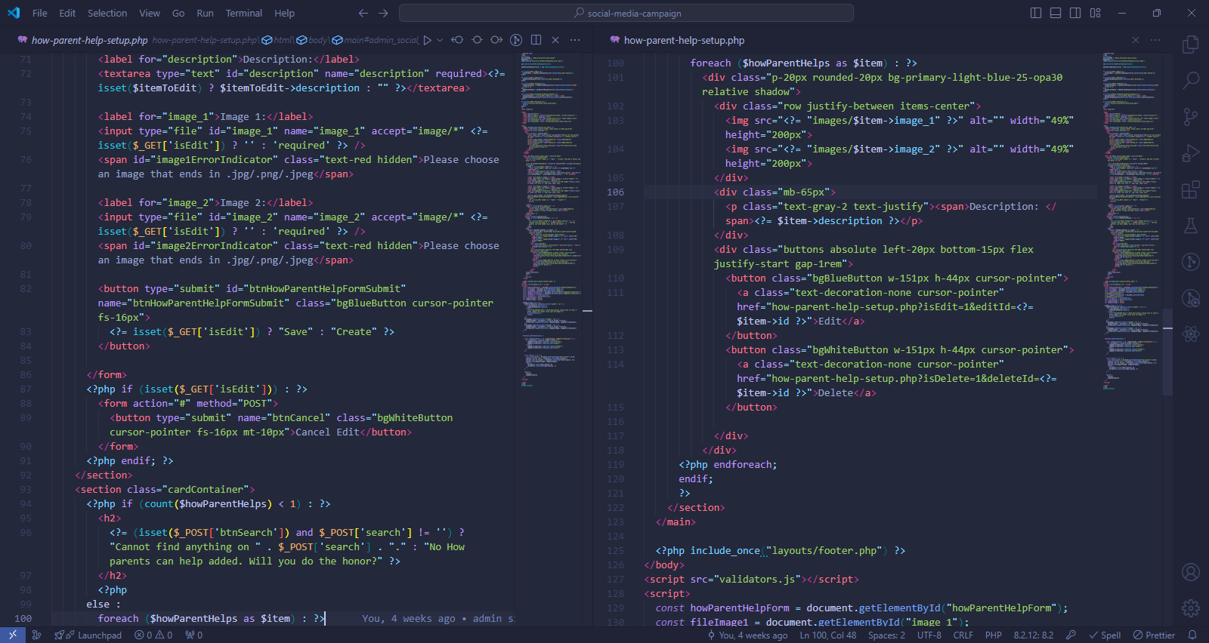

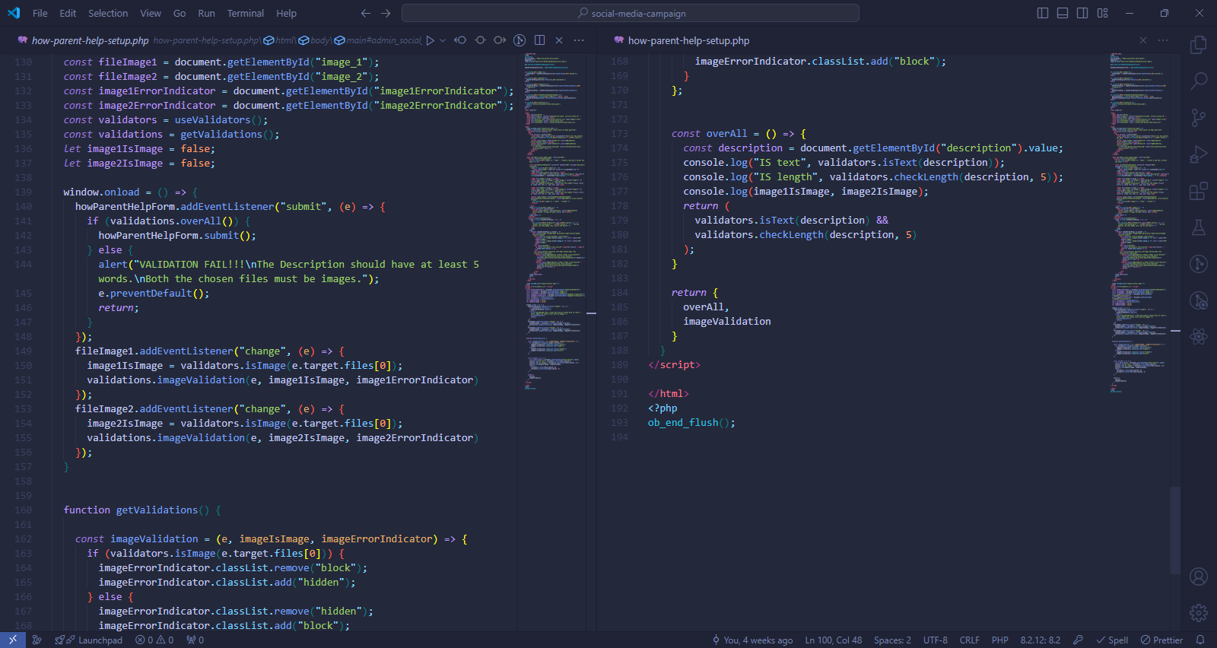

### Methods used in how-parent-help-setup.php

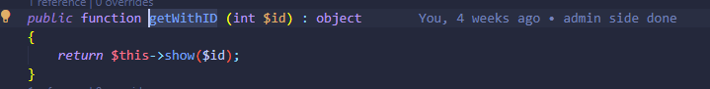

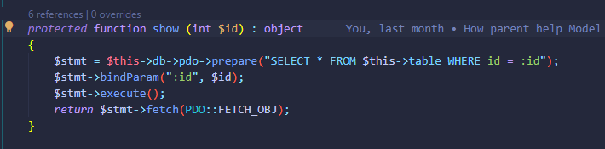

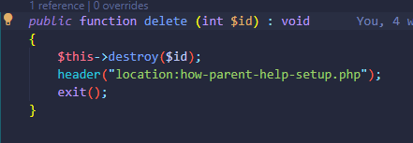

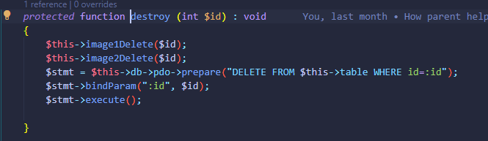

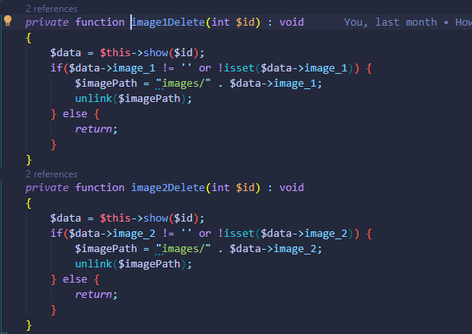

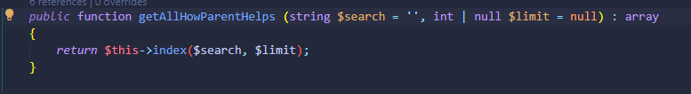

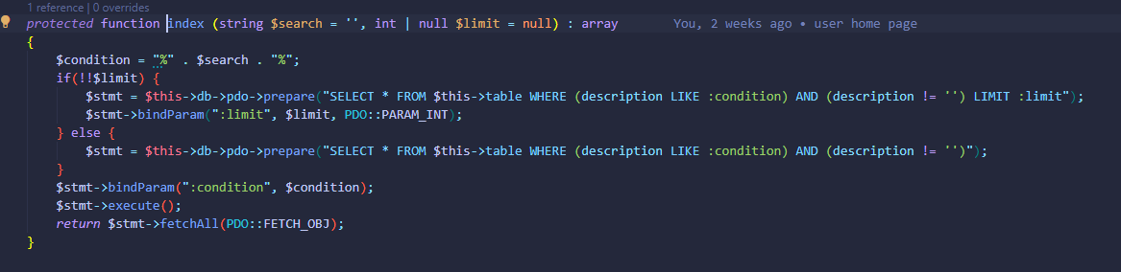

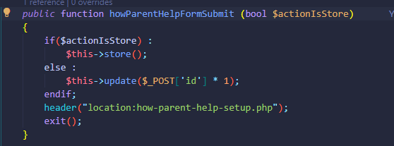

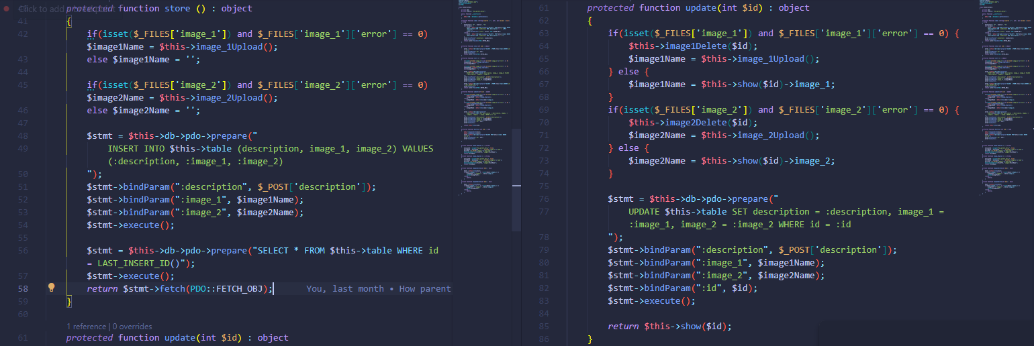

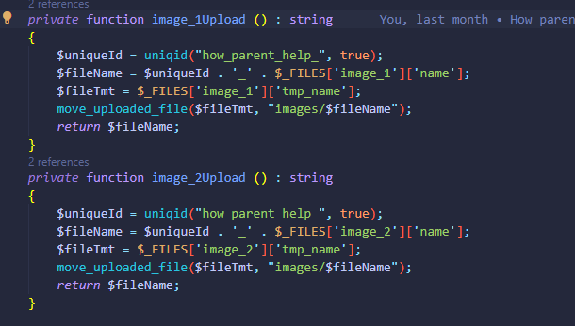

All methods directly used in how-parent-help-setup.php are methods of HowParentHelpController which extends the HowParentHelp Model whose functions are responsible for reading and manipulating data of the table “how_parent_helps”.

### Output of how-parent-help-setup.php

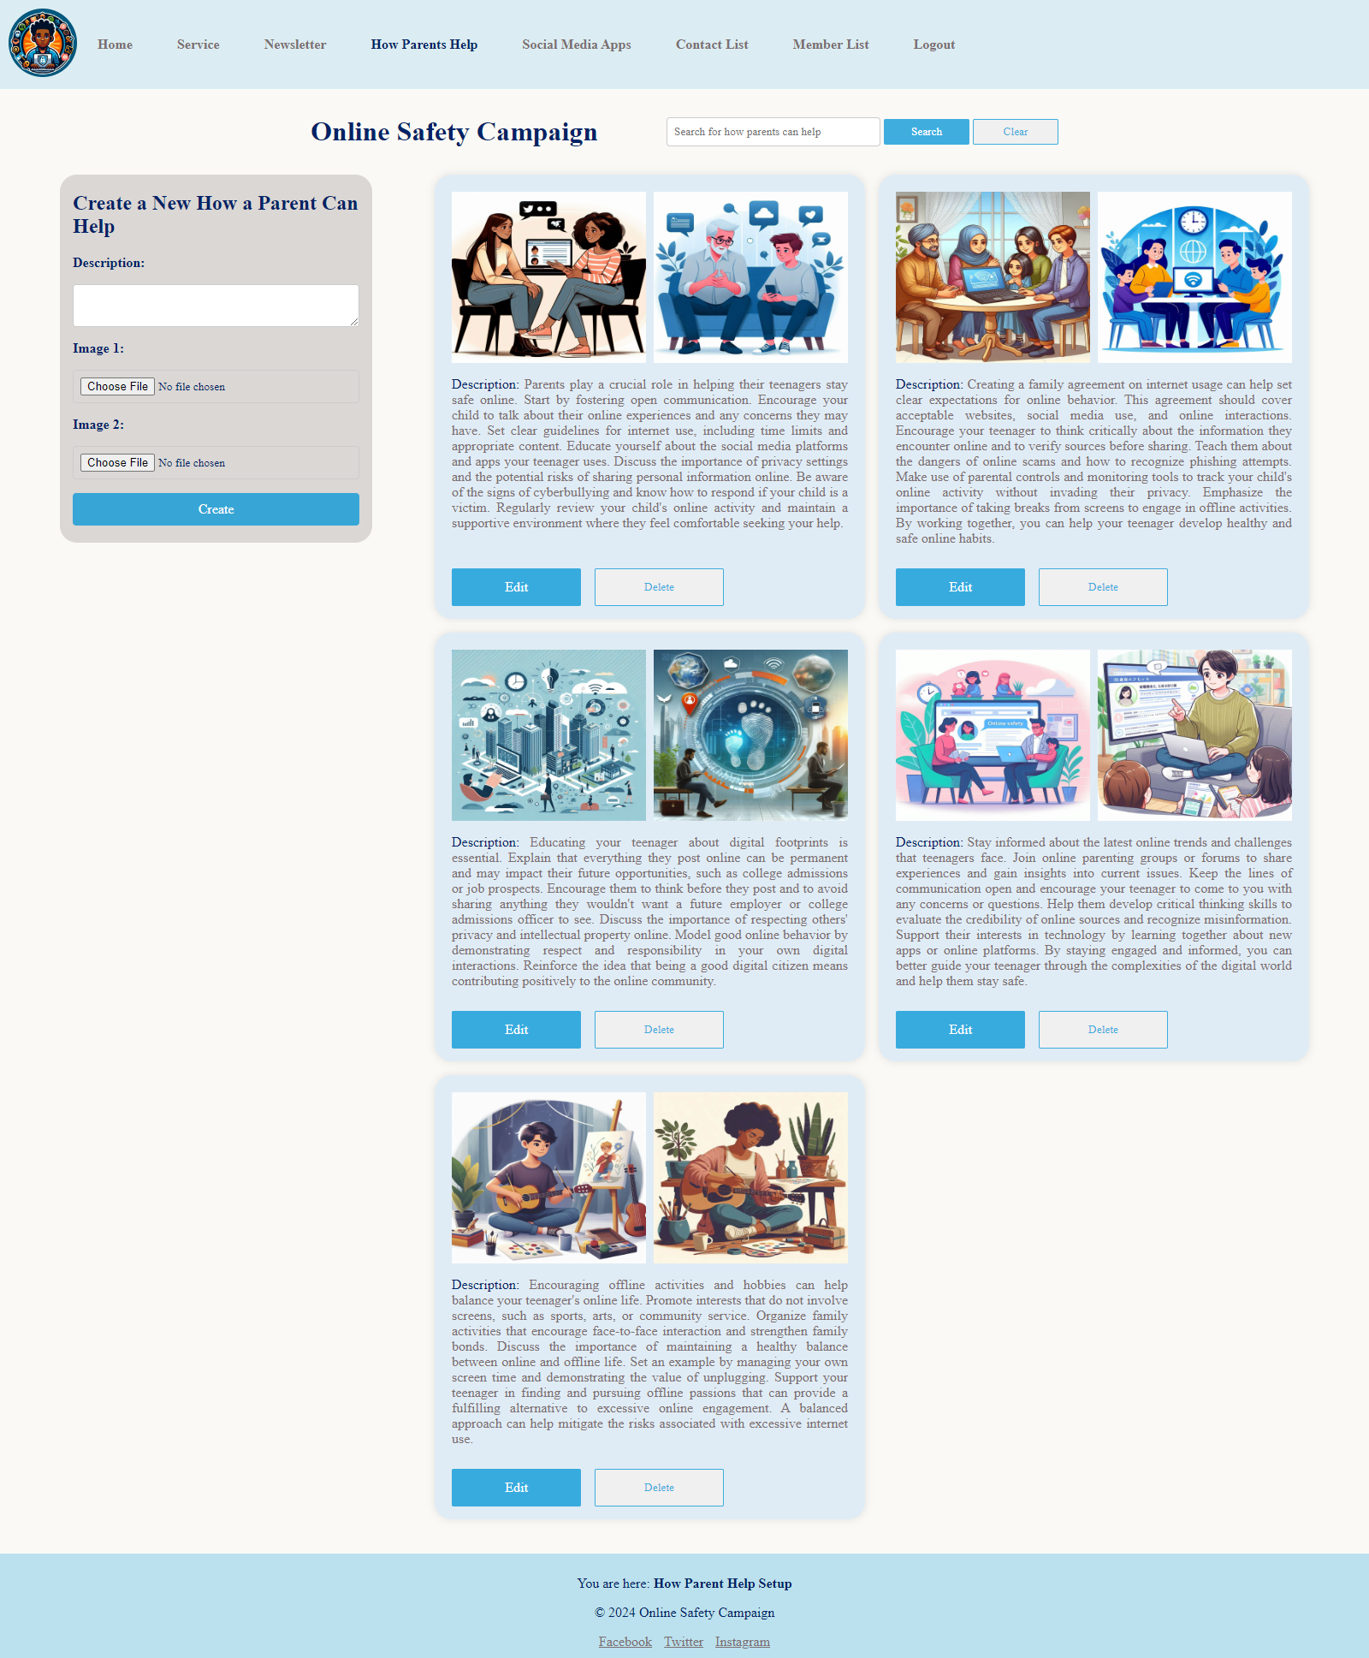

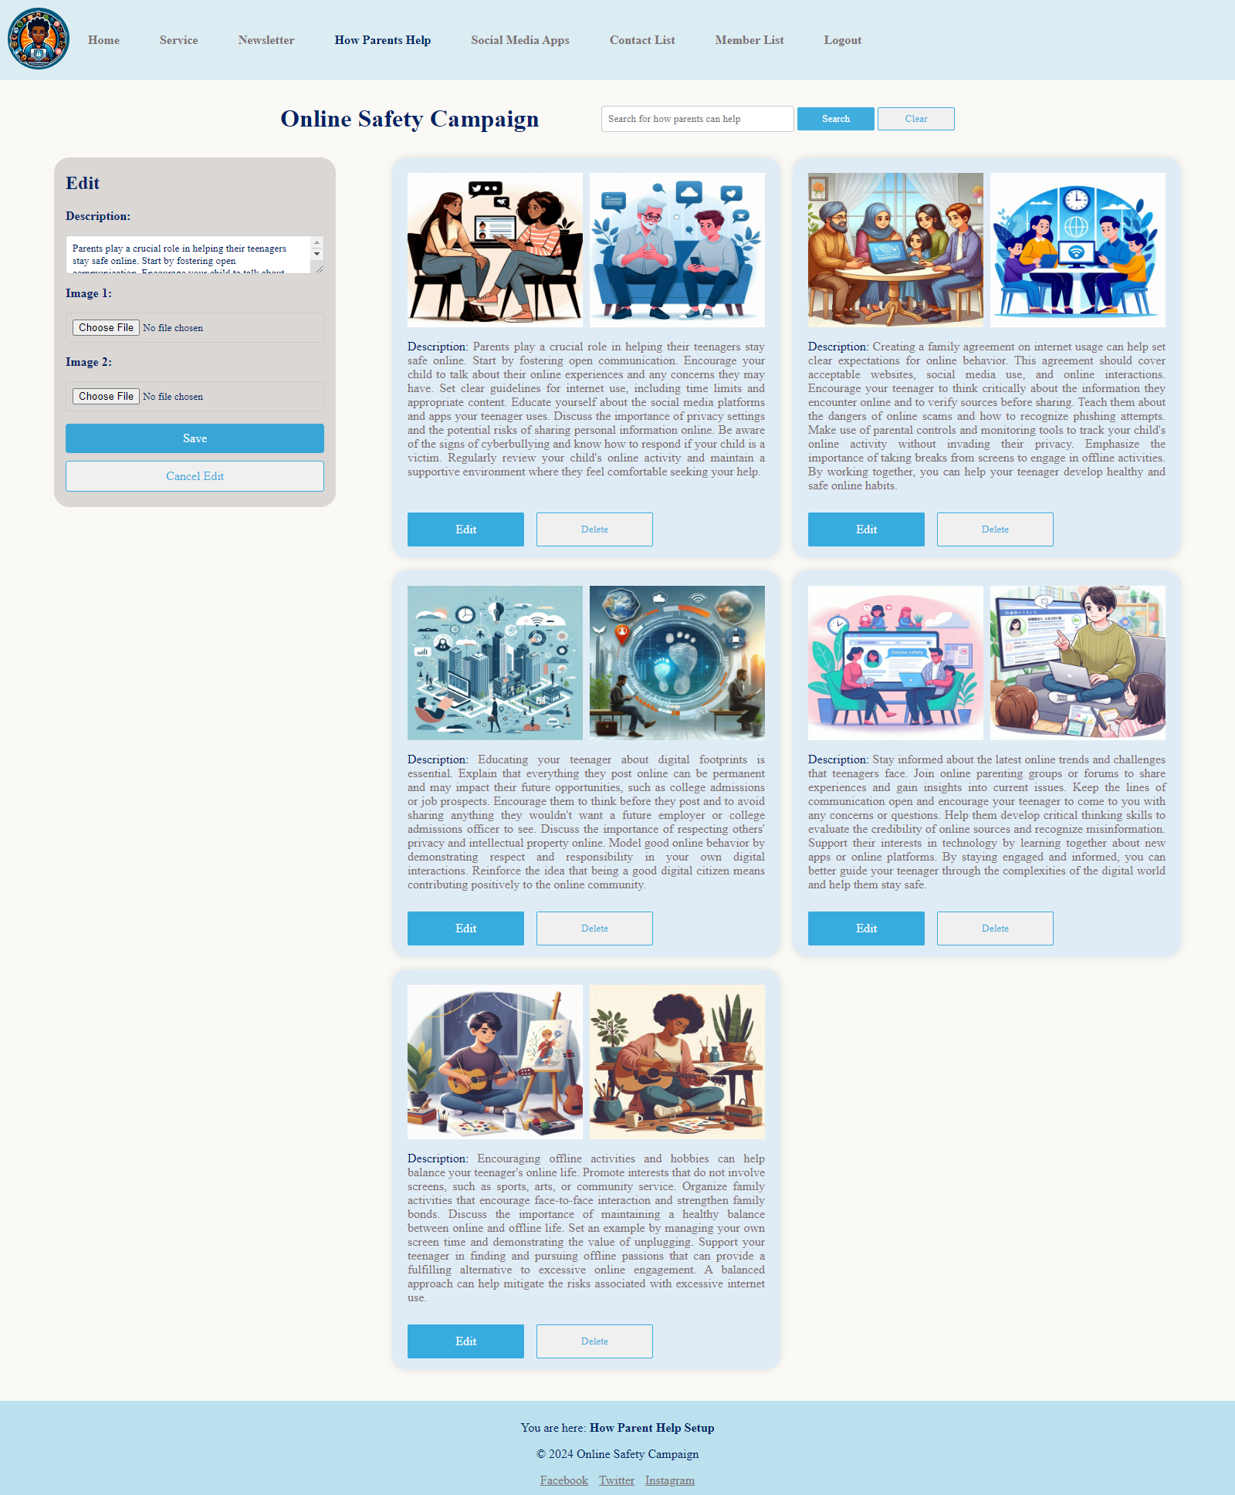

Output with edit form

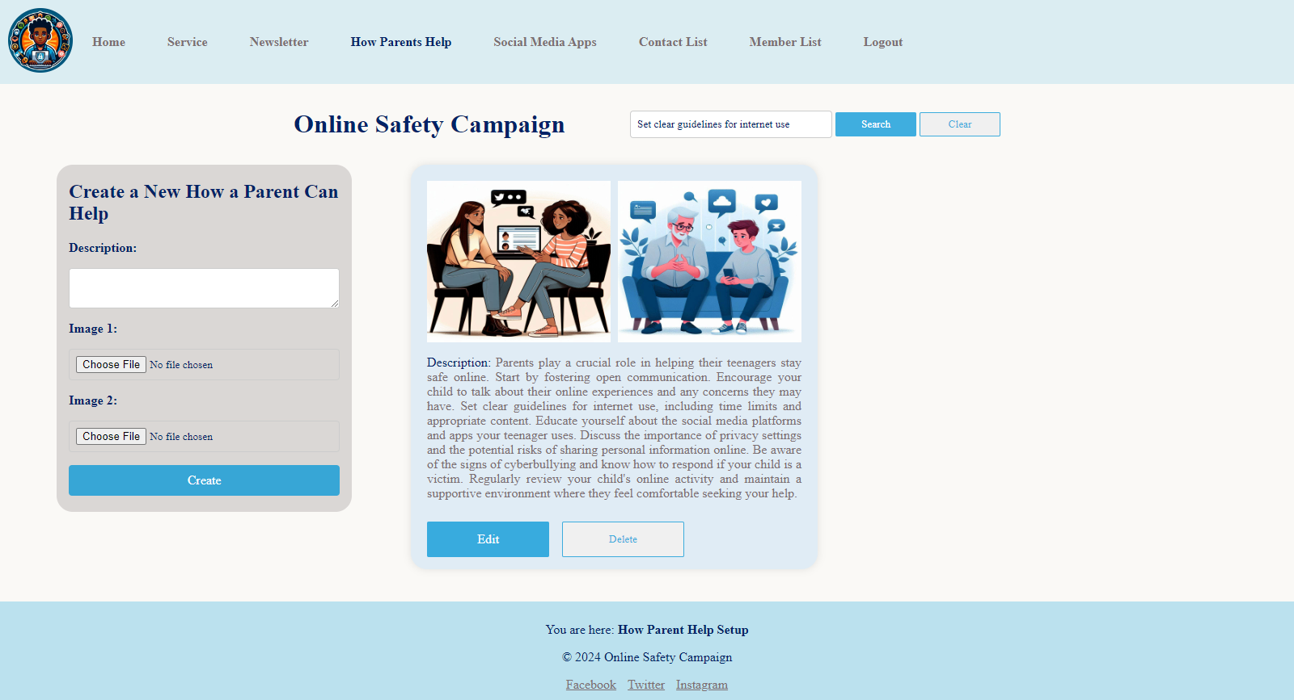

Output with search

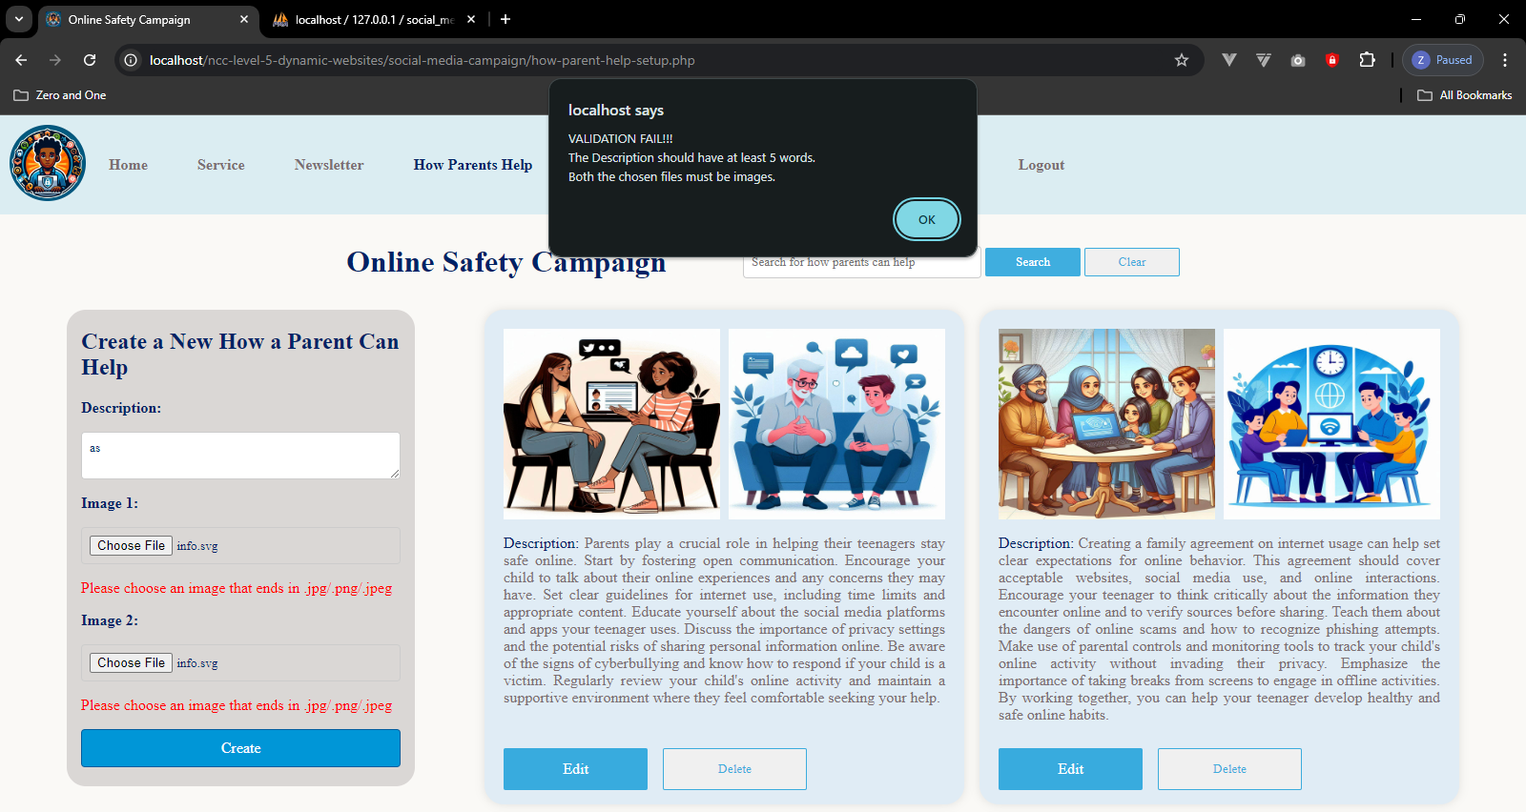

Parent help form validation with JavaScript

## social-media-app-setup.php (admin page)

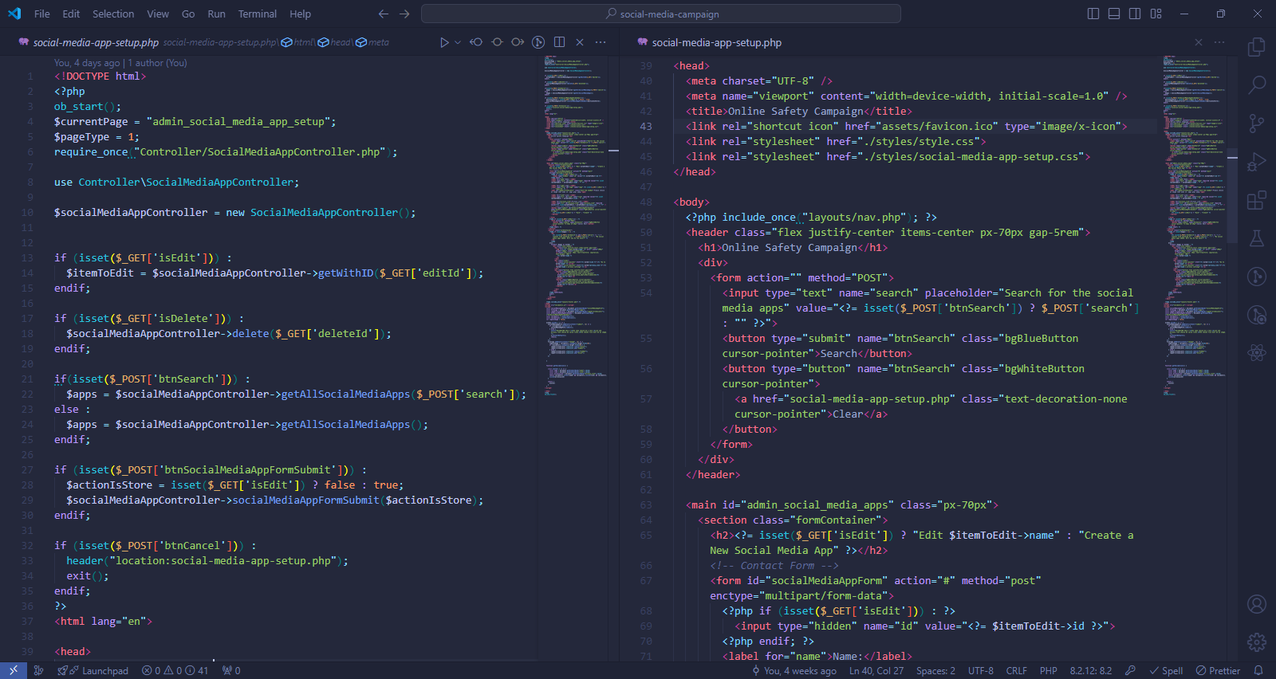

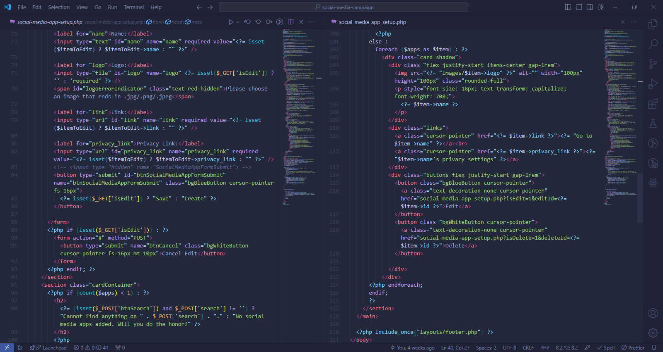

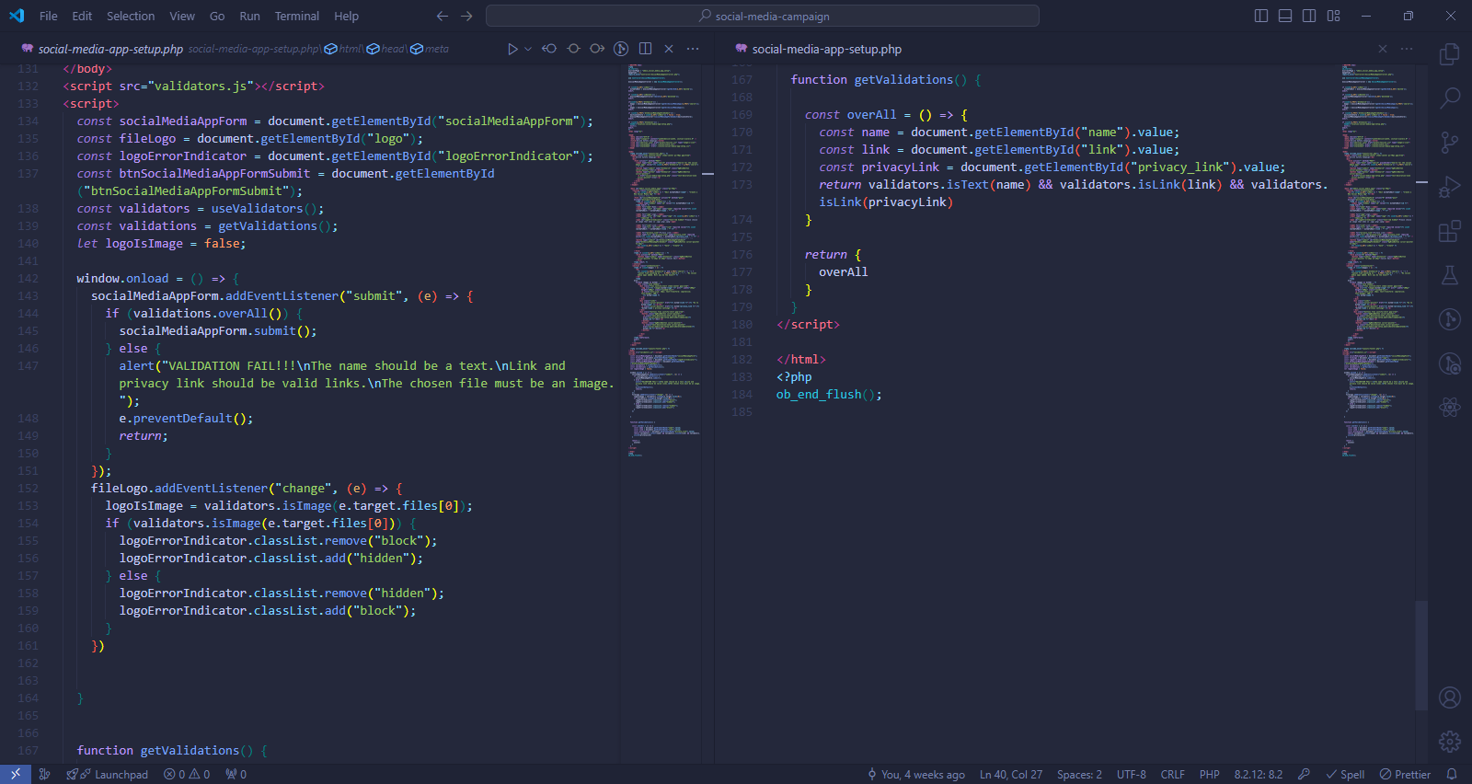

### Methods used in social-media-app-setup.php

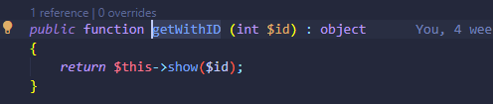

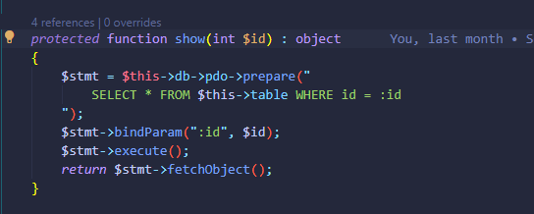

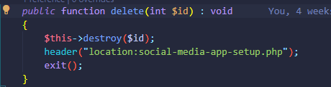

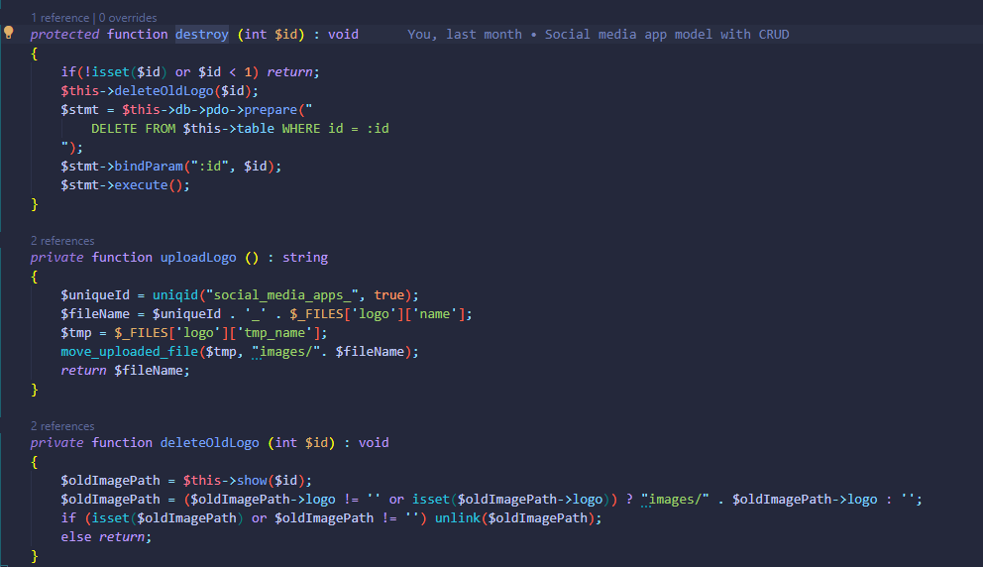

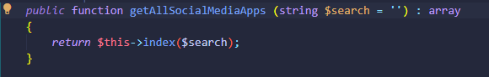

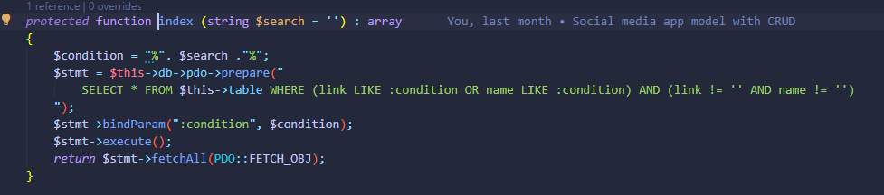

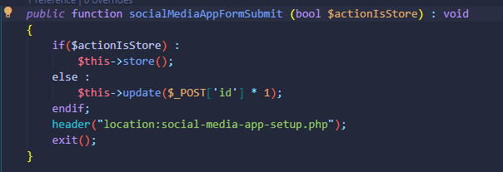

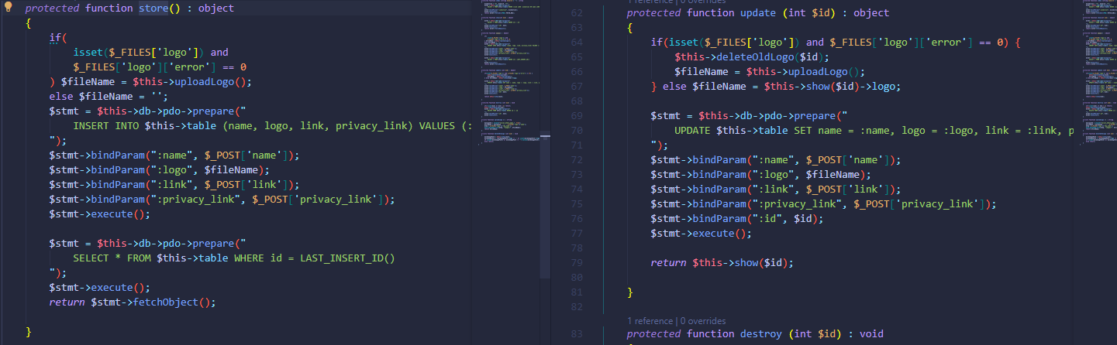

All methods directly used in social-media-app-setup.php are methods of SocialMediaAppController which extends the SocialMediaApp Model whose functions are responsible for reading and manipulating data of the table “social_media_apps”.

### Output of social-media-app-setup.php

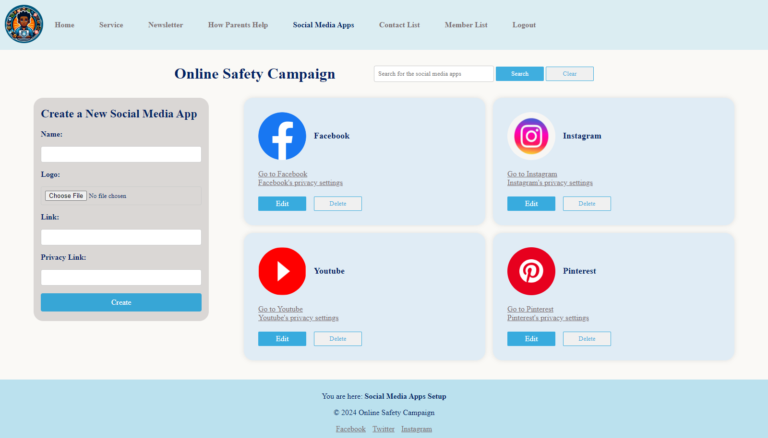



Output with edit form

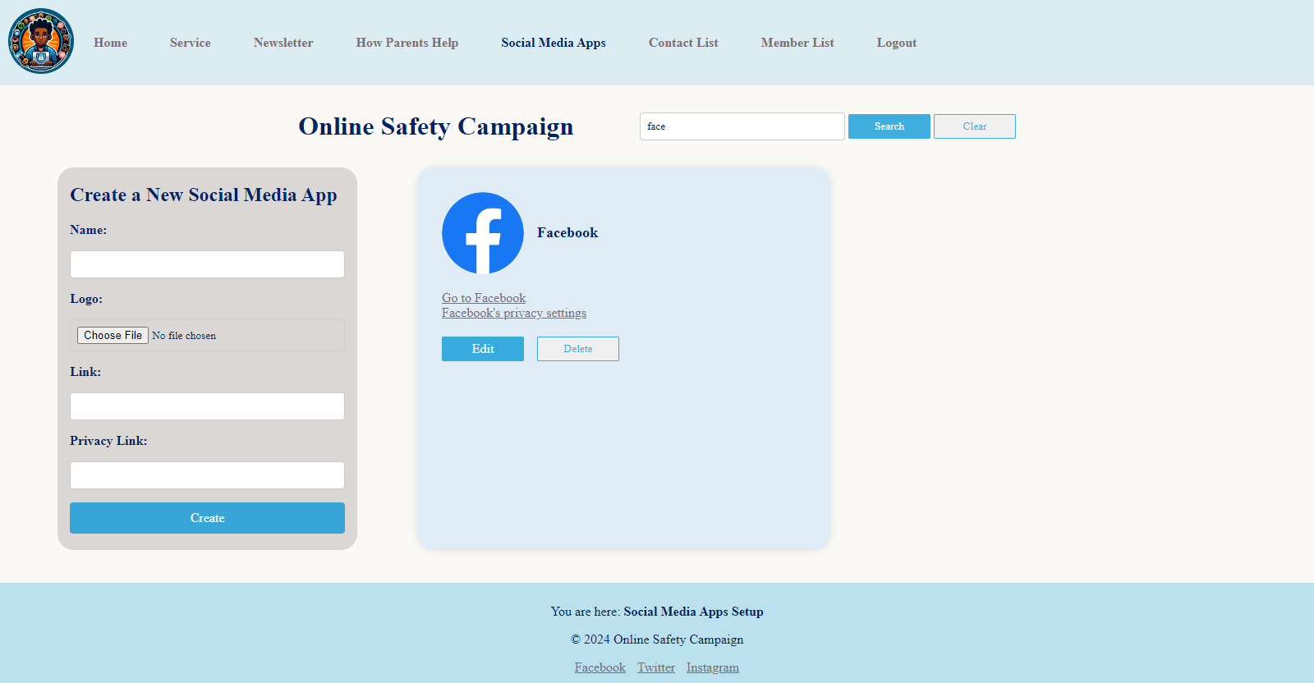

Output with search

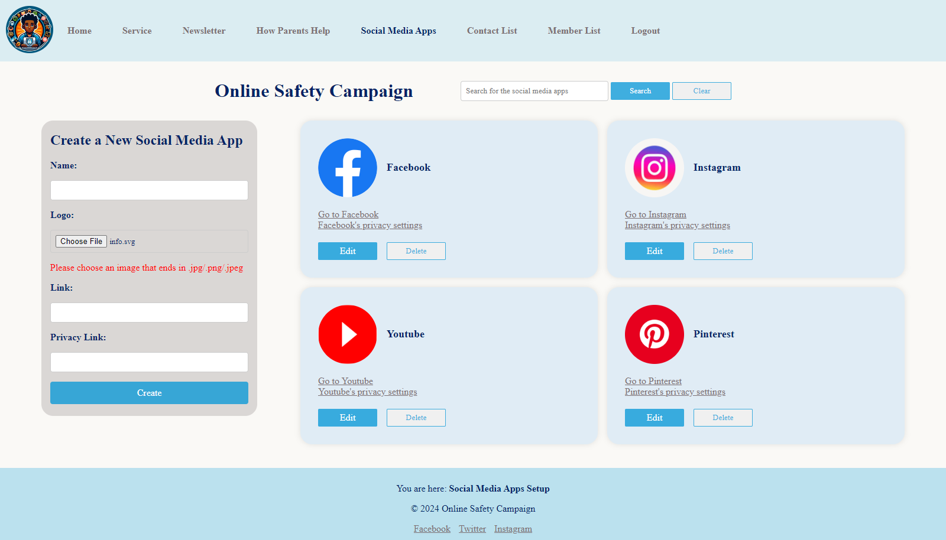

Form validation with JavaScript

## contact-list.php (admin page)

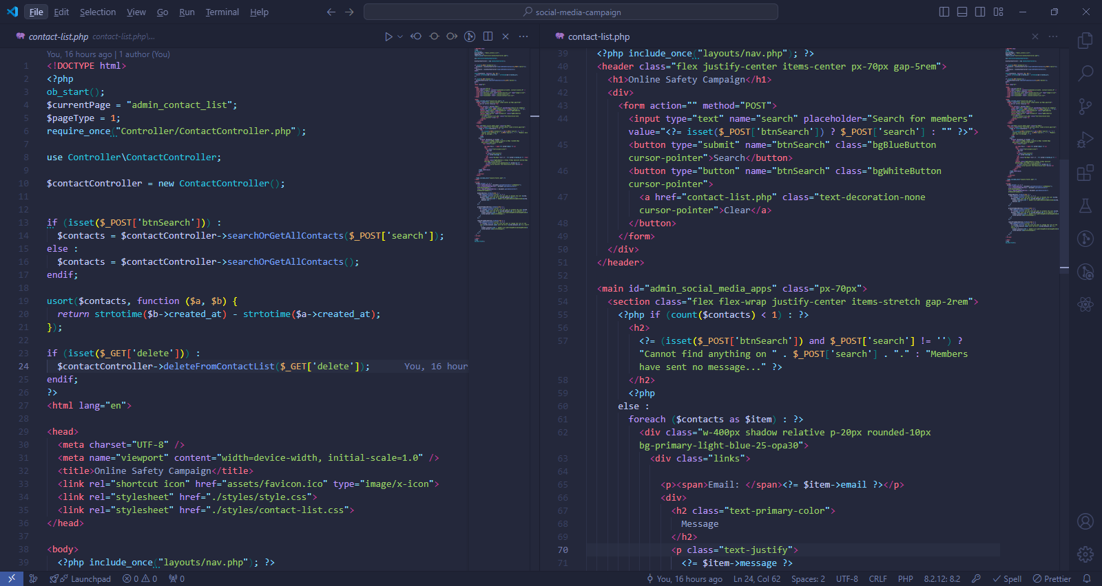

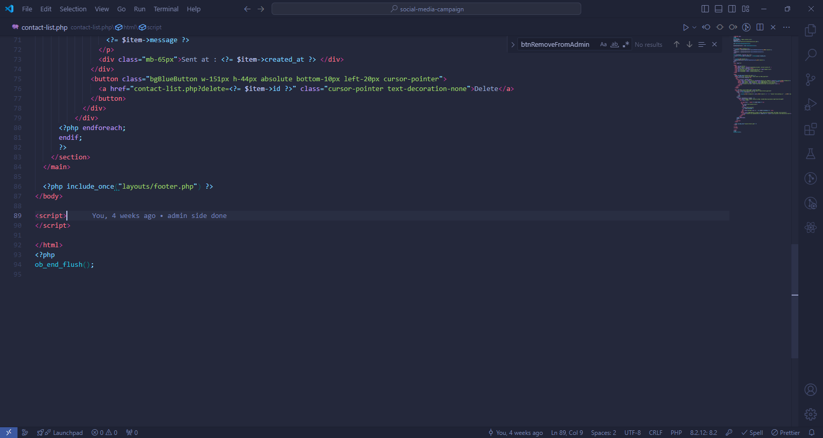

### Methods used in contact-list.php

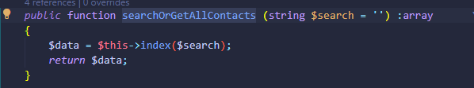

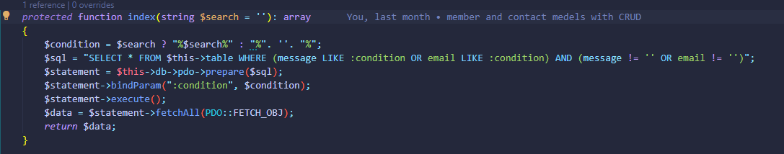

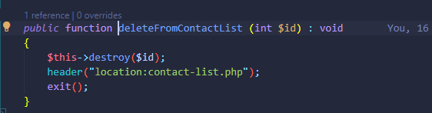

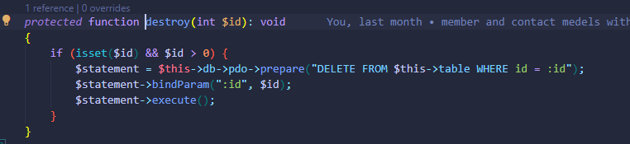

All methods directly used in contact-list.php are methods of ContactController which extends the Contact Model whose functions are responsible for reading and manipulating data of the table “contacts”.

### Output of contact-list.php

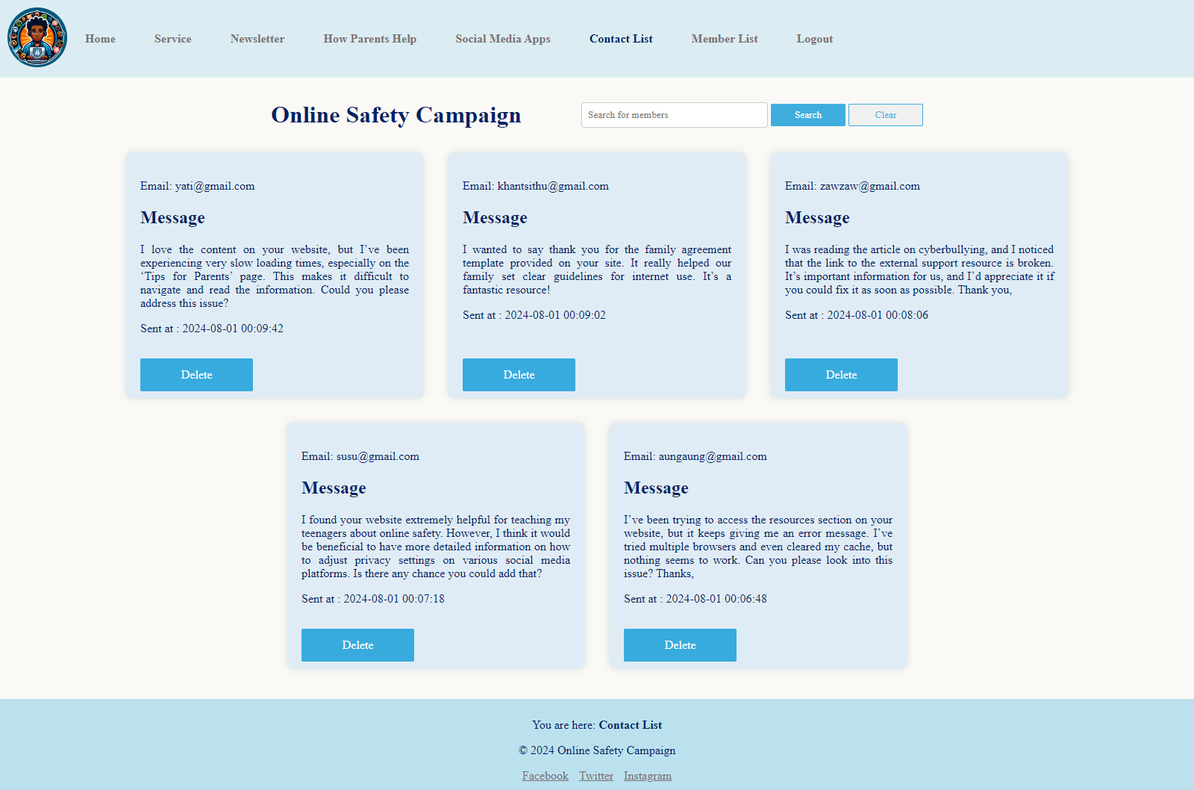

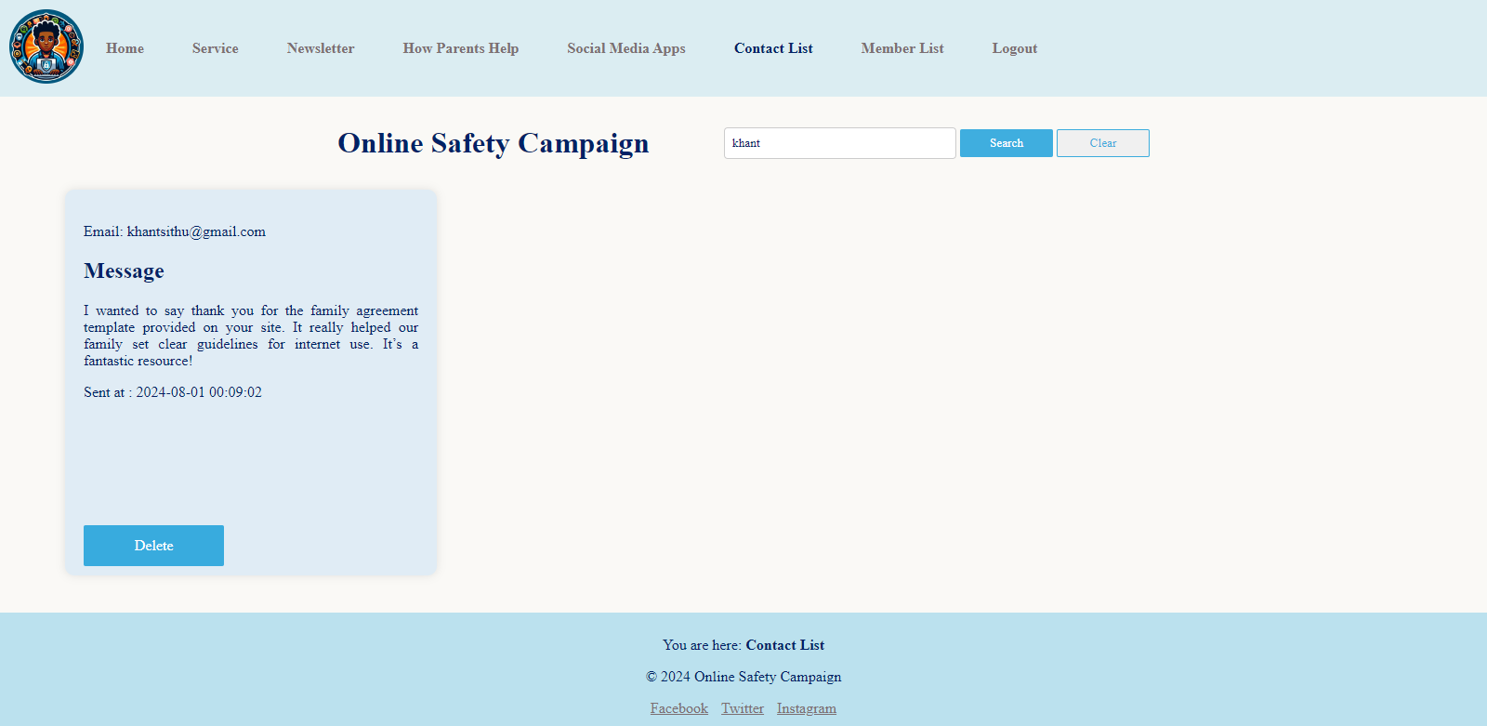

Output with search

## member-list.php (admin page)

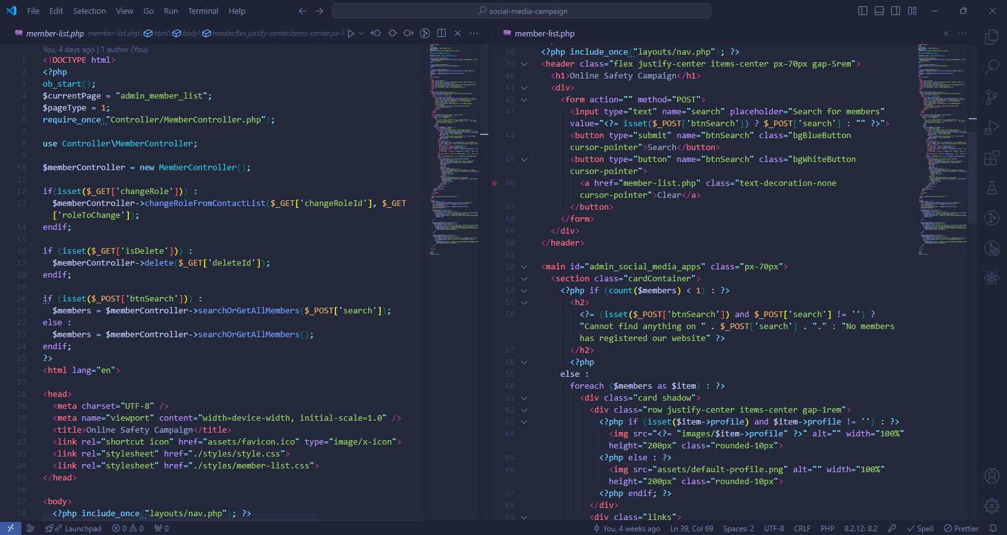

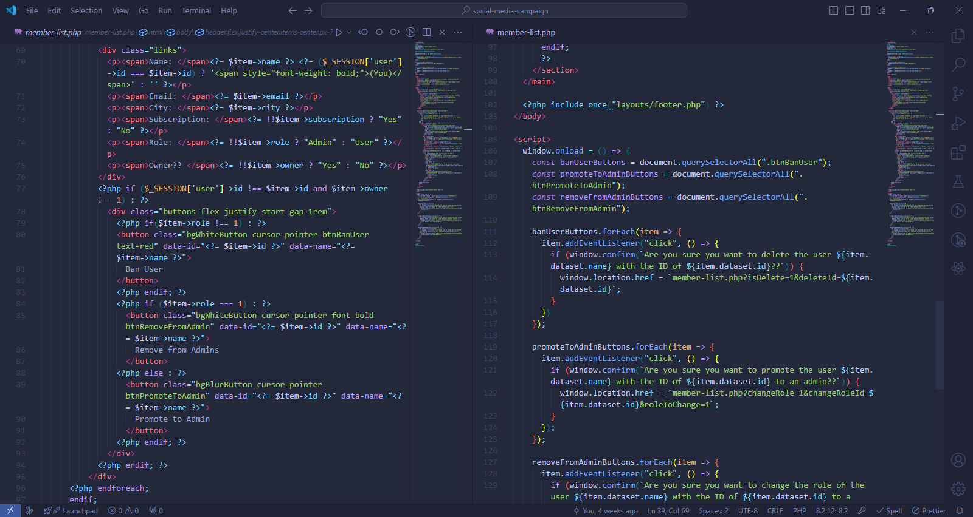

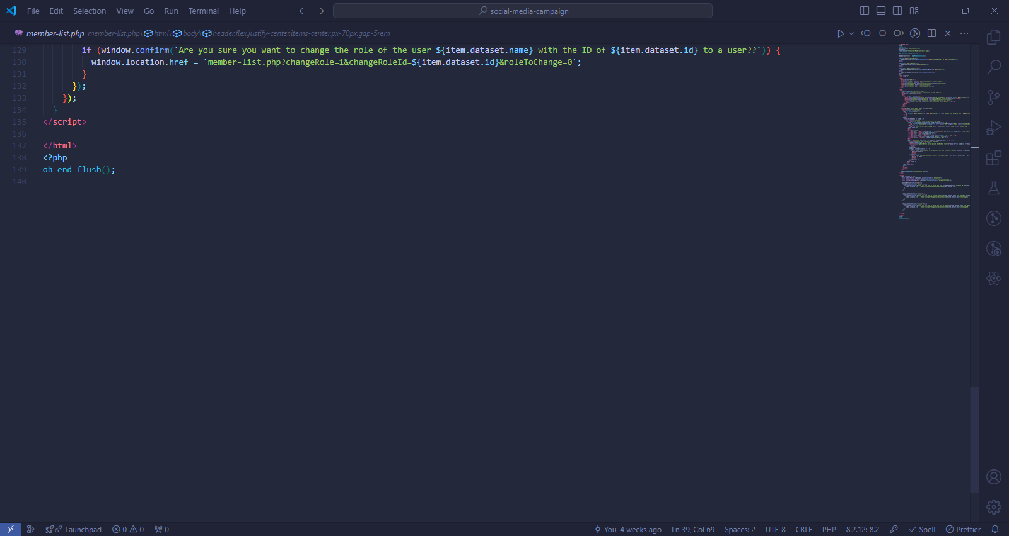

### Methods used in member-list.php

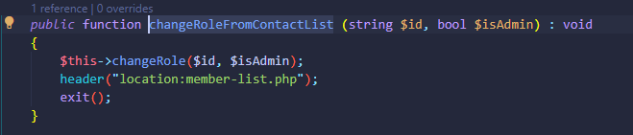

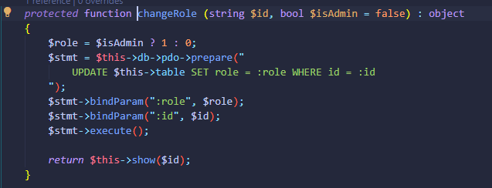

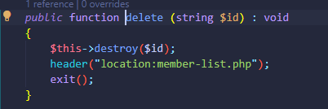

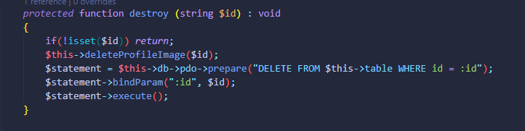

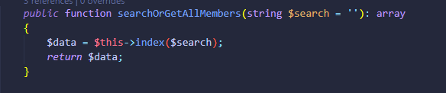

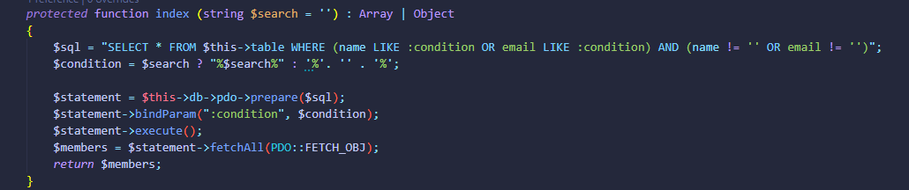

All methods directly used in member-list.php are methods of MemberController which extends the Member Model whose functions are responsible for reading and manipulating data of the table “members”.

### Output of member-list.php

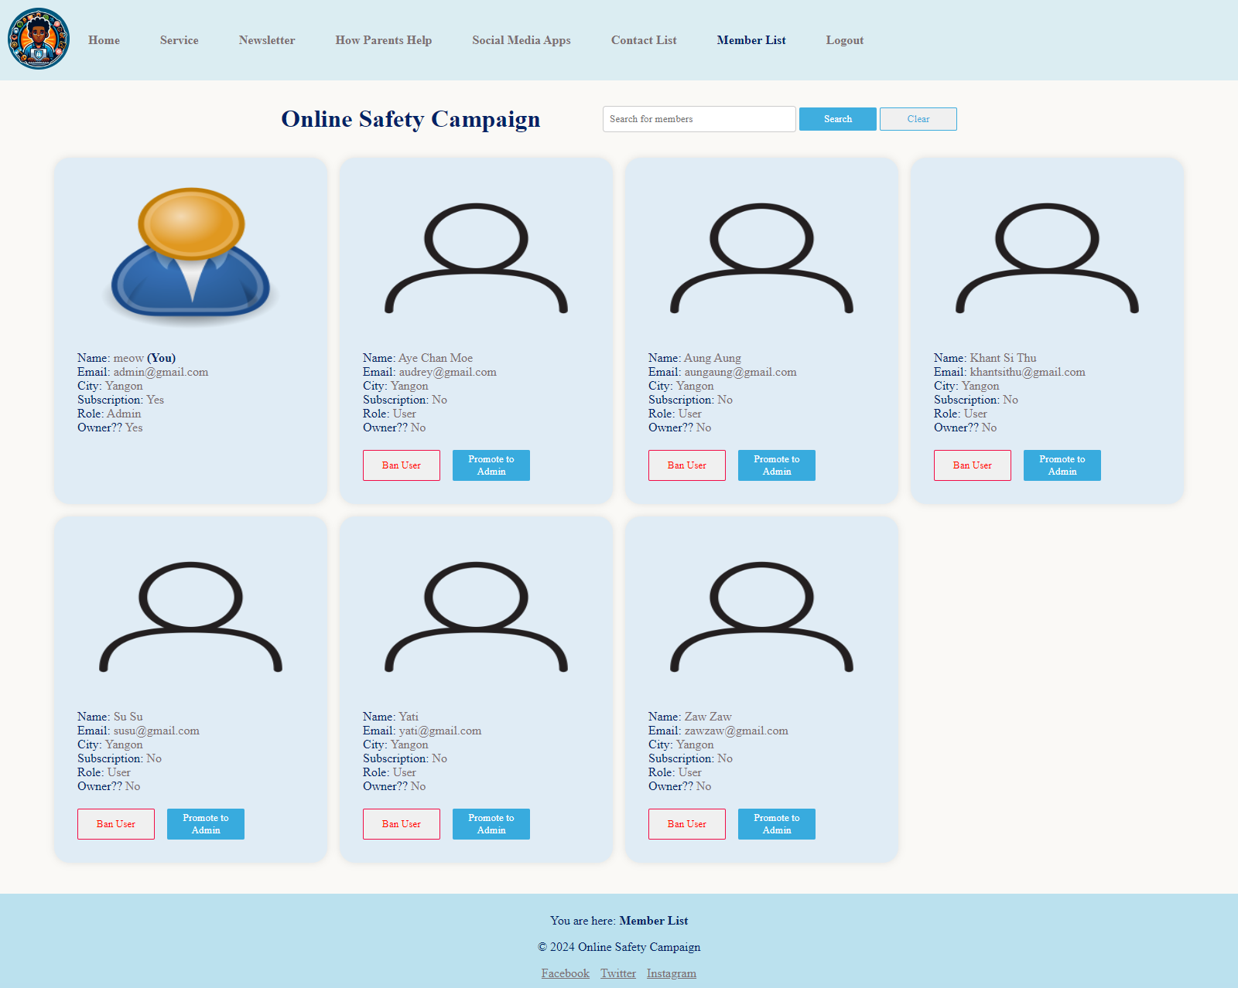

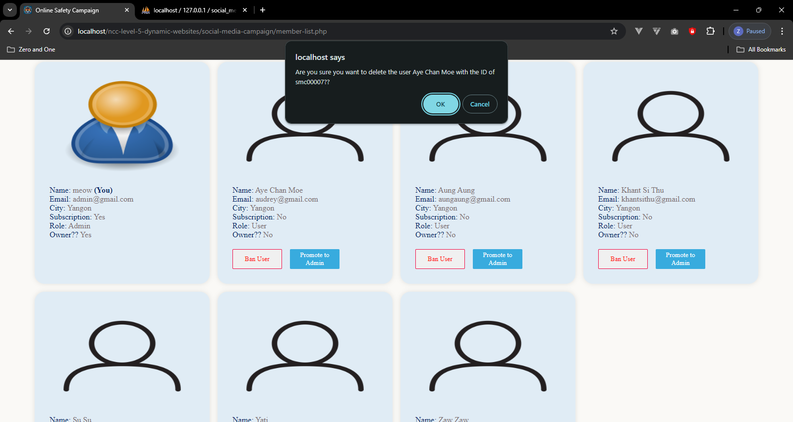

Ban user confirmation

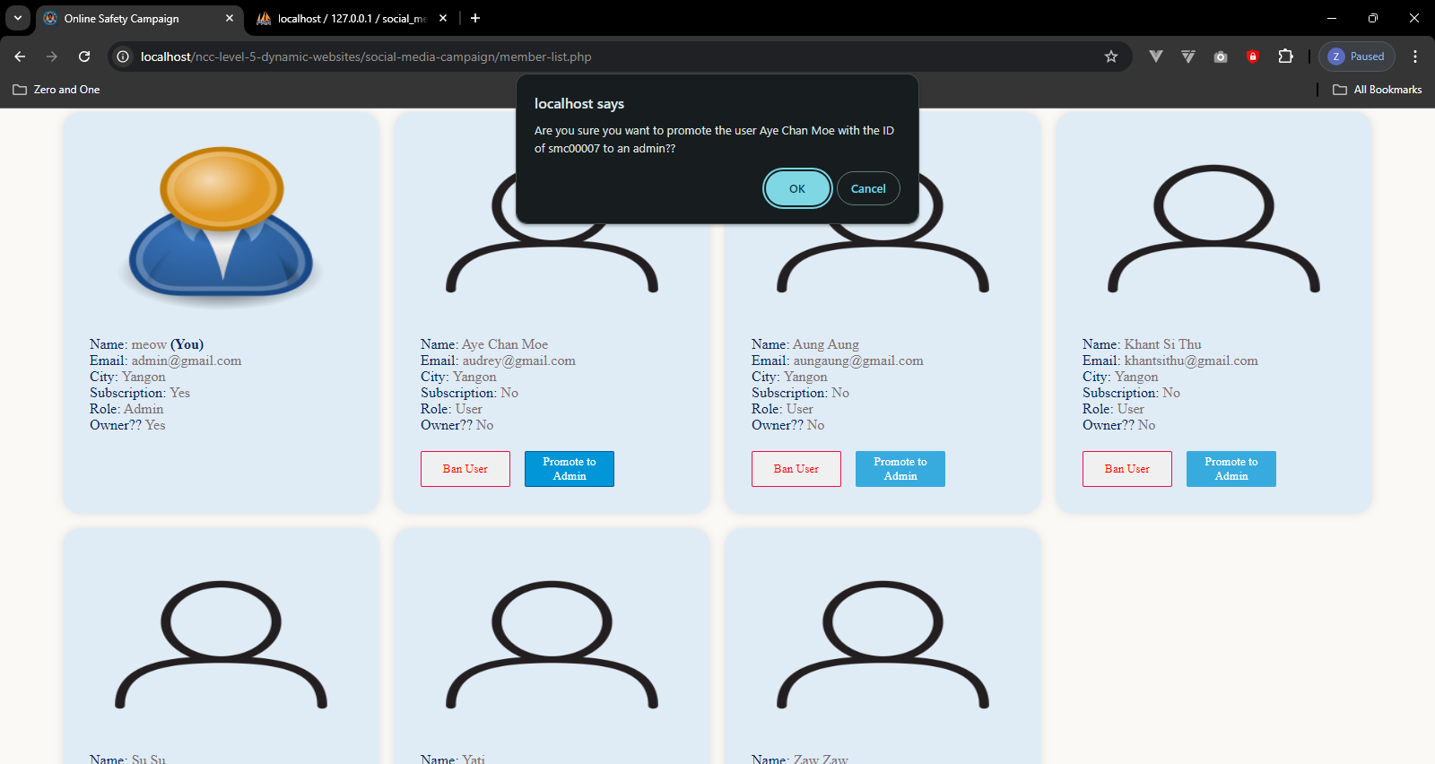

Admin promotion confirmation

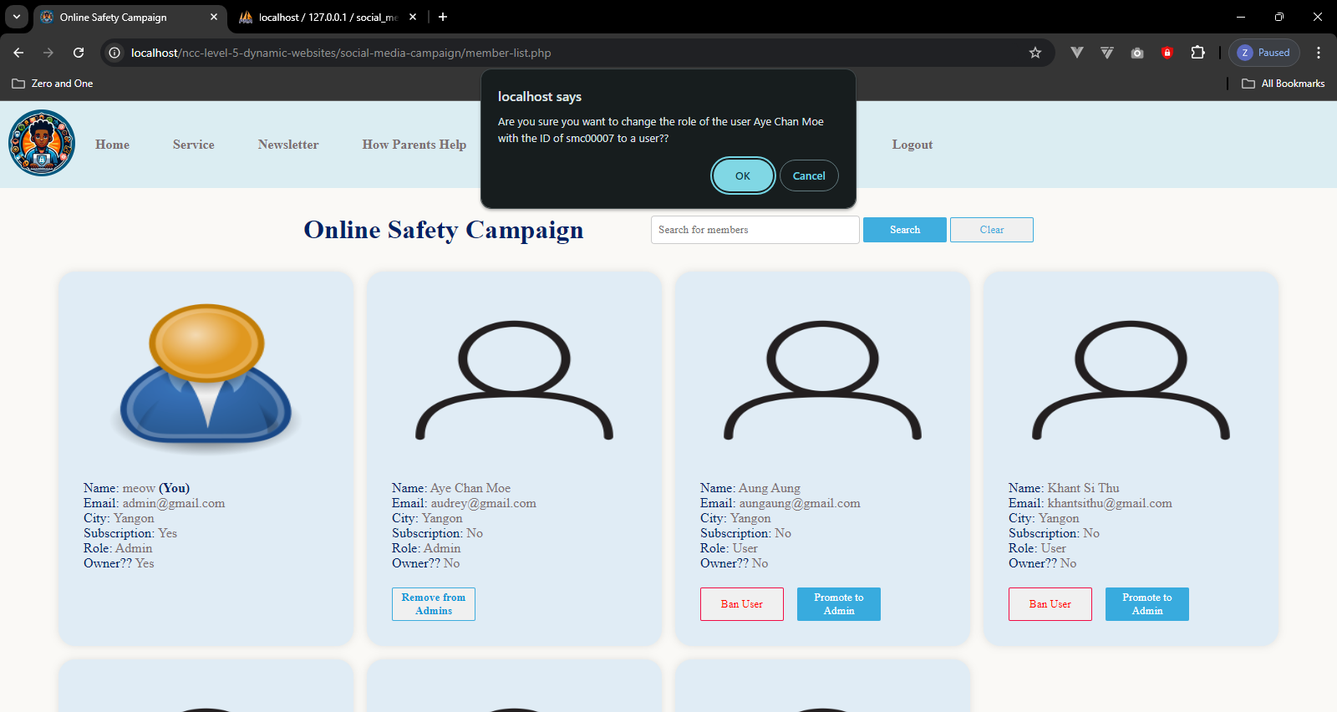

Admin demote confirmation

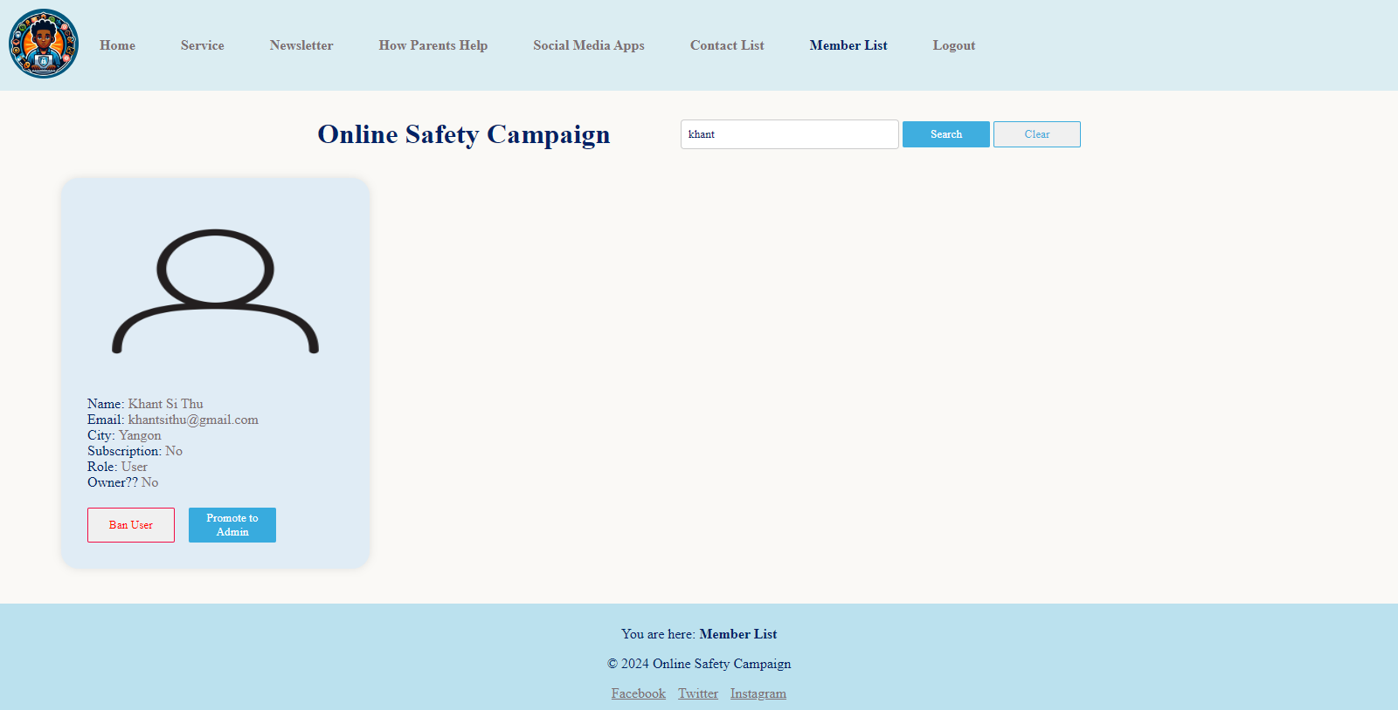

Output with search

## admin-profile.php (admin page)

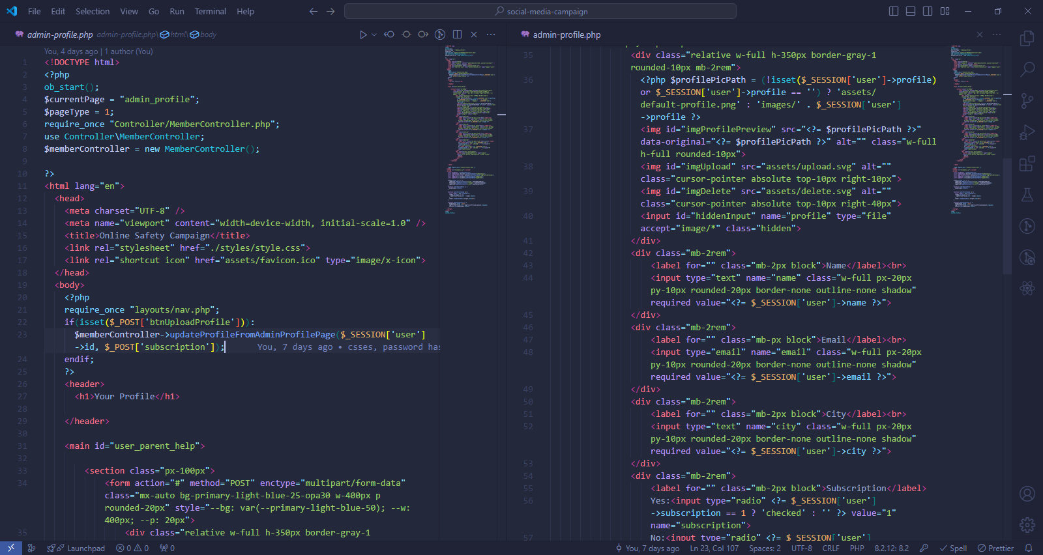

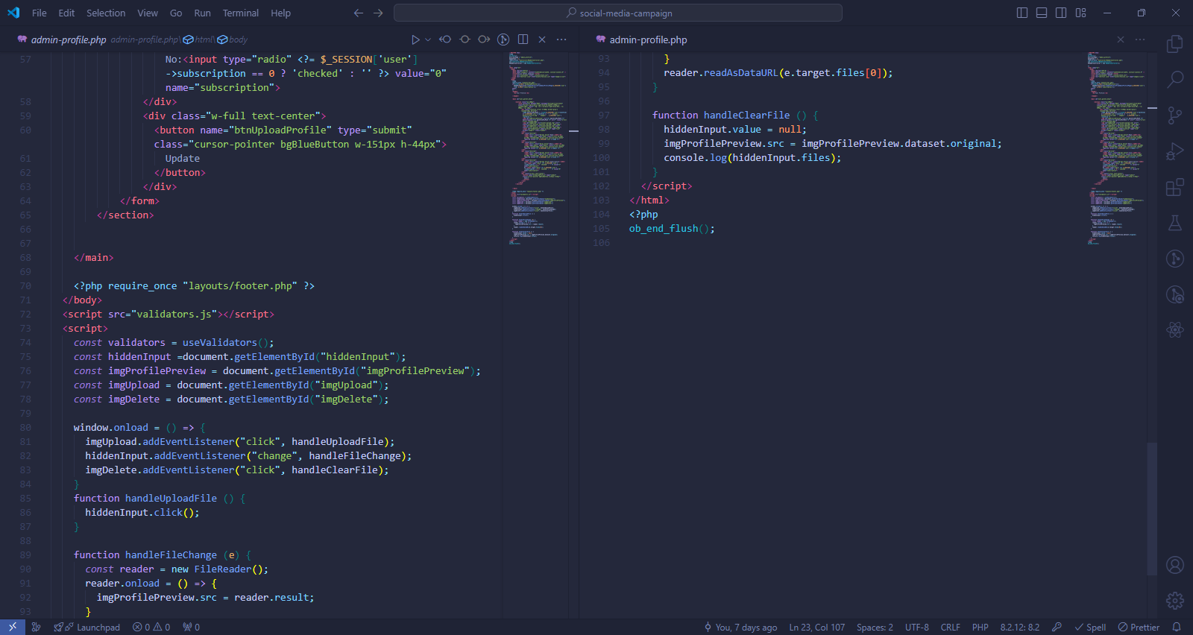

### Methods used in admin-profile.php

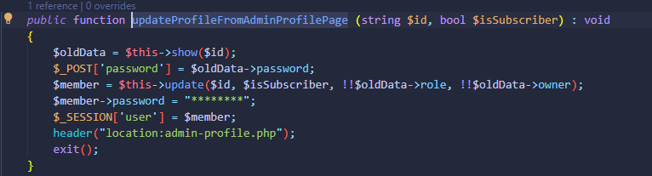

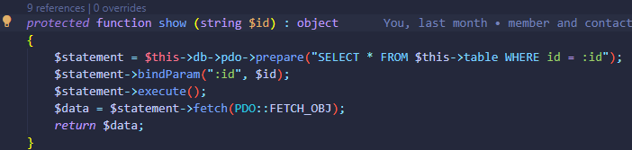

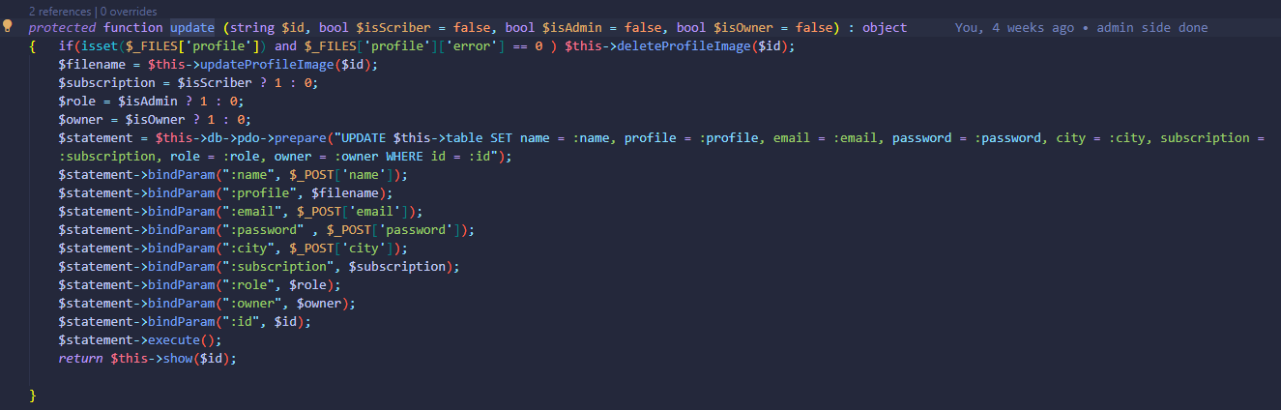

All methods directly used in admin-profile.php are methods of MemberController which extends the Member Model whose functions are responsible for reading and manipulating data of the table “members”.

### Output of admin-profile.php

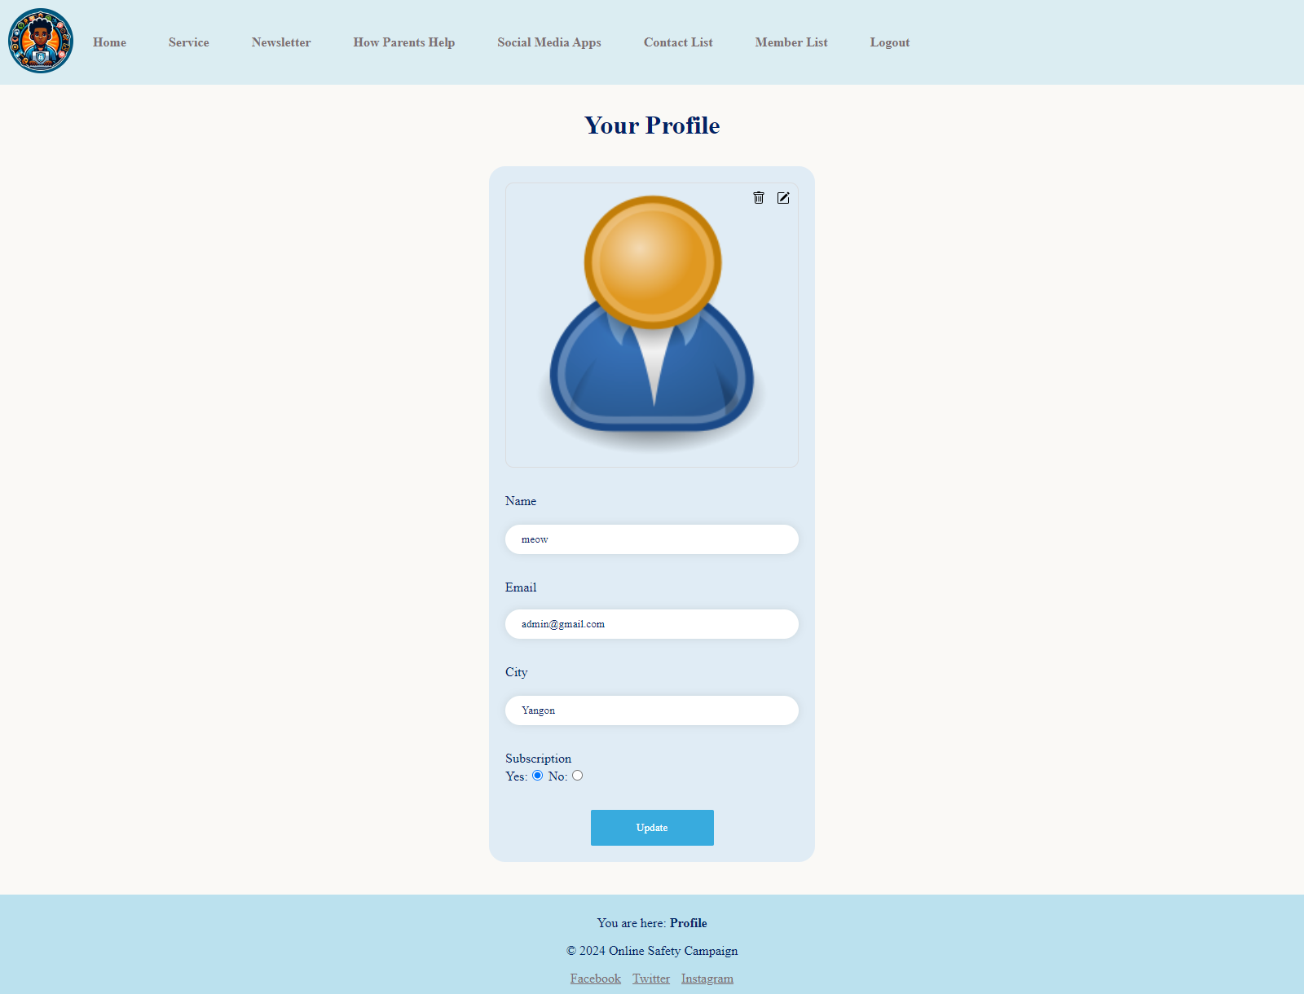

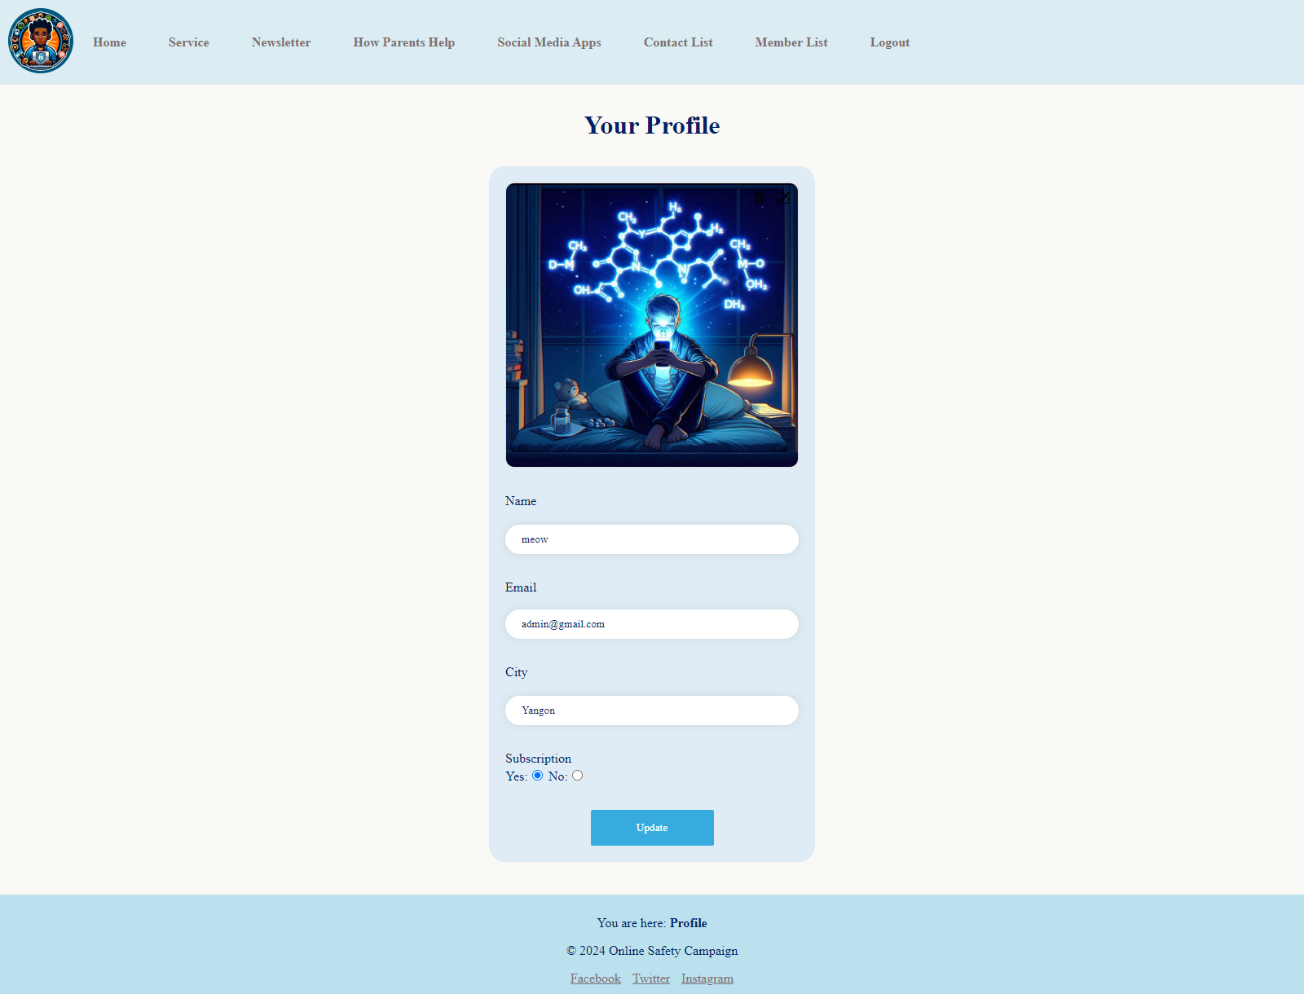

**Task - 2**

# Task – 2 – CSS and Database

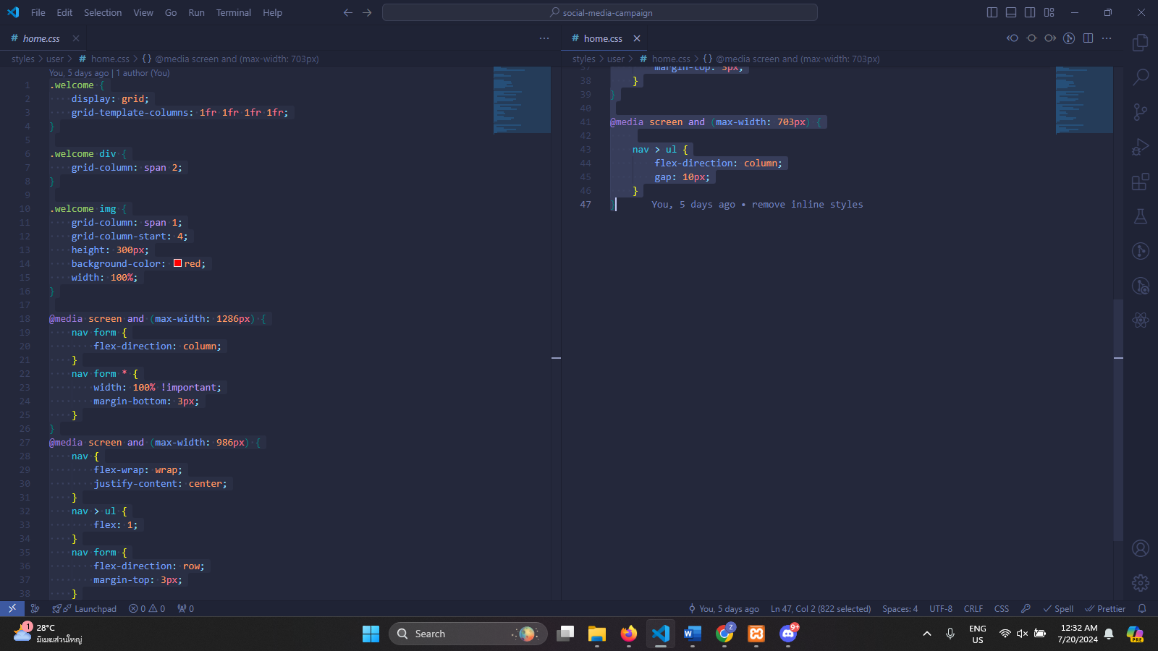

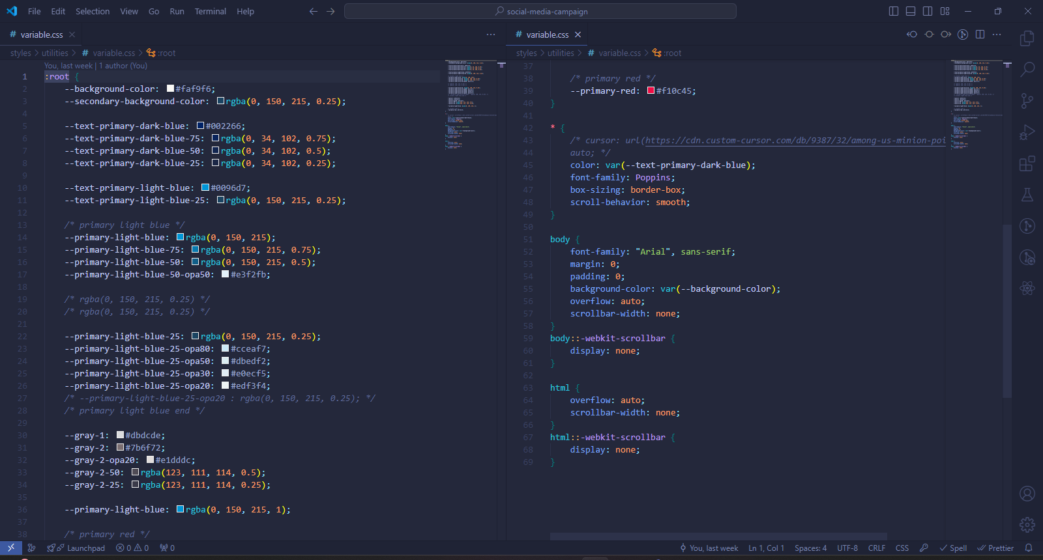

**Task - 3**

# Task – 3 – Critical Evaluation

## Introduction and Benefits of the Website

As today is the age of communication, the social media have taken place in everyone's everyday lives especially teenagers. The proposed website, social media campaign, show the ways and activities of how to sail through the waves of the social media ocean safely. The website will contain the information of popular social media applications, the services that the website provide, how parents can participate in the cyber safety of their children, and help and support which also includes contacting directly to the admins. By using the website, the teenagers will get the benefaction of knowledge concerning the ways of using the social media platforms safely.

## Web Development Tools for the Website

The development tools that I use during the development process are Visual Studio Code (VSCode), Chrome Browser and Xampp.

VSCode is a one of the famous text editors that can also use as an integrated development environment using its built-in command line interface(CLI) and other features. VSCode's extensions also provide error detection, especially PHP Intelliphense in this case, code formatting and other so many useful features. (EITCA, 2023)

Chrome is also a browser that improves developer experience by its excellent tools and features such as cache clearing and hard reloading, developer tools, and Chrome's development extensions. (Kanai, 2022)

Xampp is used for client server system. It is quite convenient as it is quite a package for PHP development. As Xampp is installed, an according version of PHP, a local development server with port configurations will be automatically installed. (Karan, 2023)

## Usage of PHP to Design and Build the Website Database

In this project, object-oriented programming (OOP) style of PHP is used effectively for quality, maintainability and scalability of the code.

A class for Database connection and that class's instance will be used as a property of each Model class. There will be one Model class for each table in the database. Each method of the Model classes will perform only one of creating, reading, updating and deleting the data of the table in the database following the solid principle.

Then, there will be one controller class for each table in the database. Each controller class is an inheritance of the corresponding model class. Controller classes will be responsible for redirecting or navigating, route parameter passing and performing the user's commands using the methods of the model classes following the model-view-controller (MVC) pattern using mostly encapsulation and inheritance of OOP.

There will be other classes like middleware and helper classes for methods that can be used all across the application.

## How Effectively the Website Meet the Requirements

This project is quite scalable, readable and maintainable as it uses object-oriented programming paradigm. Not only the code quality, the users can explore the newsletter, services, popular social media applications and how parents will be able to help in the online safety of their children at the corresponding pages of the website. Also, the website has a general search box that can search the content of all pages to increase the user's experience. The user's interface also uses light blue color for a symbol of calmness and home page also includes figures and divisions for clearance

**Task - 4**

# Task – 4 - Reflection

## Development Tools

One of the tools used for development is Firefox browser. It is a great browser, but lacks one feature that it does not include the "clear cache and hard reload" option when right clicked the refresh bottom. That feature is necessary because new CSS lines does apply to the web design automatically. The Chrome browser includes that feature when the developer tools is opened and right clicked the refresh bottom. So, chrome was ultimately chosen.

The sublime text was also tested. It is great but all the codes needed to be memorized because it's auto-complete suggestion feature is not perfect. But, in VSCode, that feature is quite strong and VSCode was chosen.

## Learning From the Development of The Website

In the development of this project, it was learned that PHP is quite a nice language for OOP even though it is a procedural language. Its OOP features are quite great. HTTP request methods GET, POST and their differences are also learned. Also, data from PHP can be obtained through data attribute of the HTML with JavaScript and how to use them. Also, how to make the project meet the requirements, the development plans, database design and how to manage the user's interface according to the content of the pages.

## Discussing for A Similar Task in The Future

If there is a similar task in the future, if the project's database is complex, the relationships between tables and multiplicity will be applied. Make the code more readable and reusable by following the best practices of the PHP programming language. Use API for data transfer between the front-end and back-end of the project would also be great for the next task.

# Bibliography

EITCA, 2023. *What are the advantages of using Visual Studio Code as a code editor for JavaScript development?.* [Online]   
Available at: https://eitca.org/web-development/eitc-wd-jsf-javascript-fundamentals/introduction-eitc-wd-jsf-javascript-fundamentals/history-of-javascript/examination-review-history-of-javascript/what-are-the-advantages-of-using-visual-studio-code-as-a-code-editor-for-  
[Accessed 20 July 2024].

Kanai, S., 2022. *Chrome - DevTools: A Complete Guide.* [Online]   
Available at: https://www.headspin.io/blog/chrome-devtools-a-complete-guide  
[Accessed 20 July 2024].

Karan, R., 2023. *Difference Between XAMPP and WAMP.* [Online]   
Available at: https://www.shiksha.com/online-courses/articles/difference-between-xampp-and-wamp/  
[Accessed 20 July 2024].